1. 第三季 课程介绍
好久不见，差不多两个月的时间，笔者去制作了另一门课程，换了换脑子，顺便也休息一下。在这两个月的时间内笔者一直在构思本课程的第三季，现在有了一些进展。
到目前为止得到了一个大致的内容规划，如下:
- 决定版架构作为 QFramework 的 v1.0 版本正式发布
  - 文档编写
  - 改进一些 API
  - 点点点 和 CounterApp 作为 QFramework v1.0 的示例项目（需要用 QF v1.0 重构）
  - 完善 ShootingEditor2D 作为 QFramework v1.0 的示例项目（需要用 QF v1.0 重构）
- 理论强化篇
  - 单例模式 与 对象之间的交互 强化 14 课时左右
  - 观察者模式 5 课时左右
  - IOC 概念强化 与 简易 IOC 容器 17 课时左右
  - 深入理解命令模式 8 课时左右
总共第三季预计 50 课时，所以基本上内容就足够了。
从下一堂课开始，我们先推进 QFramework v1.0 版本发布这件事情。

2. (2~3)代码合并 和 API、Bug 修复 与 QFramework v1.0 发布
要做的事情:
- 需要把决定版架构合并为一个文件 OK
- BindableProperty 需要提供一个默认值的构造 Bug 修复
- BindableProperty 更改一下 API
  - RegisterOnValueChanged =>Register
  - RegisterWithInitValue
- 需要使用 Unity 2018 LTS 来做这件事情
把所有架构相关代码合并到了一个文件里，合并之后，代码如下:
/****************************************************************************
* Copyright (c) 2015 ~ 2022 liangxiegame MIT License
*
* QFramework v1.0
*
* https://qframework.cn
* https://github.com/liangxiegame/QFramework
*
* Author:
* liangxie
* 王二 soso
* Contributor
* TastSong
*
* Community
* QQ Group: 623597263
****************************************************************************/
using System;
using System.Collections.Generic;
using UnityEngine;
namespace QFramework
{
#region Architecture
public interface IArchitecture
{
void RegisterSystem<T>(T system) where T : ISystem;
void RegisterModel<T>(T model) where T : IModel;
void RegisterUtility<T>(T utility) where T : IUtility;
T GetSystem<T>() where T : class, ISystem;
T GetModel<T>() where T : class, IModel;
T GetUtility<T>() where T : class, IUtility;
void SendCommand<T>() where T : ICommand, new();
void SendCommand<T>(T command) where T : ICommand;
TResult SendQuery<TResult>(IQuery<TResult> query);
void SendEvent<T>() where T : new();
void SendEvent<T>(T e);
IUnRegister RegisterEvent<T>(Action<T> onEvent);
void UnRegisterEvent<T>(Action<T> onEvent);
}
public abstract class Architecture<T> : IArchitecture where T : Architecture<T>, new()
{
/// <summary>
/// 是否初始化完成
/// </summary>
private bool mInited = false;
private List<ISystem> mSystems = new List<ISystem>();
private List<IModel> mModels = new List<IModel>();
public static Action<T> OnRegisterPatch = architecture => { };
private static T mArchitecture;
public static IArchitecture Interface
{
get
{
if (mArchitecture == null)
{
MakeSureArchitecture();
}
return mArchitecture;
}
}
static void MakeSureArchitecture()
{
if (mArchitecture == null)
{
mArchitecture = new T();
mArchitecture.Init();
OnRegisterPatch?.Invoke(mArchitecture);
foreach (var architectureModel in mArchitecture.mModels)
{
architectureModel.Init();
}
mArchitecture.mModels.Clear();
foreach (var architectureSystem in mArchitecture.mSystems)
{
architectureSystem.Init();
}
mArchitecture.mSystems.Clear();
mArchitecture.mInited = true;
}
}
protected abstract void Init();
private IOCContainer mContainer = new IOCContainer();
public void RegisterSystem<TSystem>(TSystem system) where TSystem : ISystem
{
system.SetArchitecture(this);
mContainer.Register<TSystem>(system);
if (!mInited)
{
mSystems.Add(system);
}
else
{
system.Init();
}
}
public void RegisterModel<TModel>(TModel model) where TModel : IModel
{
model.SetArchitecture(this);
mContainer.Register<TModel>(model);
if (!mInited)
{
mModels.Add(model);
}
else
{
model.Init();
}
}
public void RegisterUtility<TUtility>(TUtility utility) where TUtility : IUtility
{
mContainer.Register<TUtility>(utility);
}
public TSystem GetSystem<TSystem>() where TSystem : class, ISystem
{
return mContainer.Get<TSystem>();
}
public TModel GetModel<TModel>() where TModel : class, IModel
{
return mContainer.Get<TModel>();
}
public TUtility GetUtility<TUtility>() where TUtility : class, IUtility
{
return mContainer.Get<TUtility>();
}
public void SendCommand<TCommand>() where TCommand : ICommand, new()
{
var command = new TCommand();
command.SetArchitecture(this);
command.Execute();
}
public void SendCommand<TCommand>(TCommand command) where TCommand : ICommand
{
command.SetArchitecture(this);
command.Execute();
}
public TResult SendQuery<TResult>(IQuery<TResult> query)
{
query.SetArchitecture(this);
return query.Do();
}
private ITypeEventSystem mTypeEventSystem = new TypeEventSystem();
public void SendEvent<TEvent>() where TEvent : new()
{
mTypeEventSystem.Send<TEvent>();
}
public void SendEvent<TEvent>(TEvent e)
{
mTypeEventSystem.Send<TEvent>(e);
}
public IUnRegister RegisterEvent<TEvent>(Action<TEvent> onEvent)
{
return mTypeEventSystem.Register<TEvent>(onEvent);
}
public void UnRegisterEvent<TEvent>(Action<TEvent> onEvent)
{
mTypeEventSystem.UnRegister<TEvent>(onEvent);
}
}
#endregion
#region Controller
public interface IController : IBelongToArchitecture,ICanSendCommand,ICanGetSystem,ICanGetModel,ICanRegisterEvent,ICanSendQuery
{
}
#endregion
#region System
public interface ISystem : IBelongToArchitecture ,ICanSetArchitecture,ICanGetModel,ICanGetUtility,ICanRegisterEvent,ICanSendEvent,ICanGetSystem
{
void Init();
}
public abstract class AbstractSystem : ISystem
{
private IArchitecture mArchitecture;
IArchitecture IBelongToArchitecture.GetArchitecture()
{
return mArchitecture;
}
void ICanSetArchitecture.SetArchitecture(IArchitecture architecture)
{
mArchitecture = architecture;
}
void ISystem.Init()
{
OnInit();
}
protected abstract void OnInit();
}
#endregion
#region Model
public interface IModel : IBelongToArchitecture,ICanSetArchitecture,ICanGetUtility,ICanSendEvent
{
void Init();
}
public abstract class AbstractModel: IModel
{
private IArchitecture mArchitecturel;
IArchitecture IBelongToArchitecture.GetArchitecture()
{
return mArchitecturel;
}
void ICanSetArchitecture.SetArchitecture(IArchitecture architecture)
{
mArchitecturel = architecture;
}
void IModel.Init()
{
OnInit();
}
protected abstract void OnInit();
}
#endregion
#region Utility
public interface IUtility
{
}
#endregion
#region Command
public interface ICommand : IBelongToArchitecture,ICanSetArchitecture,ICanGetSystem,ICanGetModel,ICanGetUtility,ICanSendEvent,ICanSendCommand,ICanSendQuery
{
void Execute();
}
public abstract class AbstractCommand : ICommand
{
private IArchitecture mArchitecture;
IArchitecture IBelongToArchitecture.GetArchitecture()
{
return mArchitecture;
}
void ICanSetArchitecture.SetArchitecture(IArchitecture architecture)
{
mArchitecture = architecture;
}
void ICommand.Execute()
{
OnExecute();
}
protected abstract void OnExecute();
}
#endregion
#region Query
public interface IQuery<TResult> : IBelongToArchitecture,ICanSetArchitecture,ICanGetModel,ICanGetSystem,ICanSendQuery
{
TResult Do();
}
public abstract class AbstractQuery<T> : IQuery<T>
{
public T Do()
{
return OnDo();
}
protected abstract T OnDo();
private IArchitecture mArchitecture;
public IArchitecture GetArchitecture()
{
return mArchitecture;
}
public void SetArchitecture(IArchitecture architecture)
{
mArchitecture = architecture;
}
}
#endregion
#region Rule
public interface IBelongToArchitecture
{
IArchitecture GetArchitecture();
}
public interface ICanSetArchitecture
{
void SetArchitecture(IArchitecture architecture);
}
public interface ICanGetModel : IBelongToArchitecture
{
}
public static class CanGetModelExtension
{
public static T GetModel<T>(this ICanGetModel self) where T : class, IModel
{
return self.GetArchitecture().GetModel<T>();
}
}
public interface ICanGetSystem : IBelongToArchitecture
{
}
public static class CanGetSystemExtension
{
public static T GetSystem<T>(this ICanGetSystem self) where T : class, ISystem
{
return self.GetArchitecture().GetSystem<T>();
}
}
public interface ICanGetUtility : IBelongToArchitecture
{
}
public static class CanGetUtilityExtension
{
public static T GetUtility<T>(this ICanGetUtility self) where T : class, IUtility
{
return self.GetArchitecture().GetUtility<T>();
}
}
public interface ICanRegisterEvent : IBelongToArchitecture
{
}
public static class CanRegisterEventExtension
{
public static IUnRegister RegisterEvent<T>(this ICanRegisterEvent self, Action<T> onEvent)
{
return self.GetArchitecture().RegisterEvent<T>(onEvent);
}
public static void UnRegisterEvent<T>(this ICanRegisterEvent self, Action<T> onEvent)
{
self.GetArchitecture().UnRegisterEvent<T>(onEvent);
}
}
public interface ICanSendCommand : IBelongToArchitecture
{
}
public static class CanSendCommandExtension
{
public static void SendCommand<T>(this ICanSendCommand self) where T : ICommand, new()
{
self.GetArchitecture().SendCommand<T>();
}
public static void SendCommand<T>(this ICanSendCommand self,T command) where T : ICommand
{
self.GetArchitecture().SendCommand<T>(command);
}
}
public interface ICanSendEvent : IBelongToArchitecture
{
}
public static class CanSendEventExtension
{
public static void SendEvent<T>(this ICanSendEvent self) where T : new()
{
self.GetArchitecture().SendEvent<T>();
}
public static void SendEvent<T>(this ICanSendEvent self, T e)
{
self.GetArchitecture().SendEvent<T>(e);
}
}
public interface ICanSendQuery : IBelongToArchitecture
{
}
public static class CanSendQueryExtension
{
public static TResult SendQuery<TResult>(this ICanSendQuery self, IQuery<TResult> query)
{
return self.GetArchitecture().SendQuery(query);
}
}
#endregion
#region TypeEventSystem
public interface ITypeEventSystem
{
void Send<T>() where T : new();
void Send<T>(T e);
IUnRegister Register<T>(Action<T> onEvent);
void UnRegister<T>(Action<T> onEvent);
}
public interface IUnRegister
{
void UnRegister();
}
public struct TypeEventSystemUnRegister<T> : IUnRegister
{
public ITypeEventSystem TypeEventSystem;
public Action<T> OnEvent;
public void UnRegister()
{
TypeEventSystem.UnRegister<T>(OnEvent);
TypeEventSystem = null;
OnEvent = null;
}
}
public class UnRegisterOnDestroyTrigger : MonoBehaviour
{
private HashSet<IUnRegister> mUnRegisters = new HashSet<IUnRegister>();
public void AddUnRegister(IUnRegister unRegister)
{
mUnRegisters.Add(unRegister);
}
private void OnDestroy()
{
foreach (var unRegister in mUnRegisters)
{
unRegister.UnRegister();
}
mUnRegisters.Clear();
}
}
public static class UnRegisterExtension
{
public static void UnRegisterWhenGameObjectDestroyed(this IUnRegister unRegister, GameObject gameObject)
{
var trigger = gameObject.GetComponent<UnRegisterOnDestroyTrigger>();
if (!trigger)
{
trigger = gameObject.AddComponent<UnRegisterOnDestroyTrigger>();
}
trigger.AddUnRegister(unRegister);
}
}
public class TypeEventSystem : ITypeEventSystem
{
public interface IRegistrations
{
}
public class Registrations<T> : IRegistrations
{
public Action<T> OnEvent = e => { };
}
private Dictionary<Type, IRegistrations> mEventRegistration = new Dictionary<Type, IRegistrations>();
public void Send<T>() where T : new()
{
var e = new T();
Send<T>(e);
}
public void Send<T>(T e)
{
var type = typeof(T);
IRegistrations registrations;
if (mEventRegistration.TryGetValue(type, out registrations))
{
(registrations as Registrations<T>).OnEvent(e);
}
}
public IUnRegister Register<T>(Action<T> onEvent)
{
var type = typeof(T);
IRegistrations registrations;
if (mEventRegistration.TryGetValue(type, out registrations))
{
}
else
{
registrations = new Registrations<T>();
mEventRegistration.Add(type, registrations);
}
(registrations as Registrations<T>).OnEvent += onEvent;
return new TypeEventSystemUnRegister<T>()
{
OnEvent = onEvent,
TypeEventSystem = this
};
}
public void UnRegister<T>(Action<T> onEvent)
{
var type = typeof(T);
IRegistrations registrations;
if (mEventRegistration.TryGetValue(type, out registrations))
{
(registrations as Registrations<T>).OnEvent -= onEvent;
}
}
}
#endregion
#region IOC
public class IOCContainer
{
private Dictionary<Type, object> mInstances = new Dictionary<Type, object>();
public void Register<T>(T instance)
{
var key = typeof(T);
if (mInstances.ContainsKey(key))
{
mInstances[key] = instance;
}
else
{
mInstances.Add(key, instance);
}
}
public T Get<T>() where T : class
{
var key = typeof(T);
if (mInstances.TryGetValue(key, out var retInstance))
{
return retInstance as T;
}
return null;
}
}
#endregion
#region BindableProperty
public class BindableProperty<T>
{
public BindableProperty(T defaultValue = default)
{
mValue = defaultValue;
}
private T mValue = default(T);
public T Value
{
get => mValue;
set
{
if (value == null && mValue == null) return;
if (value != null && value.Equals(mValue)) return;
mValue = value;
mOnValueChanged?.Invoke(value);
}
}
private Action<T> mOnValueChanged = (v) => { };
public IUnRegister Register(Action<T> onValueChanged)
{
mOnValueChanged += onValueChanged;
return new BindablePropertyUnRegister<T>()
{
BindableProperty = this,
OnValueChanged = onValueChanged
};
}
public IUnRegister RegisterWithInitValue(Action<T> onValueChanged)
{
onValueChanged(mValue);
return Register(onValueChanged);
}
public static implicit operator T(BindableProperty<T> property)
{
return property.Value;
}
public override string ToString()
{
return Value.ToString();
}
public void UnRegister(Action<T> onValueChanged)
{
mOnValueChanged -= onValueChanged;
}
}
public class BindablePropertyUnRegister<T> : IUnRegister
{
public BindableProperty<T> BindableProperty { get; set; }
public Action<T> OnValueChanged { get; set; }
public void UnRegister()
{
BindableProperty.UnRegister(OnValueChanged);
BindableProperty = null;
OnValueChanged = null;
}
}
#endregion
}

4. CounterApp 重构与发布
QFramework v1.0 版本正式发布
- github （大家多给 Star 哦~）
  - 地址：https://github.com/liangxiegame/QFramework
- Asset Store （直接搜 QFramework 即可，多给好评哦~ ）
  - 地址：https://assetstore.unity.com/packages/tools/game-toolkits/qframework-system-design-architecture-93872
CounterApp 地址:
- github
  - 地址：https://github.com/liangxiegame/QFramework.Example
- gitee
  - 地址：https://gitee.com/liangxiegame/QFramework.Example

5. 《点点点》重构与发布
《点点点》地址:
- github
  - 地址：https://github.com/liangxiegame/QFramework.Example
- gitee
  - 地址：https://gitee.com/liangxiegame/QFramework.Example

6. 新增 API 示例
- BindableProperty 的新增用法
  - 构造赋值
- TypeEventSystem 的新增用法
  - Global 全局事件
  - IOnEvent 接口事件

BindableProperty 示例
using UnityEngine;
namespace QFramework.Example
{
public class BindablePropertyExample : MonoBehaviour
{
public BindableProperty<int> Age = new BindableProperty<int>(10);
public BindableProperty<int> Counter = new BindableProperty<int>();
// Start is called before the first frame update
void Start()
{
Age.Register(age =>
{
Debug.Log(nameof(age) + ":" + age);
Counter.Value = 10 * age;
}).UnRegisterWhenGameObjectDestroyed(gameObject);
Counter.RegisterWithInitValue(counter =>
{
Debug.Log(nameof(counter) + ":" + counter);
}).UnRegisterWhenGameObjectDestroyed(gameObject);
}
// Update is called once per frame
void Update()
{
if (Input.GetMouseButtonDown(0))
{
Age.Value++;
}
}
}
}
运行之后结果如下:
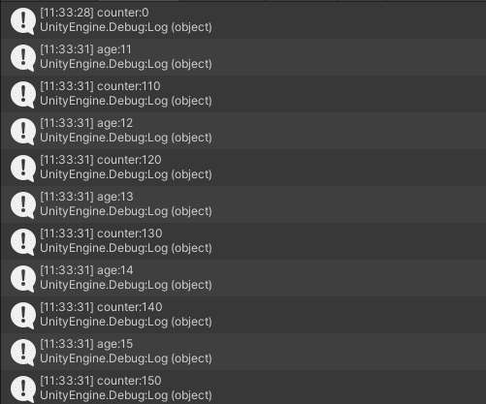

TypeEventSystem.Global 示例
using UnityEngine;
namespace QFramework.Example
{
public class GlobalEventExample : MonoBehaviour
,IOnEvent<GlobalEventExample.GlobalEventA>
,IOnEvent<GlobalEventExample.GlobalEventB>
{
public struct GlobalEventA
{
}
public struct GlobalEventB
{
}
void Start()
{
TypeEventSystem.Global.Register<GlobalEventA>(OnGlobalEventA)
.UnRegisterWhenGameObjectDestroyed(gameObject);
this.RegisterEvent<GlobalEventA>();
this.RegisterEvent<GlobalEventB>();
}
private void OnDestroy()
{
this.UnRegisterEvent<GlobalEventA>();
this.UnRegisterEvent<GlobalEventB>();
}
private void OnGlobalEventA(GlobalEventA e)
{
Debug.Log(e.ToString());
}
// Update is called once per frame
void Update()
{
if (Input.GetMouseButtonDown(0))
{
TypeEventSystem.Global.Send<GlobalEventA>();
}
if (Input.GetMouseButtonDown(1))
{
TypeEventSystem.Global.Send<GlobalEventB>();
}
}
public void OnEvent(GlobalEventA e)
{
Debug.Log(e);
}
public void OnEvent(GlobalEventB e)
{
Debug.Log(e);
}
}
}
运行之后结果如下:
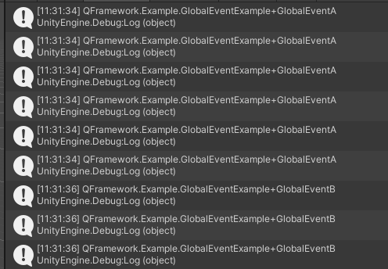

6 次鼠标左键输入，3 次鼠标右键输入。

7. ShootingEditor2D：v0.0.6 QF 重构与开源发布
环境：
- Unity 2019.4LTS
地址：
- github 地址：https://github.com/liangxiegame/ShootingEditor2D
- 镜像地址：https://gitee.com/liangxiegame/ShootingEditor2D
- QFramework 地址：https://github.com/liangxiegame/QFramework
会在第三季结束之后，陆陆续续以版本为单位迭代 ShootingEditor2D。

8. 单例专精（一）SingletonKit 快速入门
从这堂课开始，我们来进行理论强化篇的内容。
首先我们要学习的是 单例专精 与 对象之间的交互 这个专题。
为什么要先学习单例呢？
很简单，单例是我们最常用的设计模式，尤其是在 Unity 项目开发中，几乎每个项目都会用到单例模式。但是我们经常能听到网上或者前辈对于单例的诟病，单例到底哪里有问题？就是我们接下来要探讨的内容。我们了解了单例的利弊之后，并不是说以后再也不去使用单例，而是说我们就知道了怎样去用好单例。
知道了为什么要学习单例之后，我们需要一份单例的实现，以往的框架搭建中，笔者会带着大家从头到尾在教程中敲出一份单例的实现，但是单例的实现对大家来说其实不是什么难事，所以这里笔者直接给出一份以前 QFramework 中包含的实现--SingletonKit.cs。
完整代码如下:
/****************************************************************************
* Copyright (c) 2017 ~ 2021 liangxie MIT License
*
* https://github.com/liangxiegame/SingletonKit
****************************************************************************/
using System;
using System.Reflection;
using UnityEngine;
namespace QFramework
{
/// <summary>
/// 单例接口
/// </summary>
public interface ISingleton
{
/// <summary>
/// 单例初始化(继承当前接口的类都需要实现该方法)
/// </summary>
void OnSingletonInit();
}
/// <summary>
/// 普通类的单例
/// </summary>
/// <typeparam name="T"></typeparam>
public abstract class Singleton<T> : ISingleton where T : Singleton<T>
{
/// <summary>
/// 静态实例
/// </summary>
protected static T mInstance;
/// <summary>
/// 标签锁：确保当一个线程位于代码的临界区时，另一个线程不进入临界区。
/// 如果其他线程试图进入锁定的代码，则它将一直等待（即被阻止），直到该对象被释放
/// </summary>
static object mLock = new object();
/// <summary>
/// 静态属性
/// </summary>
public static T Instance
{
get
{
lock (mLock)
{
if (mInstance == null)
{
mInstance = SingletonCreator.CreateSingleton<T>();
}
}
return mInstance;
}
}
/// <summary>
/// 资源释放
/// </summary>
public virtual void Dispose()
{
mInstance = null;
}
/// <summary>
/// 单例初始化方法
/// </summary>
public virtual void OnSingletonInit()
{
}
}
/// <summary>
/// 属性单例类
/// </summary>
/// <typeparam name="T"></typeparam>
public static class SingletonProperty<T> where T : class, ISingleton
{
/// <summary>
/// 静态实例
/// </summary>
private static T mInstance;
/// <summary>
/// 标签锁
/// </summary>
private static readonly object mLock = new object();
/// <summary>
/// 静态属性
/// </summary>
public static T Instance
{
get
{
lock (mLock)
{
if (mInstance == null)
{
mInstance = SingletonCreator.CreateSingleton<T>();
}
}
return mInstance;
}
}
/// <summary>
/// 资源释放
/// </summary>
public static void Dispose()
{
mInstance = null;
}
}
/// <summary>
/// 普通单例创建类
/// </summary>
internal static class SingletonCreator
{
static T CreateNonPublicConstructorObject<T>() where T : class
{
var type = typeof(T);
// 获取私有构造函数
var constructorInfos = type.GetConstructors(BindingFlags.Instance | BindingFlags.NonPublic);
// 获取无参构造函数
var ctor = Array.Find(constructorInfos, c => c.GetParameters().Length == 0);
if (ctor == null)
{
throw new Exception("Non-Public Constructor() not found! in " + type);
}
return ctor.Invoke(null) as T;
}
public static T CreateSingleton<T>() where T : class, ISingleton
{
var type = typeof(T);
var monoBehaviourType = typeof(MonoBehaviour);
if (monoBehaviourType.IsAssignableFrom(type))
{
return CreateMonoSingleton<T>();
}
else
{
var instance = CreateNonPublicConstructorObject<T>();
instance.OnSingletonInit();
return instance;
}
}
/// <summary>
/// 单元测试模式 标签
/// </summary>
public static bool IsUnitTestMode { get; set; }
/// <summary>
/// 查找Obj（一个嵌套查找Obj的过程）
/// </summary>
/// <param name="root">父节点</param>
/// <param name="subPath">拆分后的路径节点</param>
/// <param name="index">下标</param>
/// <param name="build">true</param>
/// <param name="dontDestroy">不要销毁 标签</param>
/// <returns></returns>
private static GameObject FindGameObject(GameObject root, string[] subPath, int index, bool build,
bool dontDestroy)
{
GameObject client = null;
if (root == null)
{
client = GameObject.Find(subPath[index]);
}
else
{
var child = root.transform.Find(subPath[index]);
if (child != null)
{
client = child.gameObject;
}
}
if (client == null)
{
if (build)
{
client = new GameObject(subPath[index]);
if (root != null)
{
client.transform.SetParent(root.transform);
}
if (dontDestroy && index == 0 && !IsUnitTestMode)
{
GameObject.DontDestroyOnLoad(client);
}
}
}
if (client == null)
{
return null;
}
return ++index == subPath.Length ? client : FindGameObject(client, subPath, index, build, dontDestroy);
}
/// <summary>
/// 泛型方法：创建MonoBehaviour单例
/// </summary>
/// <typeparam name="T"></typeparam>
/// <returns></returns>
public static T CreateMonoSingleton<T>() where T : class, ISingleton
{
T instance = null;
var type = typeof(T);
//判断T实例存在的条件是否满足
if (!IsUnitTestMode && !Application.isPlaying)
return instance;
//判断当前场景中是否存在T实例
instance = UnityEngine.Object.FindObjectOfType(type) as T;
if (instance != null)
{
instance.OnSingletonInit();
return instance;
}
//MemberInfo：获取有关成员属性的信息并提供对成员元数据的访问
MemberInfo info = typeof(T);
//获取T类型 自定义属性，并找到相关路径属性，利用该属性创建T实例
var attributes = info.GetCustomAttributes(true);
foreach (var atribute in attributes)
{
var defineAttri = atribute as MonoSingletonPath;
if (defineAttri == null)
{
continue;
}
instance = CreateComponentOnGameObject<T>(defineAttri.PathInHierarchy, true);
break;
}
//如果还是无法找到instance 则主动去创建同名Obj 并挂载相关脚本 组件
if (instance == null)
{
var obj = new GameObject(typeof(T).Name);
if (!IsUnitTestMode)
UnityEngine.Object.DontDestroyOnLoad(obj);
instance = obj.AddComponent(typeof(T)) as T;
}
instance.OnSingletonInit();
return instance;
}
/// <summary>
/// 在GameObject上创建T组件（脚本）
/// </summary>
/// <typeparam name="T"></typeparam>
/// <param name="path">路径（应该就是Hierarchy下的树结构路径）</param>
/// <param name="dontDestroy">不要销毁 标签</param>
/// <returns></returns>
private static T CreateComponentOnGameObject<T>(string path, bool dontDestroy) where T : class
{
var obj = FindGameObject(path, true, dontDestroy);
if (obj == null)
{
obj = new GameObject("Singleton of " + typeof(T).Name);
if (dontDestroy && !IsUnitTestMode)
{
UnityEngine.Object.DontDestroyOnLoad(obj);
}
}
return obj.AddComponent(typeof(T)) as T;
}
/// <summary>
/// 查找Obj（对于路径 进行拆分）
/// </summary>
/// <param name="path">路径</param>
/// <param name="build">true</param>
/// <param name="dontDestroy">不要销毁 标签</param>
/// <returns></returns>
private static GameObject FindGameObject(string path, bool build, bool dontDestroy)
{
if (string.IsNullOrEmpty(path))
{
return null;
}
var subPath = path.Split('/');
if (subPath == null || subPath.Length == 0)
{
return null;
}
return FindGameObject(null, subPath, 0, build, dontDestroy);
}
}
/// <summary>
/// 静态类：MonoBehaviour类的单例
/// 泛型类：Where约束表示T类型必须继承MonoSingleton<T>
/// </summary>
/// <typeparam name="T"></typeparam>
public abstract class MonoSingleton<T> : MonoBehaviour, ISingleton where T : MonoSingleton<T>
{
/// <summary>
/// 静态实例
/// </summary>
protected static T mInstance;
/// <summary>
/// 静态属性：封装相关实例对象
/// </summary>
public static T Instance
{
get
{
if (mInstance == null && !mOnApplicationQuit)
{
mInstance = SingletonCreator.CreateMonoSingleton<T>();
}
return mInstance;
}
}
/// <summary>
/// 实现接口的单例初始化
/// </summary>
public virtual void OnSingletonInit()
{
}
/// <summary>
/// 资源释放
/// </summary>
public virtual void Dispose()
{
if (SingletonCreator.IsUnitTestMode)
{
var curTrans = transform;
do
{
var parent = curTrans.parent;
DestroyImmediate(curTrans.gameObject);
curTrans = parent;
} while (curTrans != null);
mInstance = null;
}
else
{
Destroy(gameObject);
}
}
/// <summary>
/// 当前应用程序是否结束 标签
/// </summary>
protected static bool mOnApplicationQuit = false;
/// <summary>
/// 应用程序退出：释放当前对象并销毁相关GameObject
/// </summary>
protected virtual void OnApplicationQuit()
{
mOnApplicationQuit = true;
if (mInstance == null) return;
Destroy(mInstance.gameObject);
mInstance = null;
}
/// <summary>
/// 释放当前对象
/// </summary>
protected virtual void OnDestroy()
{
mInstance = null;
}
/// <summary>
/// 判断当前应用程序是否退出
/// </summary>
public static bool IsApplicationQuit
{
get { return mOnApplicationQuit; }
}
}
/// <summary>
/// MonoSingleton路径
/// </summary>
[AttributeUsage(AttributeTargets.Class)] //这个特性只能标记在Class上
public class MonoSingletonPath : Attribute
{
private string mPathInHierarchy;
public MonoSingletonPath(string pathInHierarchy)
{
mPathInHierarchy = pathInHierarchy;
}
public string PathInHierarchy
{
get { return mPathInHierarchy; }
}
}
/// <summary>
/// 继承Mono的属性单例？
/// </summary>
/// <typeparam name="T"></typeparam>
public static class MonoSingletonProperty<T> where T : MonoBehaviour, ISingleton
{
private static T mInstance;
public static T Instance
{
get
{
if (null == mInstance)
{
mInstance = SingletonCreator.CreateMonoSingleton<T>();
}
return mInstance;
}
}
public static void Dispose()
{
if (SingletonCreator.IsUnitTestMode)
{
UnityEngine.Object.DestroyImmediate(mInstance.gameObject);
}
else
{
UnityEngine.Object.Destroy(mInstance.gameObject);
}
mInstance = null;
}
}
/// <summary>
/// 如果跳转到新的场景里已经有了实例，则不创建新的单例（或者创建新的单例后会销毁掉新的单例）
/// </summary>
/// <typeparam name="T"></typeparam>
public abstract class PersistentMonoSingleton<T> : MonoBehaviour where T : Component
{
protected static T mInstance;
protected bool mEnabled;
/// <summary>
/// Singleton design pattern
/// </summary>
/// <value>The instance.</value>
public static T Instance
{
get
{
if (mInstance == null)
{
mInstance = FindObjectOfType<T>();
if (mInstance == null)
{
var obj = new GameObject();
mInstance = obj.AddComponent<T>();
}
}
return mInstance;
}
}
/// <summary>
/// On awake, we check if there's already a copy of the object in the scene. If there's one, we destroy it.
/// </summary>
protected virtual void Awake()
{
if (!Application.isPlaying)
{
return;
}
if (mInstance == null)
{
//If I am the first instance, make me the Singleton
mInstance = this as T;
DontDestroyOnLoad(transform.gameObject);
mEnabled = true;
}
else
{
//If a Singleton already exists and you find
//another reference in scene, destroy it!
if (this != mInstance)
{
Destroy(this.gameObject);
}
}
}
}
/// <summary>
/// 如果跳转到新的场景里已经有了实例，则删除已有示例，再创建新的实例
/// </summary>
/// <typeparam name="T"></typeparam>
public class ReplaceableMonoSingleton<T> : MonoBehaviour where T : Component
{
protected static T mInstance;
public float InitializationTime;
/// <summary>
/// Singleton design pattern
/// </summary>
/// <value>The instance.</value>
public static T Instance
{
get
{
if (mInstance == null)
{
mInstance = FindObjectOfType<T>();
if (mInstance == null)
{
GameObject obj = new GameObject();
obj.hideFlags = HideFlags.HideAndDontSave;
mInstance = obj.AddComponent<T>();
}
}
return mInstance;
}
}
/// <summary>
/// On awake, we check if there's already a copy of the object in the scene. If there's one, we destroy it.
/// </summary>
protected virtual void Awake()
{
if (!Application.isPlaying)
{
return;
}
InitializationTime = Time.time;
DontDestroyOnLoad(this.gameObject);
// we check for existing objects of the same type
T[] check = FindObjectsOfType<T>();
foreach (T searched in check)
{
if (searched != this)
{
// if we find another object of the same type (not this), and if it's older than our current object, we destroy it.
if (searched.GetComponent<ReplaceableMonoSingleton<T>>().InitializationTime < InitializationTime)
{
Destroy(searched.gameObject);
}
}
}
if (mInstance == null)
{
mInstance = this as T;
}
}
}
}
代码很多，大家可以将此代码复制到任意 Unity 工程中。当然如果想获得最新版本的代码可以从 https://github.com/liangxiegame/SingletonKit 获得，当然此链接也提供了其他安装 SingletonKit 的方式。
笔者用的 Unity 版本是 2018.4LTS 版本，已经装好了一份实现，如下所示:
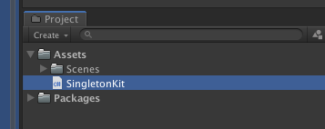

安装好了后，我们就直接快速过一遍它的基本使用。

SingletonKit 使用指南
1. Singleton
namespace QFramework.Example
{
using UnityEngine;
internal class Class2Singleton : Singleton<Class2Singleton>
{
private static int mIndex = 0;
private Class2Singleton() {}
public override void OnSingletonInit()
{
mIndex++;
}
public void Log(string content)
{
Debug.Log("Class2Singleton" + mIndex + ":" + content);
}
}
public class Singleton : MonoBehaviour
{
private void Start()
{
Class2Singleton.Instance.Log("Hello World!");
// delete instance
Class2Singleton.Instance.Dispose();
// a differente instance
Class2Singleton.Instance.Log("Hello World!");
}
}
}
运行结果
控制台:
Class2Singleton1:Hello World!
Class2Singleton2:Hello World!
2.MonoSingleton
namespace QFramework.Example
{
using System.Collections;
using UnityEngine;
internal class Class2MonoSingleton : MonoSingleton<Class2MonoSingleton>
{
public override void OnSingletonInit()
{
Debug.Log(name + ":" + "OnSingletonInit");
}
private void Awake()
{
Debug.Log(name + ":" + "Awake");
}
private void Start()
{
Debug.Log(name + ":" + "Start");
}
protected override void OnDestroy()
{
base.OnDestroy();
Debug.Log(name + ":" + "OnDestroy");
}
}
public class MonoSingletonExample : MonoBehaviour
{
private IEnumerator Start()
{
var instance = Class2MonoSingleton.Instance;
yield return new WaitForSeconds(3.0f);
instance.Dispose();
}
}
}
运行结果:
场景结构(Hierarchy)
Scene
MonoSingleton
DontDestroyOnLoad（3 秒钟后消失）
Class2MonoSingleton
控制台
Class2MonoSingleton:Awake
Class2MonoSingleton:OnSingletonInit
Class2MonoSingleton:Start
3 秒中后
Class2MonoSingleton:OnDestroy
3.SingletonProperty
namespace QFramework.Example
{
using UnityEngine;
internal class Class2SignetonProperty : ISingleton
{
public static Class2SignetonProperty Instance
{
get { return SingletonProperty<Class2SignetonProperty>.Instance; }
}
private Class2SignetonProperty() {}
private static int mIndex = 0;
public void OnSingletonInit()
{
mIndex++;
}
public void Dispose()
{
SingletonProperty<Class2SignetonProperty>.Dispose();
}
public void Log(string content)
{
Debug.Log("Class2SingletonProperty" + mIndex + ":" + content);
}
}
public class SingletonProperty : MonoBehaviour
{
// Use this for initialization
void Start ()
{
Class2SignetonProperty.Instance.Log("Hello World!");
// delete current instance
Class2SignetonProperty.Instance.Dispose();
// new instance
Class2SignetonProperty.Instance.Log("Hello World!");
}
}
}
结果:
控制台
Class2SingletonProperty1:Hello World!
Class2SingletonProperty2:Hello World!
4.MonoSingletonProperty
namespace QFramework.Example
{
using System.Collections;
using UnityEngine;
internal class Class2MonoSingletonProperty : MonoBehaviour,ISingleton
{
public static Class2MonoSingletonProperty Instance
{
get { return MonoSingletonProperty<Class2MonoSingletonProperty>.Instance; }
}
public void Dispose()
{
MonoSingletonProperty<Class2MonoSingletonProperty>.Dispose();
}
public void OnSingletonInit()
{
Debug.Log(name + ":" + "OnSingletonInit");
}
private void Awake()
{
Debug.Log(name + ":" + "Awake");
}
private void Start()
{
Debug.Log(name + ":" + "Start");
}
protected void OnDestroy()
{
Debug.Log(name + ":" + "OnDestroy");
}
}
public class MonoSingletonProperty : MonoBehaviour
{
private IEnumerator Start()
{
var instance = Class2MonoSingletonProperty.Instance;
yield return new WaitForSeconds(3.0f);
instance.Dispose();
}
}
}
运行结果
场景结构(Hierarchy)
Scene
MonoSingletonProperty
DontDestroyOnLoad（3 秒钟后消失）
Class2MonoSingletonProperty
控制台
Class2MonoSingletonProperty:Awake
Class2MonoSingletonProperty:OnSingletonInit
Class2MonoSingletonProperty:Start
3 秒中后
Class2MonoSingletonProperty:OnDestroy
5.MonoSingletonPath
namespace QFramework.Example
{
using UnityEngine;
[QFramework.MonoSingletonPath("[Example]/MonoSingletonPath")]
internal class ClassUseMonoSingletonPath : MonoSingleton<ClassUseMonoSingletonPath>
{
}
public class MonoSingletonPath : MonoBehaviour
{
private void Start()
{
var intance = ClassUseMonoSingletonPath.Instance;
}
}
}
运行结果
场景结构(Hierarchy)
Scene
MonoSingletonPath
DontDestroyOnLoad
[Example]
MonoSingletonPath
6.PersistentMonoSingleton
using System.Collections;
using UnityEngine;
namespace QFramework.Example
{
public class PersistentMonoSingletonExample : MonoBehaviour
{
// Use this for initialization
IEnumerator Start()
{
// 创建一个单例
var instance = GameManager.Instance;
// 强制创建一个实例
new GameObject().AddComponent<GameManager>();
// 等一帧，等待第二个 GameManager 把自己删除
yield return new WaitForEndOfFrame();
// 结果为 1
Debug.Log(FindObjectsOfType<GameManager>().Length);
// 保留最先创建的实例
Debug.Log(instance == FindObjectOfType<GameManager>());
}
public class GameManager : PersistentMonoSingleton<GameManager>
{
}
}
}
结果
控制台
1
True
7.ReplaceableMonoSingleton
using System.Collections;
using UnityEngine;
namespace QFramework.Example
{
public class ReplaceableMonoSingletonExample : MonoBehaviour
{
// Use this for initialization
IEnumerator Start()
{
// 创建一个单例
var instance = GameManager.Instance;
// 强制创建一个实例
new GameObject().AddComponent<GameManager>();
// 等一帧，等待第二个 GameManager 把自己删除
yield return new WaitForEndOfFrame();
// 结果为 1
Debug.Log(FindObjectsOfType<GameManager>().Length);
// 最先创建的实例已经被删除
Debug.Log(instance != FindObjectOfType<GameManager>());
}
public class GameManager : ReplaceableMonoSingleton<GameManager>
{
}
}
}
结果
控制台：
1
True
以上就是 SingletonKit 的全部功能了，只要看代码和结果，就知道这些特性的用法了。
这堂课的内容就这些，我们下堂课再见拜拜。

9. 单例专精（二）SingletonKit 与接口

SingletonKit 中接口
SingletonKit 中有一处接口定义，代码如下:
public interface ISingleton
{
void OnSingletonInit();
}
接口中定义了 OnSingletonInit 方法，即在初始化单例实例时调用此方法。
一个单例模块，为什么要有接口呢？而接口中为什么要有 OnSingletonInit 这样的方法呢？
首先回答第一个问题:
- 为什么要有接口？
市面上比较常见的单例模块，都只需一个类就搞定了。
其使用方式也很简单，只需继承即可，如下所示:
public class MonoSingletonExample : MonoSingleton<MonoSingletonExample> {}
public class SingletonExample : Singleton<SingletonExample> {}
这种单例工具对于逻辑层的需求来说，大部分情况下足够使用。
而少部分情况下，则会受到限制。
这个情况就是，需要继承其他类的时候。
例如以上代码中的 MonoSingletonExample 想要继承一个经过自己封装的 MonoBehaviour（比如 ABCMonoBehaviour)，这时如果想达到此目的，就需要做很多编码工作了。
比如单独提供一个单例版本的 ABCMonoBehaviour。
这样就会导致一些冗余的代码产生，代码则越来越臃肿。
而这个限制造成的原因是 C# 的 class 只能单继承。
为了解决以上问题，QFramework 提供了 MonoSingletonProperty/SingletonProperty 这两个工具。

MonoSingletonProperty/SingletonProperty
有了这两个工具，实现一个单例就不需要继承 MonoSingleton 或 Singleton 了。
使用代码如下:
using UnityEngine;
namespace QFramework
{
public class MonoSingletonExample : MonoBehaviour,ISingleton
{
public static MonoSingletonExample Instance
{
get { return MonoSingletonProperty<MonoSingletonExample>.Instance; }
}
public void OnSingletonInit()
{
}
}
}
namespace QFramework
{
public class SingletonExample : ISingleton
{
private SingletonExample()
{
}
public static SingletonExample Instance
{
get { return SingletonProperty<SingletonExample>.Instance; }
}
public void OnSingletonInit()
{
}
}
}
这样 MonoSingletonExample 和 SingletonExample 不会因 C# 只支持单继承而受到不能继承其他类的限制。
那么到这里，还没有讲为什么要有一个 ISingleton 接口 ？
在以上示例中，ISingleton 是一个标记，它标记了 MonoSingletonExample 和 SingletonExample 是一个单例，经过标记的类，可以通过 MonoSingletonProperty 和 SingletonProperty 来创建单例。
当然，以上这句话是从一个使用的角度去描述 ISingleton 的。
从技术实现的角度讲，SingletonProperty 和 MonoSingletonProperty 是泛型类，而泛型是可以有约束的，而这个约束则是 ISingleton。
我们看下 SingletonProperty 的部分定义:
public static class SingletonProperty<T> where T : class, ISingleton
{
...
}
可以看到，定义了 SingletonProperty 之后 ，还有 where T : class, ISingleton 这句代码。
意思是：泛型 T 必须继承 class，必须实现 ISingleton，否则编译不让通过。
所以 ISingleton 的其中一个作用，就是标记作用。

OnSingletonInit
OnSingletonInit 意思是"在单例初始化的时"，是由单例的创建机制主动调用的。
为什么要搞出一个 OnSingletonInit 这个方法呢？
首先，我们可以把单例理解为有对象声明周期的静态类，对象的生命周期很简单，就是构造和析构。
析构我们用得比较少，构造用得比较多。
所以有对象生命周期，意味着单例是有创建和销毁的过程的。
而静态类是全局唯一的，虽然单例不是静态类，但是作用和静态类差不多，全局访问，并且全局唯一。
到此我们只需关注：单例是有生命周期的，这一个特性上即可。
而一个对象的创建的周期，我们一般是在构造的时候完成。
这个在其他平台（Xamarin、.Net) 平台没什么问题，但是在 Unity 平台却有很大的风险。
Unity 的一些 API（new GameObject,Application.isPlaying) 等，在构造里调用的话会报异常。
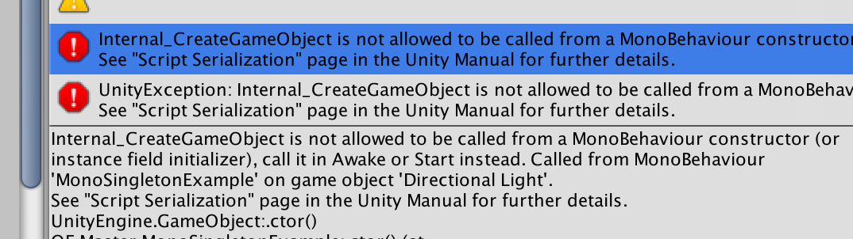

如果指定在 OnSingletonInit 去写一些初始化代码，就可以避免以上的问题出现。
这是使用 OnSingletonInit 的第一个原因。
第二个原因是，有的时候我们会纠结初始代码到底应该写在哪里，现在有了答案，写在 OnSingletonInit 里。
实际上，作为对仗，应该在加上一个 OnSingletonDispose 方法在 ISingleton 接口里。
不过销毁单例这个需求，笔者很少遇到，所以就没搞 OnSingletonDispose 了。
OK，到此做个小结。
为什么要有 ISingleton？
- 为了支持 SingletonProperty/MonoSingletonProperty，提供约束。
为什么有 OnSingletonInit
- 避免风险
- 终结选择困难症
本来此篇是要收录 QFramework 中的 Singleton 模块的，不过光介绍 Singleton 中的接口了，所以收录部分的内容留到下一篇继续。
此篇的内容就这些。

10. 单例专精（三）Singleton UML绘制
在上一篇，我们介绍了 Singleton 中的接口。
得到的总结如下：
为什么要有 ISingleton？
- 为了支持 SingletonProperty/MonoSingletonProperty，提供约束。
为什么有 OnSingletonInit
- 避免风险
- 终结选择困难症

Singleton
首先我们把上一篇文章介绍的 ISingleton 绘制成 UML
先看下核心代码，如下：
public interface ISingleton
{
void OnSingletonInit();
}
UML 类图如下：
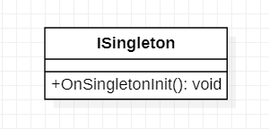

接着是 SingletonCreator。
核心代码如下：
...
public static class SingletonCreator
{
public static T CreateSingleton<T>() where T : class, ISingleton
{
// 获取私有构造函数
var ctors = typeof(T).GetConstructors(BindingFlags.Instance | BindingFlags.NonPublic);
// 获取无参构造函数
var ctor = Array.Find(ctors, c => c.GetParameters().Length == 0);
if (ctor == null)
{
throw new Exception("Non-Public Constructor() not found! in " + typeof(T));
}
// 通过构造函数，常见实例
var retInstance = ctor.Invoke(null) as T;
retInstance.OnSingletonInit();
return retInstance;
}
}
...
SingletonCreator 的职责很简单，就是通过反射去创建一个 ISingleton 的实例，而用于创建实例的构造函数是非 public 的构造函数。
以上这段代码所涉及的知识点有 反射 和 泛型，如果觉得比较陌生的童鞋还是建议去过一遍 C# 知识体系构建的专栏（笔者会在近期出）。
UML 类图如下：
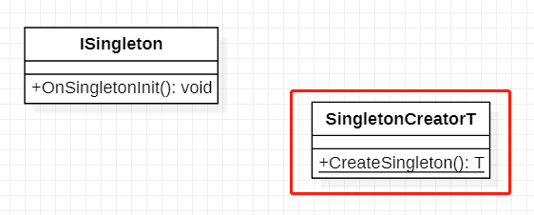

用于创建单例实例的 SingletonCreactor 写好了，接下来， 我们来看通过继承方式实现单例的工具类，Singleton，代码如下：
...
public abstract class Singleton<T> : ISingleton where T : Singleton<T>
{
protected static T mInstance;
static object mLock = new object();
public static T Instance
{
get
{
lock (mLock)
{
if (mInstance == null)
{
mInstance = SingletonCreator.CreateSingleton<T>();
}
}
return mInstance;
}
}
public virtual void Dispose()
{
mInstance = null;
}
public virtual void OnSingletonInit()
{
}
}
...
代码非常简单，由于定死了 Singleton 必须要通过继承才能使用，所以 Singleton 中的 T 添加了 where T : Singleton 这样的泛型约束。
同时也把 Singleton 设置成了抽象类。
UML 类图如下：
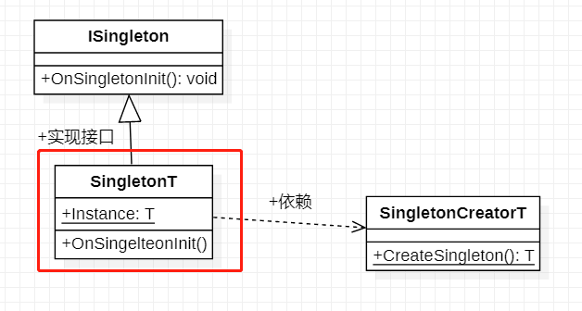

目前完整的 UML 类图如下：
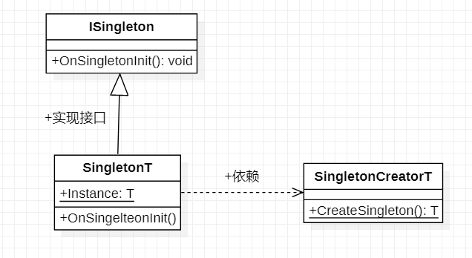

此篇的内容就这些。

10. 单例专精（三）Singleton UML绘制
在上一篇，我们介绍了 Singleton 中的接口。
得到的总结如下：
为什么要有 ISingleton？
- 为了支持 SingletonProperty/MonoSingletonProperty，提供约束。
为什么有 OnSingletonInit
- 避免风险
- 终结选择困难症

Singleton
首先我们把上一篇文章介绍的 ISingleton 绘制成 UML
先看下核心代码，如下：
public interface ISingleton
{
void OnSingletonInit();
}
UML 类图如下：

接着是 SingletonCreator。
核心代码如下：
...
public static class SingletonCreator
{
public static T CreateSingleton<T>() where T : class, ISingleton
{
// 获取私有构造函数
var ctors = typeof(T).GetConstructors(BindingFlags.Instance | BindingFlags.NonPublic);
// 获取无参构造函数
var ctor = Array.Find(ctors, c => c.GetParameters().Length == 0);
if (ctor == null)
{
throw new Exception("Non-Public Constructor() not found! in " + typeof(T));
}
// 通过构造函数，常见实例
var retInstance = ctor.Invoke(null) as T;
retInstance.OnSingletonInit();
return retInstance;
}
}
...
SingletonCreator 的职责很简单，就是通过反射去创建一个 ISingleton 的实例，而用于创建实例的构造函数是非 public 的构造函数。
以上这段代码所涉及的知识点有 反射 和 泛型，如果觉得比较陌生的童鞋还是建议去过一遍 C# 知识体系构建的专栏（笔者会在近期出）。
UML 类图如下：

用于创建单例实例的 SingletonCreactor 写好了，接下来， 我们来看通过继承方式实现单例的工具类，Singleton，代码如下：
...
public abstract class Singleton<T> : ISingleton where T : Singleton<T>
{
protected static T mInstance;
static object mLock = new object();
public static T Instance
{
get
{
lock (mLock)
{
if (mInstance == null)
{
mInstance = SingletonCreator.CreateSingleton<T>();
}
}
return mInstance;
}
}
public virtual void Dispose()
{
mInstance = null;
}
public virtual void OnSingletonInit()
{
}
}
...
代码非常简单，由于定死了 Singleton 必须要通过继承才能使用，所以 Singleton 中的 T 添加了 where T : Singleton 这样的泛型约束。
同时也把 Singleton 设置成了抽象类。
UML 类图如下：

目前完整的 UML 类图如下：

此篇的内容就这些。

11. 单例专精（四）MonoSingletonProperty UML 绘制
在上一篇，绘制了 Singleton 类，UML 类图如下：
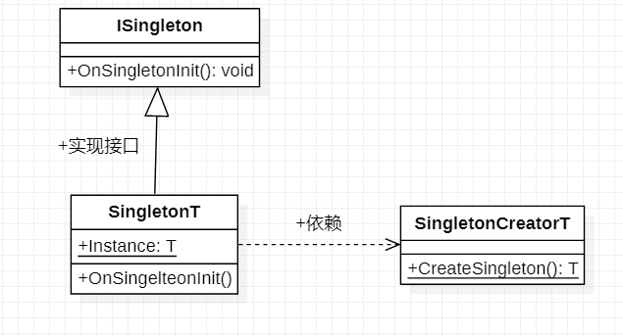

在此篇，我们接着往下绘制 SingletonKit 的其他的类。

MonoSingleton 绘制
上一篇绘制的 Singleton 类只能让普通的 C# 类变成单例，而我们在 Unity 开发中，经常会用到 MonoBehaviour 脚本实现的单例。
这时候我们就会用到支持 MonoBehaviour 的单例工具：MonoSingleton。
与 Singleton 类类似，MonoSingleton 首先要实现一个叫做 MonoSingletonCreator 的一个类，代码如下：
...
public static class MonoSingletonCreator
{
public static T CreateMonoSingleton<T>() where T : MonoBehaviour, ISingleton
{
// 尝试获取场景内的 T 脚本
var instance = Object.FindObjectOfType<T>();
// 如果存在则直接返回
if (instance)
{
instance.OnSingletonInit();
return instance;
}
// 创建实例
if (!instance)
{
var gameObj = new GameObject(typeof(T).Name);
Object.DontDestroyOnLoad(gameObj);
instance = gameObj.AddComponent<T>();
}
instance.OnSingletonInit();
return instance;
}
}
...
对应的 UML 类图如下：
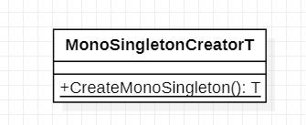

有了 MonoSingletonCreator 之后，那么实现 MonoSingleton 就会容易很多。
代码如下：
...
public abstract class MonoSingleton<T> : MonoBehaviour, ISingleton where T : MonoSingleton<T>
{
protected static T mInstance;
public static T Instance
{
get
{
if (mInstance == null && !mOnApplicationQuit)
{
mInstance = MonoSingletonCreator.CreateMonoSingleton<T>();
}
return mInstance;
}
}
public virtual void OnSingletonInit()
{
}
public static bool IsApplicationQuit
{
get { return mOnApplicationQuit; }
}
protected static bool mOnApplicationQuit = false;
protected virtual void OnApplicationQuit()
{
mOnApplicationQuit = true;
if (mInstance == null) return;
Destroy(mInstance.gameObject);
mInstance = null;
}
public virtual void Dispose()
{
Destroy(gameObject);
}
protected virtual void OnDestroy()
{
mInstance = null;
}
}
...
代码有点多，不过都比较好理解，MonoSingleton 除了要考虑单例的实现之外，还需要实现一些容错处理，以及一些全局的生命周期查询，比如 IsApplicationQuit 等。
UML 类图如下：
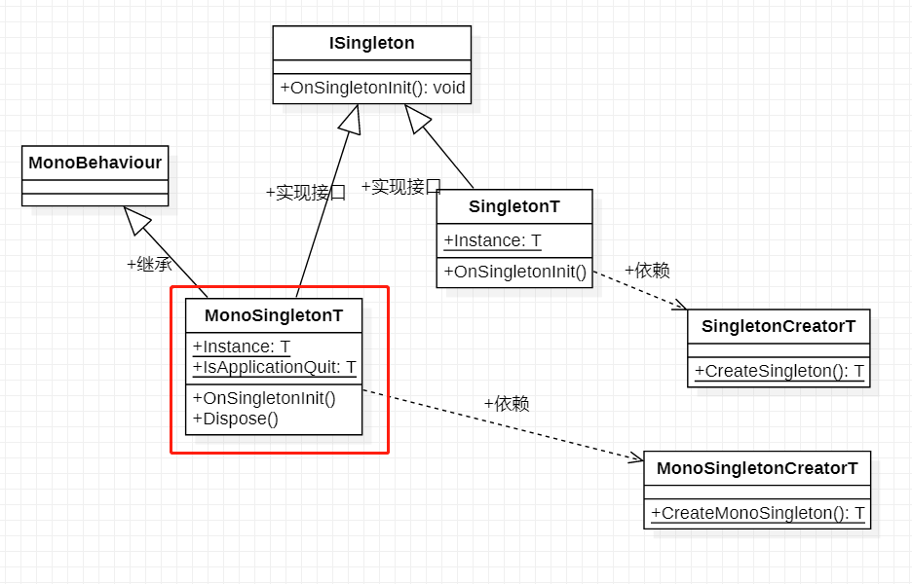

OK，到此，我们就绘制好了 MonoSingleton 的 UML 类图。
到目前为止我们已经绘制好了 Singleton 和 MonoSingleton 这两个工具类。
基本上这两个工具类能够满足大部分业务开发上对单例的实现需求，但是在一些底层的开发上就不够用了。
由于类的单继承特性，使得一个单例类继承了 Singleton 或者 MonoSingleton 之后就不能再继承其他的类了，而在底层的开发中，偶尔会遇到需要继承其他类的单例的需求。
比如 Manager Of Managers 中的 Manager 基类等，在自己实现 Manager 的时候，代码会写成如下：
public class GameManager : ManagerOfManagersBaseManager
{
...
}
这是如果想让 GameManager 变成单例，如果使用 MonoSingleton 的话就无法做到。
为了解决掉这个问题，我们需要实现一个不用通过继承就能实现单例的，单例工具。
这个工具就是 MonoSingletonProperty 和 SingletonProperty。
代码如下：
...
public static class MonoSingletonProperty<T> where T : MonoBehaviour, ISingleton
{
private static T mInstance;
public static T Instance
{
get
{
if (null == mInstance)
{
mInstance = MonoSingletonCreator.CreateMonoSingleton<T>();
}
return mInstance;
}
}
public static void Dispose()
{
Object.Destroy(mInstance.gameObject);
mInstance = null;
}
}
...
...
public static class SingletonProperty<T> where T : class, ISingleton
{
private static T mInstance;
private static readonly object mLock = new object();
public static T Instance
{
get
{
lock (mLock)
{
if (mInstance == null)
{
mInstance = SingletonCreator.CreateSingleton<T>();
}
}
return mInstance;
}
}
public static void Dispose()
{
mInstance = null;
}
}
...
UML 类图如下：
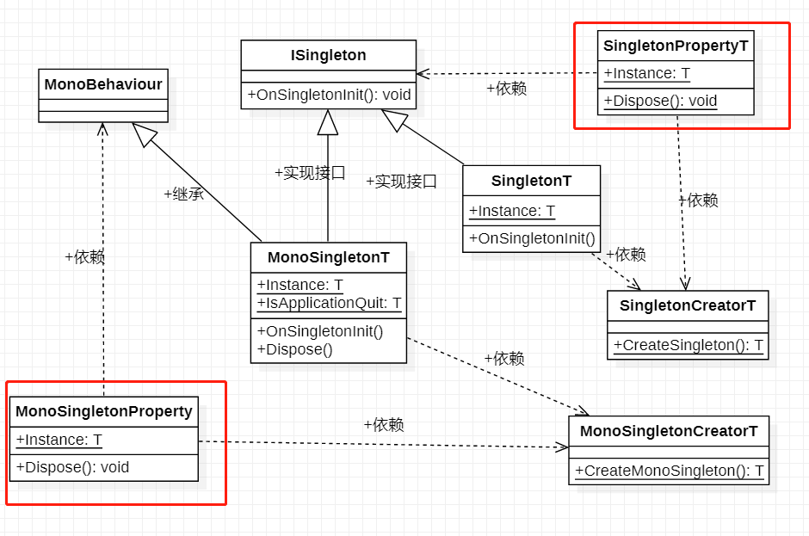

此篇的内容就这些。

12. 单例专精（五）MonoSingletonPath UML 绘制
在上一篇我们绘制了 MonoSingleton、SingletonProperty 和 MonoSingletonProperty的 UML 类图。
得到的 UML 类图如下：
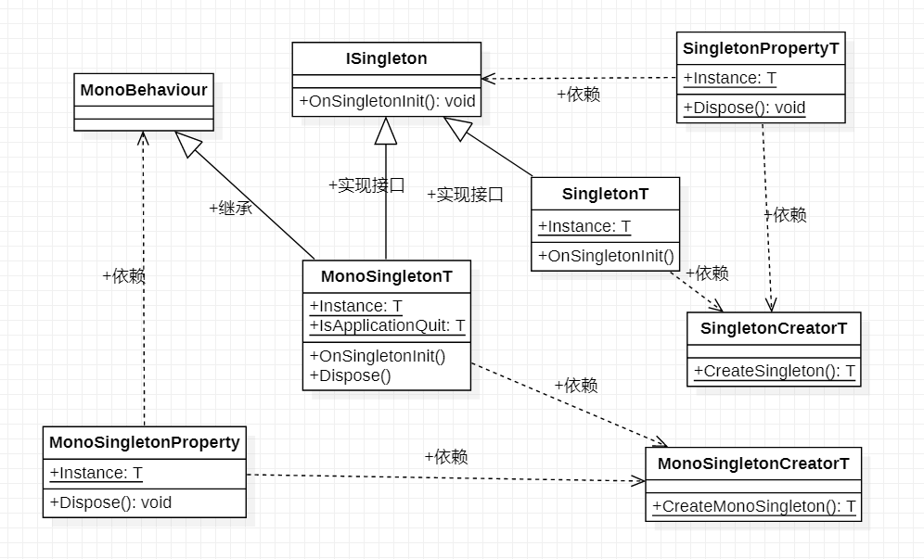

在此篇，我们来绘制 SingletonKit 的最后一个功能 MonoSingletonPath。
当一个项目中，MonoSingleton 特别多的时候，我们可能会遇到如下所示的情况：
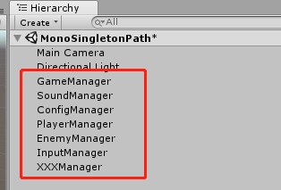

当 Manager 特别多的时候，会让场景变得特别混乱。
为了解决这个问题， SingletonKit 提供了一个 叫做 MonoSingletonPath 这样的一个功能。
我们先看下代码。
首先创建一个 MonoSingletonPathAttribute 可以让用户自己定义 Manager 创建的位置，如下：
...
[AttributeUsage(AttributeTargets.Class)]
public class MonoSingletonPath : Attribute
{
private string mPathInHierarchy;
public MonoSingletonPath(string pathInHierarchy)
{
mPathInHierarchy = pathInHierarchy;
}
public string PathInHierarchy
{
get { return mPathInHierarchy; }
}
}
...
Attribute 是反射的好搭档，是 C# 提供的一个语言特性，如果不太熟悉的童鞋可以看下《 C# 知识体系构建》中反射相关的内容，会在圣诞节前上架。
实现了 MonoSingletonPathAttribute 之后，我们还需要在创建单例的过程中去识别它，代码如下：
...
public static class MonoSingletonCreator
{
public static T CreateMonoSingleton<T>() where T : MonoBehaviour, ISingleton
{
// 尝试获取场景内的 T 脚本
var instance = Object.FindObjectOfType<T>();
// 如果存在
if (instance)
{
instance.OnSingletonInit();
return instance;
}
// 尝试根据 MonoSingletonPath 去创建单例
var info = typeof(T);
instance = info.GetCustomAttributes(false)
.Cast<MonoSingletonPath>()
.Select(monoSingletonPath => CreateSingletonWithPath<T>(monoSingletonPath.PathInHierarchy, true))
.FirstOrDefault();
// 创建实例
if (!instance)
{
var gameObject = new GameObject(typeof(T).Name);
Object.DontDestroyOnLoad(gameObject);
instance = gameObject.AddComponent<T>();
}
instance.OnSingletonInit();
return instance;
}
/// <summary>
/// 根据 Path 去创建 Singleton
/// </summary>
/// <param name="path"></param>
/// <param name="dontDestroy"></param>
/// <typeparam name="T"></typeparam>
/// <returns></returns>
private static T CreateSingletonWithPath<T>(string path, bool dontDestroy) where T : MonoBehaviour
{
var gameObj = GetOrCreateGameObjectWithPath(path, true, dontDestroy);
if (!gameObj)
{
gameObj = new GameObject("Singleton of " + typeof(T).Name);
if (dontDestroy)
{
Object.DontDestroyOnLoad(gameObj);
}
}
return gameObj.AddComponent<T>();
}
/// <summary>
///
/// </summary>
/// <param name="path"></param>
/// <param name="build"></param>
/// <param name="dontDestroy"></param>
/// <returns></returns>
private static GameObject GetOrCreateGameObjectWithPath(string path, bool build, bool dontDestroy)
{
if (string.IsNullOrEmpty(path))
{
return null;
}
var subPath = path.Split('/');
if (subPath.Length == 0)
{
return null;
}
return GetOrCreateGameObjectWithPathArray(null, subPath, 0, build, dontDestroy);
}
/// <summary>
/// 递归找到叶子 GameObject 节点
/// </summary>
/// <param name="parentGameObj"></param>
/// <param name="subPath"></param>
/// <param name="index"></param>
/// <param name="build"></param>
/// <param name="dontDestroy"></param>
/// <returns></returns>
private static GameObject GetOrCreateGameObjectWithPathArray(GameObject parentGameObj, string[] subPath, int index, bool build,
bool dontDestroy)
{
while (true)
{
GameObject currentGameObj = null;
if (!parentGameObj)
{
currentGameObj = GameObject.Find(subPath[index]);
}
else
{
var child = parentGameObj.transform.Find(subPath[index]);
if (child != null)
{
currentGameObj = child.gameObject;
}
}
if (!currentGameObj)
{
if (build)
{
currentGameObj = new GameObject(subPath[index]);
if (parentGameObj != null)
{
currentGameObj.transform.SetParent(parentGameObj.transform);
}
if (dontDestroy && index == 0)
{
Object.DontDestroyOnLoad(currentGameObj);
}
}
}
if (!currentGameObj)
{
return null;
}
// 如果是叶子节点这直接返回
if (++index == subPath.Length) return currentGameObj;
parentGameObj = currentGameObj;
}
}
}
...
OK，以上的代码比较复杂，不过所做的事情还是比较简单的，就是当创建 MonoSingleton 的时候，查看单例类有没有标记 MonoSingletonPath Attribute，如果有标记，则会根据 MonoSingletonPath 中配置的路径在 场景中进行 GameObject 的查找，如果没找到就会创建一个 GameObject 并添加单例类为组件。
这里不理解也没关系，因为这里的代码比较稳定，而且也没有啥功能新增的需要可以留着慢慢理解。
OK，这样的话 MonoSingletonPath 的完整代码就实现好了。
接下来，我们来写一个示例，代码如下：
using UnityEngine;
namespace FrameworkDesign2021
{
public class MonoSingletonPathExample : MonoBehaviour
{
[MonoSingletonPath("[Logic]/GameManager")]
public class GameManager : MonoSingleton<GameManager> {}
[MonoSingletonPath("[Framework]/ResManager")]
public class ResManager : MonoSingleton<ResManager> {}
[MonoSingletonPath("[Framework]/UIManager")]
public class UIManager : MonoSingleton<UIManager> {}
[MonoSingletonPath("[Framework]/SoundManager")]
public class SoundManager : MonoSingleton<SoundManager> {}
[MonoSingletonPath("[Logic]/ConfigManager")]
public class ConfigManager : MonoSingleton<ConfigManager> {}
[MonoSingletonPath("[Logic]/BattleManager")]
public class BattleManager : MonoSingleton<BattleManager> {}
[MonoSingletonPath("[Framework]/NetworkManager")]
public class NetworkManager : MonoSingleton<NetworkManager> {}
// Use this for initialization
void Start()
{
var gameMgr = GameManager.Instance;
var resMgr = ResManager.Instance;
var uiMgr = UIManager.Instance;
var soundMgr = SoundManager.Instance;
var configMgr = ConfigManager.Instance;
var battleMgr = BattleManager.Instance;
var networkMgr = NetworkManager.Instance;
}
}
}
运行之后，结果如下：
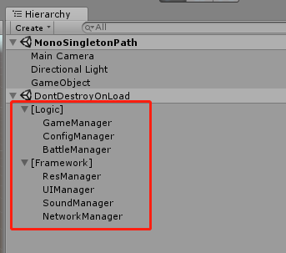

这样，场景中的 GameObject 就好管理好多。
这就是 MonoSingletonPath 存在的意义。
我们最终的 UML 类图如下所示：
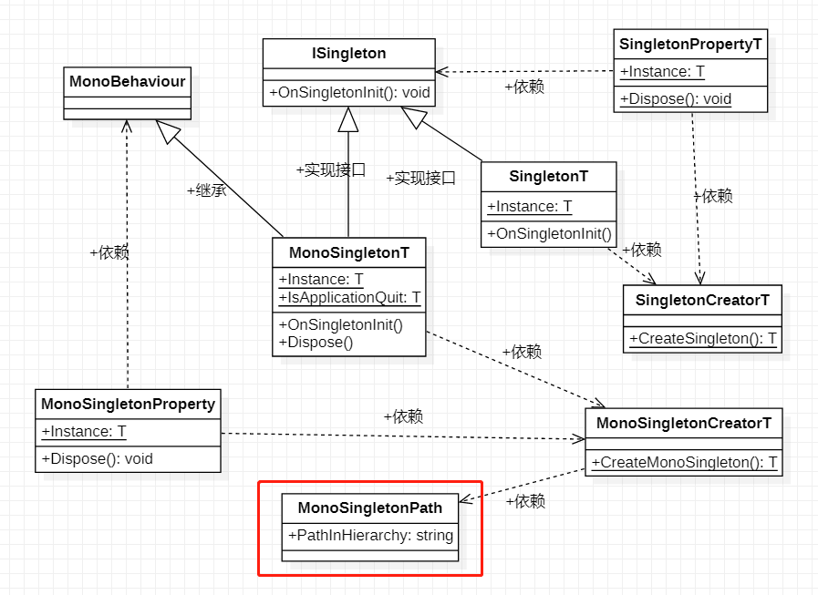

到此我们的 SingletonKit 的全部核心功能就绘制完了，还剩下一些小的功能，比如 ReplaceableMonoSingleton 和 PersistentMonoSingleton 这两个类由于很少使用到，所以就不进行 UML 的绘制了。
此篇内容就这些。

13. 单例专精（六）单例的最佳实践
在上一篇，我们了解了 Singleton 模块的最后一个功能：MonoSingletonPath。
在这一篇我们简单聊聊，单例的最佳实践。
网上对单例的使用有很大的争议，有的人认为它为项目带来风险，有的人认为它为初学者带来了便利。
有风险的同时带来了便利，这一点恰是符合单例的特性。

单例的特性
单例有两个特性:
- 保证一个类仅有一个实例。
- 并提供一个访问它的全局访问点。
从特性我们可以总结出：
- 单例有生命周期，有状态（内部的数据），因为单例是对象实例。
- 单例可以在全局的任何一个地方获取。
而所谓的风险也有两点:
- 如果是懒加载（第一次访问的时候创建实例）的单例，则当看到单例调用时，不知道在哪里做了初始化。
- 任意位置可以访问，项目规模一旦增大就会容易造成混乱。
接下来我们就试着一一避开以上的风险。

全局访问的风险
其实生命周期不确定的风险与全局访问的风险相比，后者造成的危害是慢性的，也是相对严重的。
为了展示全局访问的风险，我们先写一点代码，展示单例一般使用，代码如下：
namespace FrameworkDesign2021.BestSingleton
{
public class GameManager : MonoSingleton<GameManager>
{
public void Play()
{
}
public void Pause()
{
}
public void Resume()
{
}
public void GameOver()
{
}
}
}
以上代码，就是游戏管理器，实现了一些方法。
使用的代码如下:
GameManager.Instance.Play(); // 开始游戏
GameManager.Instance.Pause(); // 暂停游戏
代码很简单，没什么难点。
实际上这种使用方式大家应该非常熟悉。
风险在哪里呢？
风险在 GameManager.Instance 中的 Instance 这个属性。
在使用中，我们拿到了完整的 GameManager 对象。那么关于这个对象的一切，我们都是有办法获取的，比如 public 的成员变量和属性可以直接获取，更极端地是，private 可以通过反射获取（闲得蛋疼）。
假如如果我们看到以下这样的代码，会不会觉得有点不适?
GameManager.Instance.Score += 5;
GameManager.Instance.Health += 10;
GameManager.Instance.Play();
不适的原因很简单，Instance 暴露太多了，而且以上的三行代码非常有可能是顺序有关的。
例如，我们调整代码使用的顺序，如下：
GameManager.Instance.Score += 5;
GameManager.Instance.Play();
GameManager.Instance.Health += 10;
这段代码的结果非常有可能与之前的结果不一样。
所以，笔者的观点是，尽量控制单例的 API 暴露。不可以全部都暴露出来。
甚至，Instance 这个东西，笔者也不希望暴露出来。
我们将 GameManager 代码改成如下:
namespace FrameworkDesign2021.BestSingleton
{
public class GameManager : MonoBehaviour,ISingleton
{
private static GameManager mInstance
{
get { return MonoSingletonProperty<GameManager>.Instance; }
}
void ISingleton.OnSingletonInit() { }
private int mScore = 0;
private int mHealth = 100;
public static void Play(int addScore,int addHealth)
{
mInstance.mScore += addScore;
mInstance.mHealth += addHealth;
// do some thing
}
public static void Pause() {}
public static void Resume() {}
public static void GameOver() {}
}
}
GameManager 发生了以下改变:
- 单例的实现使用 MonoSingletonProperty 实现的，并且是 private 访问权限。
- Score、Health 改成私有的权限了。
- 对外开放的 API 都是静态的，比如 Play、Pause、Resume、GameOver
- Play 增加了两个参数
使用方式如下:
GameManager.Play(5,5); // 三句合一
这样就可以避免，调用顺序不对的问题了，而且，我们非常严格地控制了 API 的暴露，从而减缓了全局访问的风险。
当前的 GameManager 结构如下。
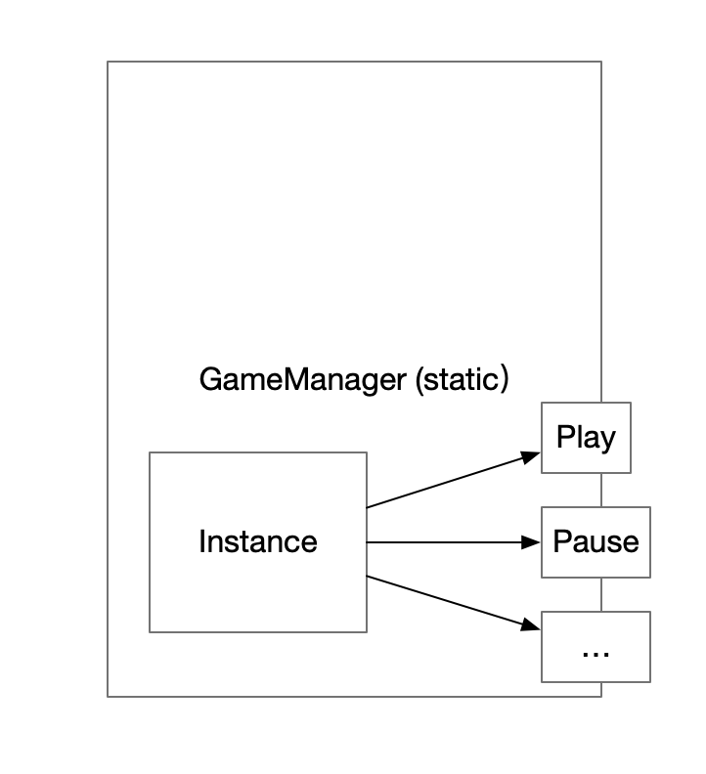

这就是单例的最佳实践，实际上 QFramework 的 UIKit 则使用的就是此结构。
UIKit.OpenPanel<UIMainPanel>();
UIKit.ClosePanel<UIMainPanel>();
它除了可以减缓全局访问的风险，还有一个好处就是，代码简短。笔者自己用 UIKit 的 API 的时候总是有一两拨千斤的体验，非常优雅。
OK，单例的全局访问的风险就先聊到这里，接下来说说由于懒加载造成的声明周期不稳定的风险。

生命周期不稳定的风险
这个风险指的是，懒加载会在第一次访问的时候创建实例。印象中，有一些比较难查的 bug 都是因为创建的实例时机不对造成的。
比如同一帧做了大量的资源加载操作（在单例的初始化时），造成大量的 GC (最高的一次有 4.7M 的 GC），在低端设备中莫名其妙地闪退，这种问题真的很难定位。
而避免产生此问题的办法非常简单，就是控制单例的初始化时机。比如，在 GameManager 类中加上 Init 方法。
如下所示:
namespace FrameworkDesign2021.BestSingleton
{
public class GameManager : MonoBehaviour,ISingleton
{
...
public static void Init()
{
mInstance.mScore = 0;
mInstance.mHealth = 0;
// do something
}
...
}
}
这样我们可以在合适的时机，主动去初始化这个单例。比如进入游戏场景前，或者项目初始化时，代码如下:
GameManager.Init();
这样就可以避免生命周期不稳定的风险了。

小结
关于一个单例是否应该使用，网上存在着很多的争议，而笔者的观点是，应该使用，但是要稍加限制：
- 严格控制对外暴露的 API
- 严格控制单例的使用范围（这个下一篇介绍）
- 严格控制单例对象的生命周期（创建、初始化、销毁）
这就是笔者自己总结的一套，单例的最佳实践，不过还没介绍完，下一篇接着介绍严格控制单例的使用范围。
今天的内容就这些。

14. 单例专精（七）单例的使用范围
在上篇，我们学习了单例的最佳实践，在设计一个单例时要尽量做到如下规则:
- 严格控制对外暴露的 API，与外界交互只通过静态方法。
- 严格控制单例的使用范围
- 严格控制单例对象的生命周期（创建、初始化、销毁）
而上篇的内容涉及了 第一条 和 第三条。
而第二条，我们在这篇进行讨论。

严格控制单例的使用范围
严格控制单例的使用范围，要做到这点，只需要记住一句话就好:不要让单例类的职责太多
什么意思呢？就是在设计单例类不要提供太多的 API，要非常谨慎地提供 API。如果一个逻辑需要调用 3 个单例的 API 完成，那么我们就要考虑，可否把这三个 API 合并成一个 API，而把原来的三个 API 迁移到 mInstance 内部实现。
严格控制单例的使用范围，一般都体现于类的命名上。
比如 GameManager，这个单例的作用范围，可能是玩家开始游戏的阶段（开始、暂停、继续、游戏结束）等，但是它的名字太大了，类的名字应该体现类的职责。GameManager 意思是 游戏管理，太模糊，单从名字上来看不知道管理什么，所以要进一步明确，比如 GameStateManager/GameStatusManager，游戏的状态管理，GamePlayManager，游戏的玩法管理（实现玩法) 等等。这样比起一个叫 GameManager 的类名，职责却是 GameStateManager 的职责好太多。
再比如，QFramework 中的 UIKit，其作用范围比较广，只要是 UI 界面相关的逻辑它都管，但是它是框架层的工具。
作为框架的部分，对单例设计的要求不太一样，对于整体框架来说，提供的概念应该尽可能地少，比如 UIKit,ResKit 等。假如 UI 的层级管理用 UILayerMgr，UI 的生命周期管理，用 UILifeMgr，UI 的事件管理用 UIEventMgr，这样做虽然符合单一职责原则，但是用户要接触三个概念才能掌握一个框架，学习成本较高，那么在 QFramework 里，只用一个 UIKit 搞定一切，用户要记住得比较少，减轻负担。
所以对于框架层，单例设计的要求又有点不一样，不过 UIKit，ResKIt 都是符合单例的最佳实践的 第一条和第三条要求的，第二条要求只是尽可能地符合，因为要考虑用户的使用体验。
到这里可能有的童鞋会问，框架层、逻辑层都是怎么分的？
我们先看下图：
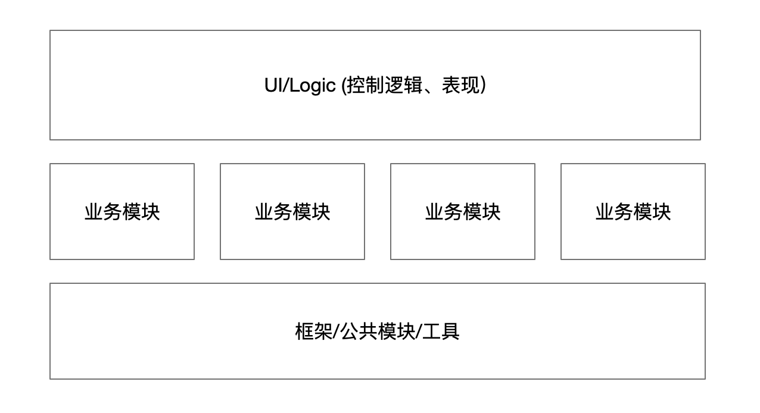

这张图为一般的项目结构，基本上分为三层。
- UI/Logic 控制逻辑、表现： 大量的死逻辑，无法复用，都是一些控制脚本还有 UI 界面的控制逻辑，主要处理玩家的输入和控制游戏的流程
- 业务模块：一些业务模块/系统，有一定的复用性，比如 GameManager，可以在多个脚本内调用。
- 框架/公共模块/工具：第三方插件、原生 SDK 、跨项目复用的框架、公共模块等，为项目提供最基本的支持。
我们可以把每个业务模块设计成一个单例，这样使用的范围就能确定，比如商店模块，装备模块等，战斗模块等，对应的名字应该为 ShopManager，EquipManager，BattleManager 等。
而每个业务模块提供极少的 API，比如：
- ShopManager
  - Buy(id):买物品
  - Sell(id):卖物品
- EquipManager
  - Equip(position,id)：穿装备
  - UnEquip(position,id)：卸掉装备
- BattleManager
  - Attack(id)：攻击
  - Defence(id)：防御
如果每个模块能够设计成这样，能够提供极少数的 API 就能实现模块本身的功能，那么整个项目结构则会非常清晰，而使用单例的危害会降到最低，项目的结构会一直保持一个比较健康的状态。
模块之间可以有依赖，但是要尽量保持树形（自顶向下，单向依赖），而不是互相依赖，OK，这是关于模块划分的内容，我们以后会重点讲这个部分内容，现在先不说这个。
OK，到此，我们简单聊过了控制单例的使用范围这条规则。
结论就是，尽量让单例的职责少一点，提供的 API 少一点，不要把一个单例类的名字起得太大了，比如：AppManager 、GameManager 等。

小结
严格控制单例的使用范围，即单例的职责要尽可能地少，类名要准确描述其职责，不能太大（AppManager，GameManager），框架层另说。

决定版 补充
以上的内容是在去年的时候写的，那个时候决定版的架构还没有作为框架搭建的主要核心架构，所以在这里需要针对决定版的架构做一些补充的内容。
我们目前接触了决定版架构，分为四个层级：
- 表现层
- 系统层
- 模型层
- 工具层
而单例的提供一般是提供两种类型的单例：
- C# 类单例
- Mono 单例
在我们的决定版架构中，C# 类的单例就完全没有必要使用了，因为我们可以使用架构中的系统层来替代，架构本身就是一个像单例一样的的东西，而且也完全符合上一篇介绍的单例的最佳实践。
但是 Mono 单例并不能完全抛弃掉，因为 Mono 单例确实在 Unity 里很方便，它可以提供生命周期委托，也可以作为 GameObject 的管理器，也可以开启协程，带来了很多的便利。这些提供的功能，很明显都是表现层需要用到的功能。
所以 Mono 单例我们把它算作我们架构中表现层的内容，它像其他的表现层一样，只需要实现一个 IController 接口就可以与我们的架构底层进行交互，这样的话既保留了 Mono 单例的优点（便利），又削弱了 Mono 单例职责，从而改善 Mono 单例职责过大的问题。相对地，我们的决定版架构几乎都是 C# 类，并没有太多与 Mono 相关的的内容，如果一个项目只使用决定版架构，那么表现层会有很多工作是比较难进行的，因为一般的项目都需要通过 Mono 单例提供统一的生命周期函数、提供协程、提供 GameObject 管理功能等，而将 Mono 单例算作决定版架构中的表现层，恰好填补了这块空缺。
下图则是一个 Mono 单例的简单的用例。
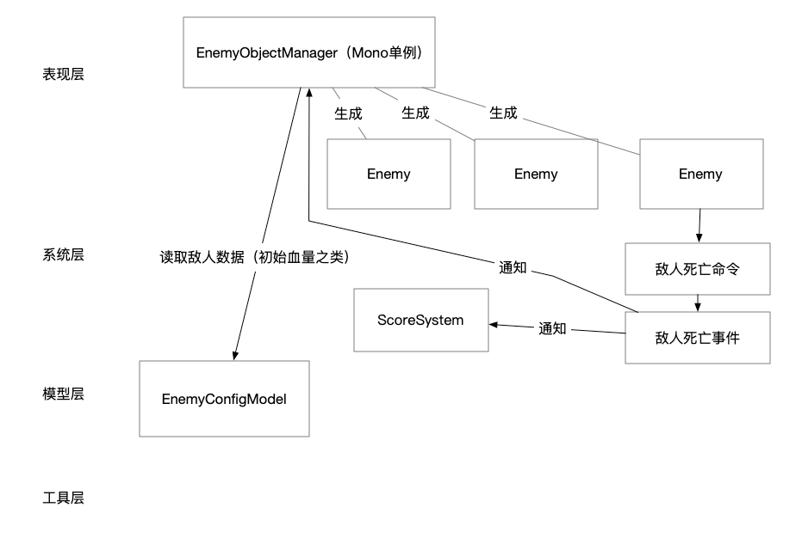

所以在第一季最开始的时候，笔者本来是把单例作为架构中的一部分，但是准备的过程中发现，单例要讲清楚，需要花费几个课时，这样会对第一季刚学习的童鞋造成干扰所以就去掉了。所以单例就成为第三季的内容了。
Mono 单例可以提供很多便利，而使用了决定版架构，可以避免单例的职责过大，再加上一篇介绍的单例最佳实践，可以获得 Mono 单例便利的同时还可以降低 Mono 单例的风险。

15. 单例专精（八）复习与补充
我们在之前花了 7 个课时，介绍了 单例模式 与 Singleton 模块的最佳实践和设计细节。
并且在解决针对决定版做了补充。
在这篇，做一个简单的复习。

Singleton 的使用
- Singleton
  - 继承
  - 私有构造
- MonoSingleton
  - 继承即可
- SingletonProperty
  - 实现 ISingleton 接口
  - 在属性器中实现
- MonoSingletonProperty
  - 实现 ISingleton 接口
  - 继承 MonoSingleton 或 其子类
  - 在属性器中实现
- MonoSingletonPath
  - 支持 MonoSingleton 与 MonoSingletonProperty

单例的最佳实践:
- 严格控制对外暴露的 API
- 严格控制单例的使用范围
  - 模块命名
  - 职责尽量少
- 严格控制单例对象的生命周期（创建、初始化、销毁）

设计原理
- ISingleton 有两个作用，一是泛型的约束，二是提供统一的初始化接口 (OnSingletonInit)。
- MonoSingletonPath 是为了让单例模块方便管理。

实现套路
- 通过反射创建实例
- Attribute 与反射的使用

补充
由于 Singleton 与 SingletonProperty 都需要用到通过反射创建实例的功能，所以把这个功能单独提取出来，放到了 SingletonCreator 里。本质上是为了减少重复代码。
MonoSingleton 与 MonoSingletonProperty 也需要相同的创建实例方式（创建 GameObject），所以也单独写了一个 MonoSignletonCreator。
SingeltonKit 看起来比一般的单例复杂一点，主要是因为它本身有一定的结构。
产生结构的原因也很简单，是因为它要满足很多需求（项目中的，框架内部的），但是最根本的原因是为了减少重复代码。
笔者脑海中，Singleton 模块的结构如下：
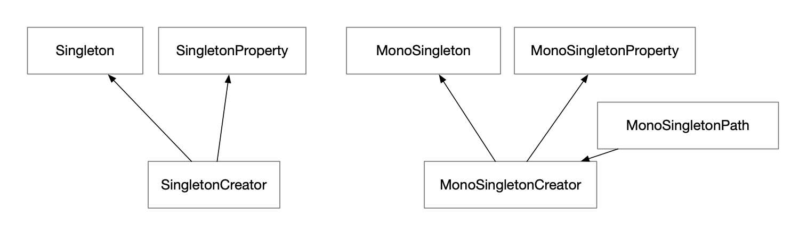

箭头表示，谁为谁提供服务。
UML 的类图如下所示：
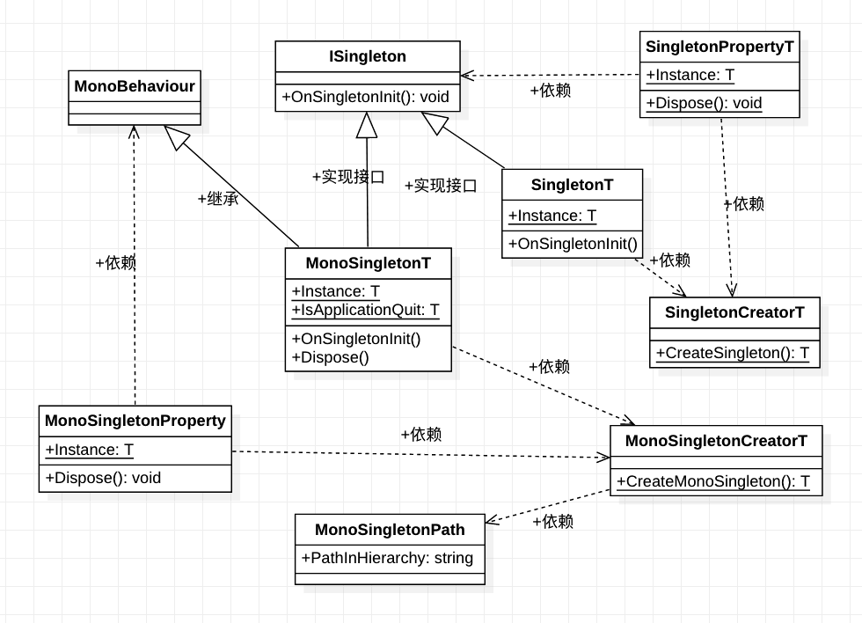

决定版补充
有了决定版架构，就不用 C# 单例了，但是 Mono 单例还需要使用，Mono 单例的数据部分交给决定版架构管理，既保留 Mono 单例的便利，又降低了 Mono 单例的风险，还可以使用决定版架构，所以很完美。
到此我们的所有复习就结束了。
此篇的内容就这些。

16. 对象之间的交互（一）单向依赖
- 对象之间的交互（一）单向依赖
在上一篇，我们对 SingletonKit做了简单的复习。
在这一篇，我们开始学习新的内容，即对象之间的交互。
对象之间的交互这个概念我们在 决定版 的第一季有接触到，对象之间的交互有三种，它们是:
- 方法
- 委托
- 事件
再加上后边学习的命令模式，总共是四种。
不过在第一季我们引出对象之间的交互，是直接给出了结论，并没有介绍对象之间的交互这个概念是如何发展出来的。
所以接下来的内容就是笔者在 决定版 发布的之前的两年，第一次写对象之间交互的内容。
最开始并没有提出对象之间的交互这个概念，而是从“依赖”这个角度逐步发展出来的。
我们接下来就开始学习这部分内容。
我们知道 对象与对象 之间是可以互相访问的。
先看如下代码:
namespace FrameworkDesign2021.ObjInteractExample
{
public class A
{
public void Say()
{
Debug.Log("Hello I'm A");
}
}
public class B
{
public B()
{
new A().Say();
}
}
}
以上代码中，在 B 的构造方法中，我们访问了 A 的 Say 方法。
这种交互是单向的 （ B -> A ），即 B 单向访问/引用/依赖/调用 A，总之叫啥都行，我们就用单向依赖来描述这种交互。

单向依赖
如果说代码中出现了单向的依赖，在一般情况下不会出现什么太大的问题，产生单向依赖是正常的，代码也可以说是合格的。一般初学者，能够控制对象之间的交互为单向，就已经很了不起了。
有单向就有双向的，不过在讲双向之前，说一说最佳的单向依赖情况是什么样的。

最佳的单向依赖
最佳的单向依赖非常简单，总结一句话就是自顶向下的调用。
比如 Panel （父脚本）通过 Button（子控件） 的 onClick 注册事件。
再比如 GameManager （顶端模块）调用 LevelManager（子模块）的方法。
再比如 车子 调用 轮胎 让它 转动。
这些都是单向依赖的例子，如果能够把对象的交互控制在自顶向下的单向依赖，那么代码会变得更有条理、清晰。
单向依赖的示意图如下:
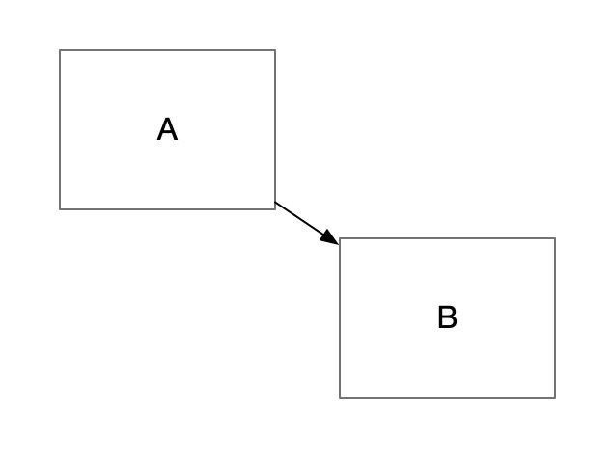

最差的单向依赖
最差的单向依赖也很简单，就是自底向上的调用。
示意图如下：
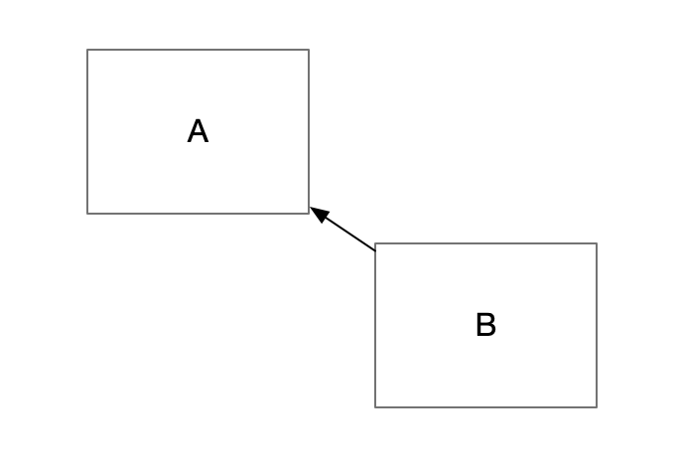

例如：
- Button （子脚本）调用 Panel （父脚本）的方法。
- 轮胎告诉汽车，让汽车前进。
为什么自底向上的调用是最差的单向依赖呢？
答案很简单，如果父节点为了对子节点的调用提供支持，那么父节点会随着子节点的增多，父节点所提供的方法会越来越多，从而造成“头大身小”的畸形结构。
我们知道，在生活中，我们的 Leader 是需要把责任和压力分给每个成员身上的，面向对象的世界里也是同样的道理，父节点是要把对象的职责拆分给子节点，每个子节点自己负责自己的事情。这样，一个项目的内部才会运转良好，而且结构也会非常清晰。
但是如果是自底向上的调用，也就是子节点调用父节点，子节点把一部分职责分给父节点，那么本应改作为控制中心的父节点变成了到处帮别人打杂，提供底层服务支持的服务人员，那么对象的职责就会乱了套，情况会变得非常混乱。
所以自底向上的调用是最差的单向依赖，如果代码中有这种情况，要尽量避免，在设计结构时，也要尽量避免这种情况发生。

同级之间的单向依赖
同级之间的单向依赖非常简单，看下图就明白了:
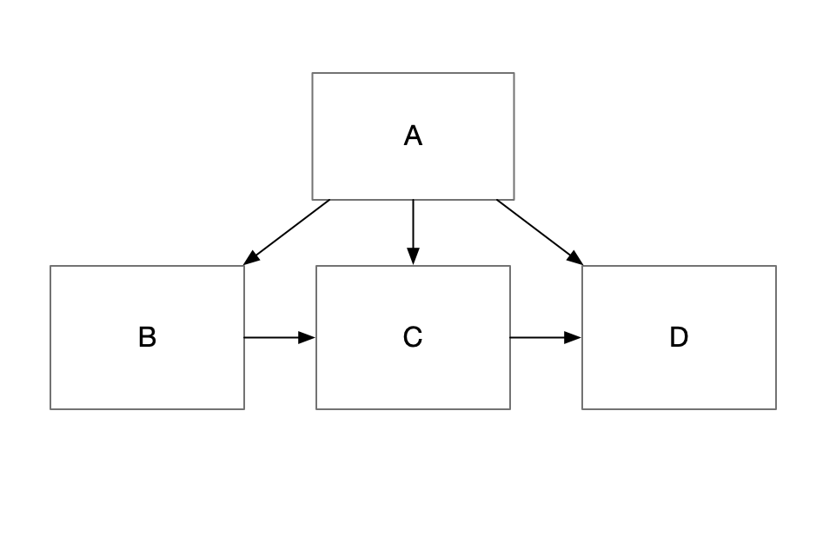

图中 B 调用了 C 的方法，C 引用了 D，相信不难理解。
这种情况比 自顶向上会好一点，但是风险也是很大的。
如果 B 想获取到 C 对象，那么肯定会做一些不干净的操作，假如在 Unity 中，可能会写如下代码
public class B:MonoBehaviour
{
void Start()
{
var c = GameObject.Find("C").GetComponent<C>();
var c1 = FindObjectOfType<C>();
...
}
}
风险很明显，不管是 FindObjectOfType 还是 GameObject.Find，这两个 API 会造成提高项目的维护成本。
总之，同级之间的单向依赖也要尽量避免。
此篇的内容就这些。

决定版补充
现在在接触决定版之后，观点发生了一些变化，就是表现层乱一些没关系，只要下边的三层不乱就行。表现层的约定具体怎么定还是看具体的团队，比如有的团队可以调用哪些 API 有的团队就随意。但是自顶向下用方法自底向上用委托、事件这两个是需要遵守的，同级之间可以放宽一点。

17. 对象之间的交互（二）单向依赖的两种实现
在上一篇，我们了解了单向依赖这个概念，总结出了比较好的情况和比较差的情况，如下:
- 自顶向下的单向依赖
- 同级之间的单向依赖
- 自底向上的单向依赖
其中同级之间和自顶向上的单向依赖，不可取。
最推荐的方式是 自顶向下的依赖。

自顶向下的单向依赖实现
自顶向下的单向依赖的实现非常简单，最简单方式就是 父节点 持有 子节点的引用。用大白话说就是 子节点作为父节点的成员变量。
代码如下:
namespace FrameworkDesign2021.Example
{
public class Parent
{
Child mChild = new Child();
}
public class Child
{
}
}
这就是一种最简单的单向依赖实现，实际上，我们可能天天在写这种代码。只不过，笔者给它赋予了概念。
这种实现是相对来说比较具体的实现。
除了这种自顶向下的单向依赖，还有其他的方式。
比如顶层模块调用底层模块。
代码如下:
namespace FrameworkDesign2021.Example
{
public class UIModule : MonoSingleton<UIModule>
{
void Start()
{
ShopModule.Instance.Init();
}
}
public class ShopModule : MonoSingleton<ShopModule>
{
public void Init()
{
}
}
}
代码非常简单。
这是模块之间的单向依赖。
到这里，我们知道，对象之间交互的最佳实践（自顶向下的单向依赖），也同样适用于 模块之间的交互。
所以本质上，设计模块与设计对象所需要遵循的设计原则是一样的。

示意图
一个良好的对象设计，符合自顶向下依赖的原则。
图中包含了，对象之间的依赖 与 模块之间的 依赖。
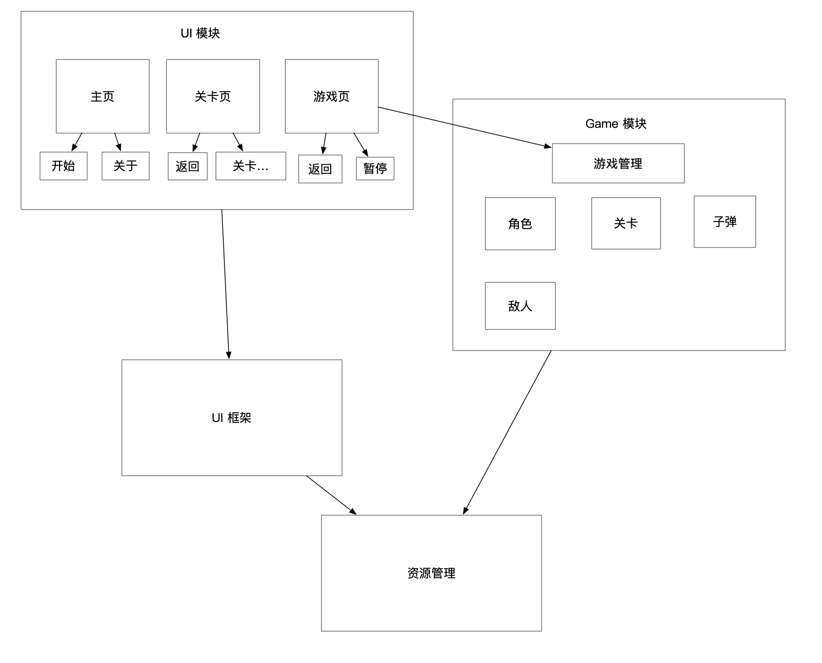

注意：以上的架构理念还是笔者在决定版两年前（2019 年的设计理念），而现在最新的架构理念就是决定版架构，很明显，决定版架构也符合单向依赖的最佳实践。
此篇的内容就这些。

18. 对象之间的交互（三）双向依赖介绍 与 单向依赖的限制
在上一篇，我们学习了自顶向下的单向依赖的两种实现，一种是基于对象的，另一种是基于模块。
从这篇开始，我们再接着探讨对象之间的交互问题。

双向依赖
在此文之前，我们讨论的都是对象之间的依赖问题，依赖除了有单向的，还有双向的，即，父节点调用子节点的方法，子节点也调用父节点的方法，如下图所示。
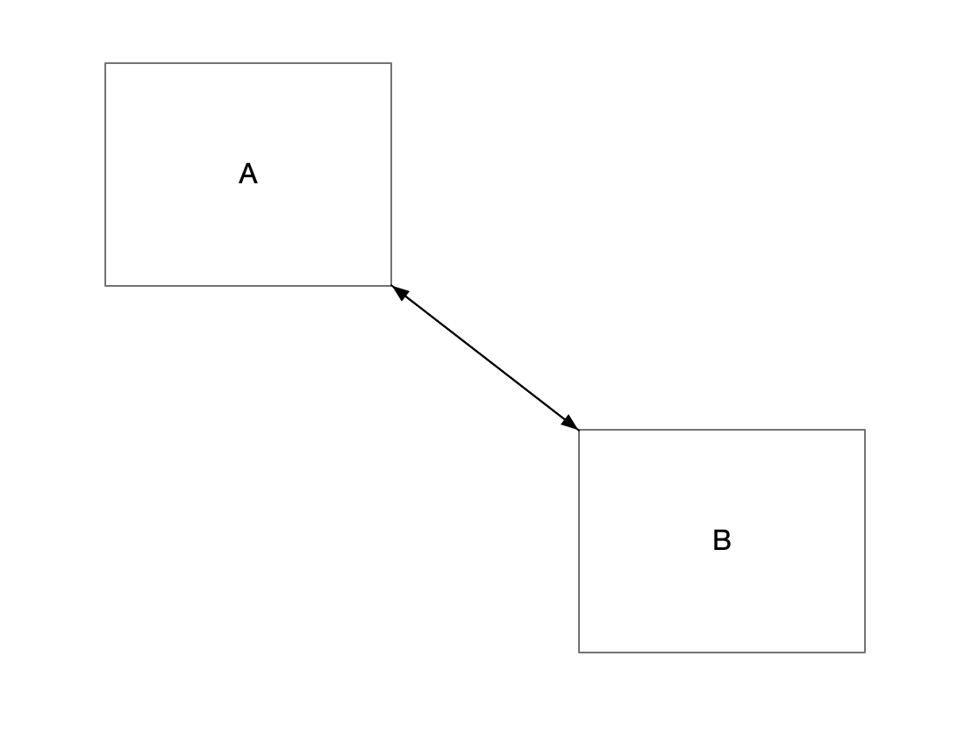

为什么说要坚决杜绝？
我们听说过很多次，代码要高内聚低耦合，耦合其实指的就是对象之间的依赖程度。而 双向依赖，则是依赖程度最强的一种情况。所以如果要追求低耦合，那么双向依赖是一定要杜绝的。
在这里不管是自顶向下或自底向上的双向依赖，还是兄弟之间的双向依赖，只要是双向依赖，都要坚决杜绝的。
关于双向依赖就先讲到这里。

自顶向下单向依赖的限制
我们知道自顶向下的单向依赖指的是，父节点调用子节点的方法。
那么我们在很多情况下，也有子节点通知父节点的情况。比如当子节点播放一段动画，动画播放完毕后，要通知父节点，动画播放完毕。
这种情况下，使用双向依赖是可以解决的，但是在上文说了，双向依赖，一定要，严格杜绝。
在这种情况下，自顶向下的单向依赖就有了限制，它限制了我们不能直接调用父节点的方法。
不过没关系，C# 和设计模式，为我们提供了非常多的方法，来解决这个限制问题。
这些方法我们可以留到下一篇接着去介绍。
此篇的内容就这些。
这种双向依赖，是坚决要杜绝的。

19. 对象之间的交互（四）通过委托解除单向依赖限制
在上一篇，我们学习了双向依赖 和 单向依赖的限制，在结尾部分，提出了 C# 和 设计模式 提供了很多方法可以用来解除 单向依赖的限制。

解除单向依赖的限制
单向依赖的限制，即 子节点 调用 父节点 的方法。
要解决这个问题，我们很容易想到使用 C# 中的 委托，来解决这个问题。
代码如下:
using UnityEngine;
namespace FrameworkDesign2021
{
public class PlayerCtrl : MonoBehaviour
{
PlayerAnimationCtrl mAnimationCtrl;
void Start()
{
mAnimationCtrl = transform.Find("Animation").GetComponent<PlayerAnimationCtrl>();
// 注册完成的事件
mAnimationCtrl.OnDoSomethingDone += ()=>{
Debug.Log("动画播放完毕");
};
mAnimationCtrl.DoSomething();
}
}
public class PlayerAnimationCtrl : MonoBehaviour
{
// 定义委托
public Action OnDoSomethingDone = ()=>{};
public void DoSomething()
{
OnDoSomethingDone();
}
}
}
以上代码是委托的非常简单的用法，PlayerCtrl 注册 PlayerAnimationCtrl 的委托，当 PlayerAnimationCtrl 需要通知 PlayerCtrl 时，只需执行这个 委托即可。
这样就可以做到，PlayerCtrl 只依赖 PlayerAnimationCtrl 而 PlayerAnimationCtrl 不需要依赖 PlayerCtrl。
所谓的使用委托解除 单向依赖的限制 就是如此。
但是委托，有一点点小问题。

委托的弊端
在上文代码中， 委托除了需要注册之外，还需要考虑注销的问题。
namespace FrameworkDesign2021
{
public class PlayerCtrl : MonoBehaviour
{
PlayerAnimationCtrl mAnimationCtrl;
void Start()
{
mAnimationCtrl = transform.Find("Animation").GetComponent<PlayerAnimationCtrl>();
// 注册完成的事件
mAnimationCtrl.OnDoSomethingDone += OnDoSomethingDone;
mAnimationCtrl.DoSomething();
}
void OnDoSomethingDone()
{
Debug.Log("动画播放完毕");
}
void OnDestroy()
{
// 注销完成的事件
mAnimationCtrl.OnDoSomethingDone -= OnDoSomethingDone;
}
}
...
}
在这段代码中，其实不注册委托也是没问题的，因为 父节点 销毁了，子节点也会跟着销毁，所以不太可能出现空引用的问题。但是总是会遇到特殊情况，比如模块之间注册委托。
所以如果想要使用好委托，那么必须要养成，注册 与 注销 成对出现的习惯（这个习惯实际上是内存申请/释放的习惯)
委托使用上的风险就在这里。
除了风险问题，还有影响代码质量的问题，大家可能听说过回调地狱这个词吧？
我们先欣赏一下所谓的回调地狱代码:
this.Delay(1,()=>{
this.Delay(1,()=>{
if (a == b) {
this.Delay(1,()=>{
});
}
});
});
大概就是这种。
毁掉地狱，这种情况要避免。
除了回调地狱问题，还有就是代码量增多的问题。
每当我们要监听一些事情的时候，就需要写一些声明委托的代码，如下所示。
namespace QFramework
{
public abstract class NodeAction : IAction
{
public Action OnBeganCallback = null;
public Action OnEndedCallback = null;
public Action OnDisposedCallback = null;
...
}
}
所以，委托的另一个不好的地方，就是要一些声明的代码。

委托小结
委托是伟大的概念，任何方面都足够吊打其他语言的匿名方法和 lambda 表达式了。
通过委托，我们可以解除单向依赖的限制，写少量的委托是没问题的。
委托在 C# 中，也算是非常传统的方式 来解决 单向依赖限制的问题了。
委托这种方式，在学习新的内容之前，实际上是最好的 自底向上 通知的方式了。
最后，再补充一条，同级之间的单向依赖，不可以使用委托，至于原因，欢迎大家在评论区讨论。
此篇的内容就这些。

20. 对象之间的交互（五）通过事件解除单向依赖限制
在上一篇，我们通过委托解除了单向依赖，在这篇，我们介绍一下通过事件解除单向依赖。

事件机制
事件机制与消息机制相同。
在这里我们先不考虑事件机制的实现，而把关注点放在时间机制的使用上。

架构中的事件机制
在第一季中，我们实现了一个事件机制，提供了 TypeEventSystem 这个 API。

基本使用
先定义几个事件
#region 事件定义
public class GameStartEvent
{
}
public class GameOverEvent
{
// 可以携带参数
public int Score;
}
public interface ISkillEvent
{
}
// 支持继承
public class PlayerSkillAEvent : ISkillEvent
{
}
public class PlayerSkillBEvent : ISkillEvent
{
}
#endregion
接着，注册这几个个事件
public class TypeEventSystemExample : MonoBehaviour
{
private void Start()
{
TypeEventSystem.Global.Register<GameStartEvent>(OnGameStartEvent);
TypeEventSystem.Global.Register<GameOverEvent>(OnGameOverEvent);
TypeEventSystem.Global.Register<ISkillEvent>(OnSkillEvent);
...
}
void OnGameStartEvent(GameStartEvent gameStartEvent)
{
Debug.Log("游戏开始了");
}
void OnGameOverEvent(GameOverEvent gameOverEvent)
{
Debug.LogFormat("游戏结束，分数:{0}", gameOverEvent.Score);
}
void OnSkillEvent(ISkillEvent skillEvent)
{
if (skillEvent is PlayerSkillAEvent)
{
Debug.Log("A 技能释放");
}
else if (skillEvent is PlayerSkillBEvent)
{
Debug.Log("B 技能释放");
}
}
...
}
接着就可以通过 TypeEventSystem 发送事件了
TypeEventSystem.Global.Send<GameStartEvent>();
TypeEventSystem.Global.Send(new GameOverEvent()
{
Score = 100
});
// 要把事件发送给父类
TypeEventSystem.Global.Send<ISkillEvent>(new PlayerSkillAEvent());
TypeEventSystem.Global.Send<ISkillEvent>(new PlayerSkillBEvent());
结果如下:
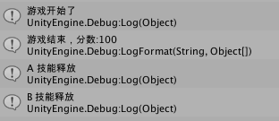

其实用方式非常简单。
可以说这种方式，已经把消息机制的使用简化到了极致，所以决定版架构就自然就集成了这套消息机制。
关于架构中的事件机制介绍到这里，我们接着讨论如何解除单向依赖.

通过消息机制解除单向依赖的限制
在上文，我们了解了消息机制的基本使用，可以说消息机制可以把两个对象之间的耦合降低到极致。
但是把耦合降低到极致，是好事情嘛?
答案很显然不是的，这个话题，我们在文章的结尾进行讨论。
通过消息解除单向依赖的限制不是很难，直接看如下代码即可:
using QFramework;
// 定义消息
public class OnAnimationDone {}
// 父节点
public class A
{
public A()
{
// 注册事件
TypeEventSystem.Global.Register<OnAnimationDone>(_=>{
// ...
});
var b = new B();
b.PlayAnimation();
}
}
public class B
{
public void PlayAnimation()
{
// 发送事件
TypeEventSystem.Global.Send(new OnAnimationDone());
}
}
代码很简单，这样通过事件解除单向依赖的限制，就算介绍完了。
但是，事件机制与 委托 一样，同样是有利弊的。
事件机制的好处很简单，就是降低耦合，并且两个对象之间不用访问彼此，就可以进行交互（也是降低耦合）。
而坏处就很多了。
首先，由于使用事件的成本很低，两个对象之间不用访问彼此，所以事件其实会影响代码的阅读体验。
试想一下，假如你刚接手到一个项目，发现里边全是事件，一个本来用单向依赖 + 委托能搞定的逻辑，通过事件把逻辑切分成了好多个小逻辑，你翻了好几个文件才把一个逻辑搞懂，想想是不是很糟糕呢？
其次，事件很容易破坏单向依赖的结构，事件的发送方和接收方不会受到任何限制，在使用事件时很不容易掌握事件的使用范围，从而导致设计时的犹豫或者是使用范围不统一。
使用范围不统一只的是，一开始事件的范围只是某一个模块内之间，结果到最后发现整个项目之间全部都使用事件了。
基于以上，我们得出结论：模块之间可以用事件，对象之间能不用事件就不用事件，事件所负责的逻辑，其颗粒度尽量要大一点，比如 GameStart，GameOever，而不是小逻辑，比如 SetAToParent 这种。
到此，我们了解了委托和事件，这两种方式解除单向依赖的限制。
而这两种方式，算是两种极端的方式，委托的范围几乎只有一条线，而事件的范围又太广。
那么有没有在两者之间的方式呢？
答案当然是有的，我们在下一篇继续讨论。

小结
- 委托
  - 范围最窄
  - 需要注册、注销成对出现
  - 需要访问对象
  - 容易产生回调地狱
  - 推荐自底向上单向依赖时使用
- 事件
  - 范围最广
  - 需要注册、注销成对出现
  - 不需要访问对象
  - 容易消息满天飞
  - 推荐模块之间、同级之间使用
此篇内容就这些。

补充
在决定版的 TypeEventSystem 实现中，增加了 UnRegisterWhenGameObjectDestroyed API，所以可以不用太在意注册注销成对出现，而是养成注册之后马上调用这个 API的习惯即可。
介于委托和事件之内的方式，现在决定版架构已经包含了，就是 BindableProperty 和 Command(Query)。

21. 对象之间的交互（六）小结
在上一篇，我们学习了使用事件机制解除单向依赖的限制。
我们花了好几个篇幅，只探讨这个对象之间的交互问题，实际上是希望大家在脑中建立起一些设计模型和设计细节。
总之学习完对象之间的交互之后，脑海中有一个结构就可以了。
其结构图如下：
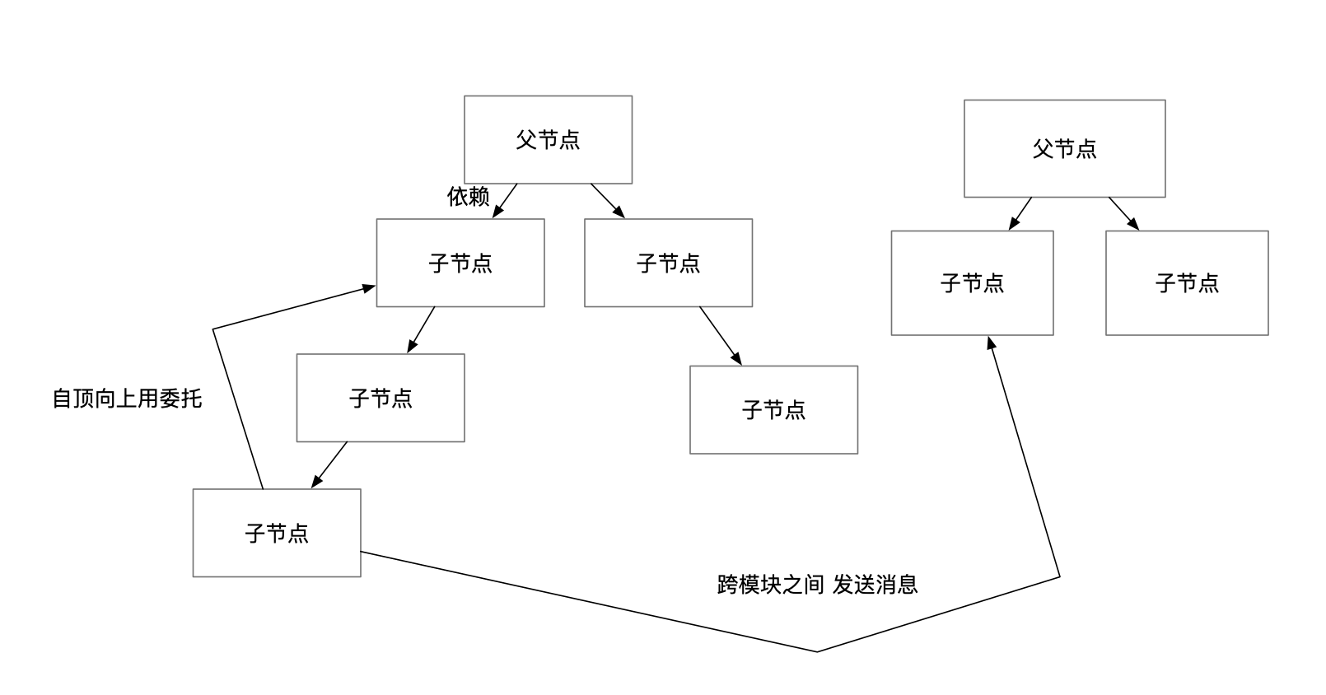

如果你能看懂这张图，那么说明对对象之间的交互的掌握还算不错。

决定版 补充
很明显，上边的这张图，对于已经接触过决定版架构的童鞋来说过时了，因为在决定版架构中，很少遇到需要跨模块发送事件的情况，因为我们引入了层级这个概念，同时在对象之间交互的方法中又多了一个 Command（包括 Query），再加上 Command→Model→StateChangedEvent 模式，所以基本上跨模块之间发送消息的情况就比较少见了。
由于上边的图是基于决定版发布两年之前的笔者的设计理念绘制的，从现在的角度来看肯定是会有一些内容过时的，这恰恰说明，我们目前的决定版架构经过两年是进步的，对象之间的交互这个理论也得到了发展。
最后再来一个简单的拓展。
对象之间的交互一开始只专注在两个对象之间，目前可以是：
- 调用方法
- 委托
- 事件
- 命令模式（或 Query，包含 CQRS 原则等）
最佳实践就是：
- 自顶向下可以调用方法和命令
- 自底向上可以用委托和事件通知
再两年前，笔者把对象之间的交互延伸到了 GameObject 的父子节点上，是适用的。
在管理模块依赖的时候，也是适用的。
而在决定版架构引入了层级的概念，在层级之间也是适用的，即从表现层和底层（System 或 Model 等）交互可以直接调用方法和发送命令或 Query，而底层（System 或 Model、Command）通知上层或其他的底层对象可以通过事件或者委托。这一点大家应该很清楚。
再往下其实我们可以把这个理论延伸到客户端-服务器的形式。
服务器实际上可以理解为我们的底层，客户端可以理解为表现层。
客户端与服务器的通信一般如下：
- HTTP 请求（如果是增删改，就有点像 Command，如果是查询，就像是 Query，有点像委托调用）
- TCP 长连接（链接之后有点像发送事件，服务器能够主动通知客户端）
- UDP（像发送事件）
- RPC（模拟方法调用，Remote Process Call，远程进程调用）
客户端和服务器之间的通信，也是可以用对象之间的交互这个理论来解释的。
客户端和服务器的通信，本质是两个应用的通信，即客户端 App 和 服务器 App。
所以在两个应用之间的通信，对象之间的交互这个理论也是解释得通的。
大家可能会问为什么非要用对象之间的交互去解释各种情况。
这是因为如果能用对象之间的交互去解释这些情况，由于我们有了决定版架构的使用经验，那么我们就可以很快抓住其他领域开发的重点，比如服务器开发的重点，抓住重点了，我们在学习、开发的过程中至少心理有个底了。
为啥要有服务器？最初就是为了在多个 App 之间共享数据，提供 API 访问。我们可以把服务器当做我们的 Model，然后把服务器提供的 API 当做我们架构中的Command、Query，服务器当然也可以像我们的架构一样，拥有自己的 System 模块，来处理统一的逻辑，本质上是一样的。
所以说决定版架构是一步到位的架构，就是掌握了这套架构，会发现架构图所提供的概念， 是能够解释很多其他领域的开发的，而且这套架构的使用经验也是同样可以复用的。
我们可以像设计架构底层一样，去写一个服务器，服务器包含四层，API 层、系统层、模型层、工具层。其设计的经验同样适用，如果你在 Unity 里用决定版架构，用得非常熟练，同理在写服务器的时候，这些经验也是完全可以使用的，所以决定版架构是一个非常值得投入时间学习的架构。这就是为啥笔者目前能写 React 前端、服务端、桌面 App、Unity 游戏、Unity 框架、Unity 的各种解决方案（资源管理、UI 管理等），在 Lua、可视化编程同样也是适用的，听起来很多，但是对于笔者来说，架构和架构使用经验没变，编程的方法也没变，只不过就是换了个语言换了个 API 而已，笔者切换一个领域，只需要花点时间学语言和 API 就可以，OK，牛就不接着吹了，哈哈。
这也是为啥这门课叫决定版的原因，笔者在摸索这套架构的时候在某一个阶段产生了一种通了的感觉，这种感觉是很欣喜的...希望大家也能感受到。
希望大家在熟练使用这套架构之后，去多多尝试一些其他语言、其他领域的开发，真的会有惊喜哦~
这篇就到这里。

22. 深入理解命令模式（一）简介 与 架构中的 Command
在上一堂课我们对对象之间的交互这个话题做了一个总结。
从这一篇开始，我们学习决定版架构中比较重要的设计模式：命令模式。

命令模式 简介
我们先看下命令模式的定义：
- 将请求封装成对象，让你可以将客户端的不同请求参数化，并配合队列、记录、复原等方法来执行请求操作。
这个定义有一点绕，笔者认为的命令模式其核心就是，将逻辑代码封装到一个对象中。

Command 模式快速入门
Command 模式有经典的实现，不过经典实现一般都有一点门槛。
所以笔者这里给出一个比较容易理解的实现:
代码如下:
public interface ICommand
{
void Execute();
}
public class OpenLightCommand : ICommand
{
public void Execute()
{
var light = GameObject.Find("Light");
light.SetActive(true);
Debug.Log("打开灯光");
}
}
void Start()
{
var command = new OpenLightCommand();
command.Execute();
}
这就是非常简单的指令模式实现。

决定版架构中的命令模式
决定版架构中的 Command是用来操作 Model 层的。
不只是决定版架构，uFrame、StrangeIOC、PureMVC、以及 CQRS 原则都是使用 Command 来操作 Model 层的。
将 Command 操作 Model 的这种实现，其实在我们日常工作中并不常见，而一些 Unity 中比较有名的 MVC 框架却都不约而同地使用了这种实现，这么做肯定有他们的道理。
那么为什么要把操作 Model 对象的逻辑都写到 Command 中呢？
这个答案其实我们在第一季的内容中就已经知道了，是为了分担 Controller 对象的交互逻辑部分的职责。
不过 Command 模式有更多的好处。

Command 模式的更多好处
其中一个好处就是将逻辑封装到对象中的好处。
将逻辑封装到对象中有什么好处呢？
答案是方便管理，管理对象比管理代码其实更加容易的。
比如我们如果要实现按顺序执行 3 ~ 4 个 Model 操作，其实也可以按照顺序执行封装好 Command 指令。
代码可能如下:
public interface ICommand
{
void Execute();
}
public class ACommand
{
public void Execute()
{
Debug.Log("Execute A Command");
}
}
public class BCommand
{
public void Execute()
{
Debug.Log("Execute B Command");
}
}
public class CCommand
{
public void Execute()
{
Debug.Log("Execute C Command");
}
}
void Start()
{
var commands = new List<ICommand>();
commands.Add(new ACommand());
commands.Add(new BCommand());
commands.Add(new CCommand());
commands.ForEach(c=>c.Execute());
}
代码很简单，就是按照顺序执行了每一个指令。
使用命令模式就可以很轻松地实现这样的功能，这就是指令模式的其中一个好处。
OK，此篇的内容就到这里。
这里做一个简单的小结。

小结
- MVC 中的 命令模式
  - 专注操作 Model 与 通知 Controller 更新 View，使 Controller 不再那么臃肿
  - 逻辑以对象为单位进行管理，可以实现比较复杂的功能

知识地图
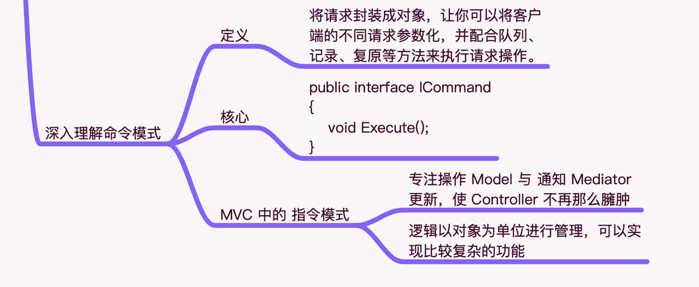

23. 深入理解命令模式（二）参数化
在上一篇，笔者对命令模式做了一个简介，并且简单聊了下 MVC 中的 Command，结果如下：

在此篇，我们再聊聊命令模式的另外一个好处：参数化

参数化
这个参数化是在命令模式的定义中出现的，我们先看下定义：
- 将请求封装成对象，让你可以将客户端的不同请求参数化，并配合队列、记录、复原等方法来执行请求操作。
定义中说道，我们可以将命令模式参数化，其实理解起来很简单，下面我们看一个例子就可以了。
public interface ICommand
{
void Execute();
}
public class AttackHeroCommand
{
private int mHP;
public AttackHeroCommand(int hp)
{
mHP = hp;
}
public void Execute()
{
var heroModel = HeroModel.Get();
heroModel.HP -= mHP;
MsgSender.Send("UPDATE_HP", heroModel.HP);
}
}
void Start()
{
var attackHeroCommand = new AttackHeroCommand(10);
attackHeroCommand.Execute();
var attackHeroCommand2 = new AttackHeroCommand(20);
attackHeroCommand2.Execute();
}
示例很简单，就是将一部分 Command 执行所需要的数据开放了出来，开放到了构造函数的参数里。
这样当我们发起命令的时候，就可以传入不同的参数来控制指令执行的效果。
这就是关于命令模式的参数化的介绍。

知识地图
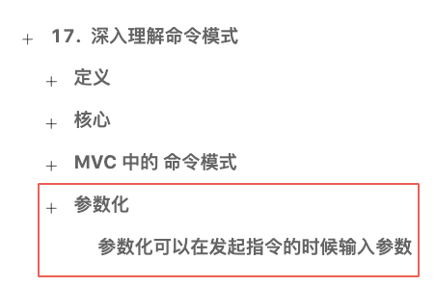



24. 深入理解命令模式（三）撤销
在上一篇，我们介绍了命令模式实现的参数化特性。
在这一篇，我们介绍一下如何使用命令模式的撤销实现。

撤销
与参数化一样，在定义命令模式的时候也提了撤销这两个字眼，如下:
- 将请求封装成对象，让你可以将客户端的不同请求参数化，并配合队列、记录、复原等方法来执行请求操作。
当然定义中没有撤销这两个字啦，不过有复原这个字眼。
复原功能通过命令模式非常容易实现，我们直接看代码，如下:
public interface IUndoableCommand
{
void Execute();
void Undo();
}
public class MoveForwardCommand : IUndoableCommand
{
public void Execute()
{
var player = GameObject.Find("Player").transform;
player.position += Vector3.forward;
}
public void Undo()
{
var player = GameObject.Find("Player").transform;
player.position -= Vector3.forward;
}
}
void Start()
{
var commands = new List<IUndoableCommand>();
commands.Add(new MoveForwardCommand());
commands.Add(new MoveForwardCommand());
commands.ForEach(c=>c.Execute());
for (int i = commands.Count - 1;i >= 0;i--)
{
commands[i].Undo();
}
}
代码很简单，这样就实现了一套可以执行，也可以撤销的命令机制。
如果要撤销，那么一定要记得要把指令都记录到一个 List 或者一个 Stack 里。
此篇的内容就这些。

知识地图
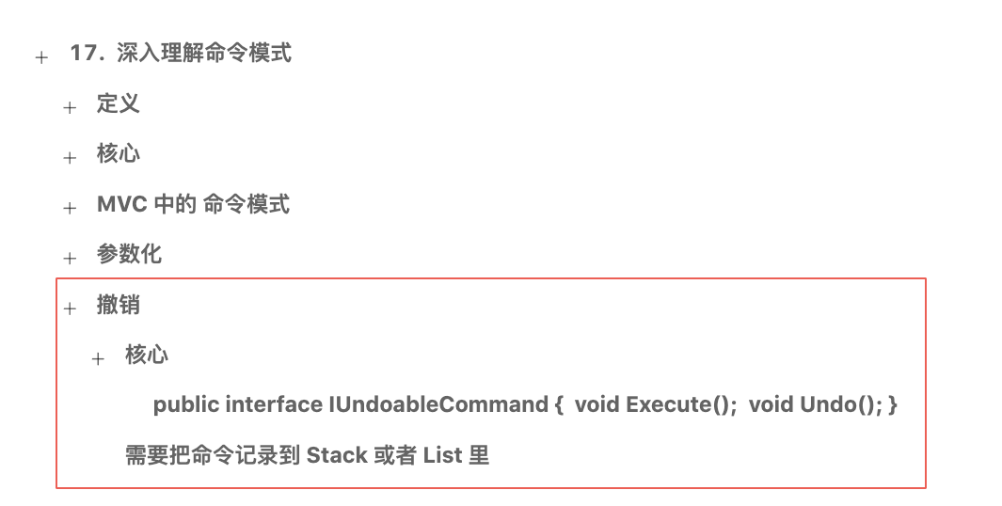

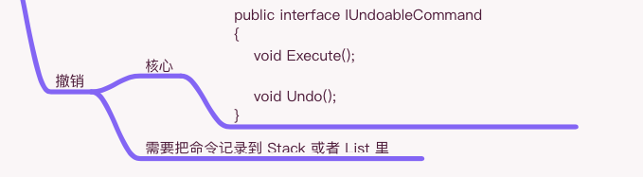

25. 深入理解命令模式（四）命令与执行分离
在上一篇，我们用命令模式实践了命令模式的撤销支持，其代码非常简单。
在此篇，我们来聊聊命令模式的命令与执行分离这个特性。

命令 与 执行 分离特性
命令模式有一个特性就是 命令 与 执行 分离。
我们先看看 命令 与 执行 不分离是什么样的？
其实在日常编程中 命令 与 执行 不分离的代码是很常见的，其中最典型的就是方法的定义。
代码如下:
void SayHello()
{
Debug.Log("Say Hello");
}
void Start()
{
// 命令 与 执行
SayHello();
}
SayHello 方法调用后会马上执行，这就是 命令（调用）与 执行 不分离的代码。
这种代码其实是很常见的，在工作中会大量接触到。
而 命令 与 执行 分离的代码是怎么样的呢？
首先我们有接触过消息机制，如果用消息机制来实现 SayHello 同样的功能，代码如下:
public class SayHelloEvent {}
void Start()
{
SimpleEventSystem.GetEvent<SayHelloEvent>()
.Subscribe(sayHello =>
{
// 执行
Debug.Log("Say Hello");
})
.AddTo(this);
// 命令
SimpleEventSystem.Publish(new SayHelloEvent());
}
代码很简单，这也算是一种 命令 与 执行（处理事件） 分离的实现。
我们再看下使用命令模式实现的 命令 与 执行 分离的代码，如下：
public interface ICommand
{
void Execute();
}
public class SayHelloCommand
{
public void Execute()
{
// 执行
Debug.Log("Say Hello");
}
}
void Start()
{
// 命令
var command = new SayHelloCommand();
command.Execute();
SimpleEventSystem.GetEvent<ICommand>.Subscribe(cmd=>cmd.Execute()).AddTo(this);
// 命令
SimpleEventSystem.Publish(new SayHelloCommand());
}
以上就是通过 Command 实现的 命令 与 执行 分离的代码。
那么三者之间有什么区别呢？如下：
- 方法：命令与执行在一起（没有分离）
- Command：执行在 Command 内部实现（有分离）
- 事件机制：执行在事件注册中实现（有分离）
Command 的 命令 与 执行 分离的程度，介于方法与事件机制之间。
事件机制也能达到 命令 与 执行 分离的效果，但是事件机制一般至少需要通过两个对象才能完整使用。
而 Command 的 命令 与 执行 分离不同，可以在自定义的位置和时机执行指令。
OK，关于 命令 与 执行 的分离介绍就到这里。
接下来我们再聊聊，空间 和 时间 上的 命令 与 执行分离。

空间 与 时间 上的 命令 与 执行分离
在上小结介绍的 命令 与 执行 分离的各个实现，都指的是空间上的 命令 与 执行 分离，或者说物理上的 命令 和 执行 分离。
空间上的 命令 与 执行 分离非常容易理解，就是 命令 的位置 与 执行 位置不同，就是所谓的空间上的 命令 与 执行分离。
那么除了 空间 上的 命令 与 执行分离，还有时间上的 命令 与 执行 分离。
那么时间上的 命令 与 执行 分离是什么样的呢？代码如下:
public interface ICommand
{
void Execute();
}
public class SayHelloCommand()
{
public void Execute()
{
Debug.Log("Say Hello");
}
}
void Start()
{
var command = new SayHelloCommand();
// 延时 1 秒后执行
Observable.Timer(TimeSpan.FromSeconds(1.0f))
.Subscribe(_=>command.Execute())
.AddTo(this);
}
代码很简单，这就是 时间 上的 命令 与 执行分离实现。
除了可以简单地延时之外，还可以做成命令队列，代码如下:
public interface ICommand
{
void Execute();
}
public class SayHelloCommand()
{
public void Execute()
{
Debug.Log("Say Hello");
}
}
Queue<ICommand> mQueue = new Queue<ICommand>();
void Start()
{
mQueue.Enqueue(new SayHelloCommand());
mQueue.Enqueue(new SayHelloCommand());
}
void Update()
{
if (mQueue.Count > 0)
{
mQueue.Dequeue().Execute();
}
}
这是非常简单的一个命令队列，这种命令队列在一些需要跨线程、跨平台通信情况下非常常见。
代码中我们可以控制每一个 Command 执行的时间在每帧执行一个 Command 的程度，这也是一种 时间 上的 命令 与 执行 分离的一种实现。
OK，到此，关于 命令 与 执行 分离的话题就到这里。
大家可能会问 命令 与 执行 分离，知道这一点有什么用呢？
现在是没什么用的，在这里介绍 命令 与 执行 分离，是为了让大家对 命令模式 有一个很深刻的印象，目前仅仅是一个强调的作用。
此篇的内容就这些。

知识地图
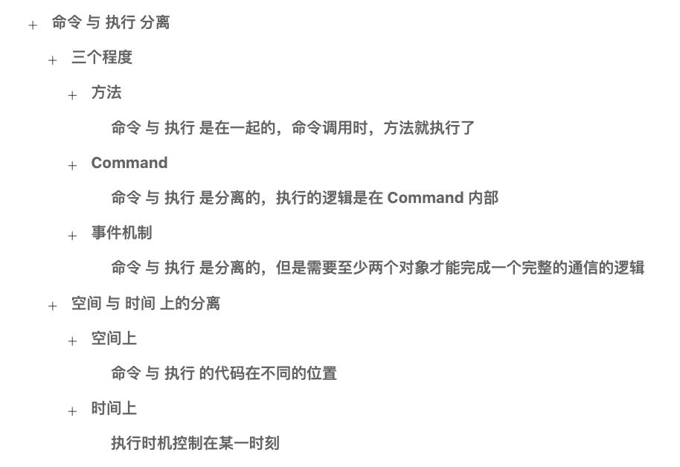

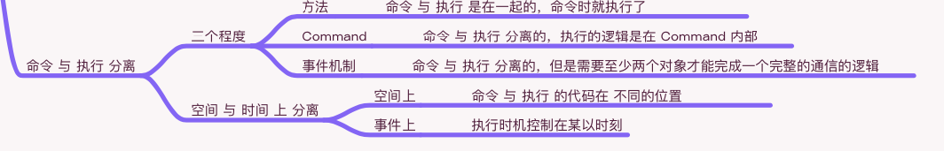

25. 深入理解命令模式（四）命令与执行分离
在上一篇，我们用命令模式实践了命令模式的撤销支持，其代码非常简单。
在此篇，我们来聊聊命令模式的命令与执行分离这个特性。

命令 与 执行 分离特性
命令模式有一个特性就是 命令 与 执行 分离。
我们先看看 命令 与 执行 不分离是什么样的？
其实在日常编程中 命令 与 执行 不分离的代码是很常见的，其中最典型的就是方法的定义。
代码如下:
void SayHello()
{
Debug.Log("Say Hello");
}
void Start()
{
// 命令 与 执行
SayHello();
}
SayHello 方法调用后会马上执行，这就是 命令（调用）与 执行 不分离的代码。
这种代码其实是很常见的，在工作中会大量接触到。
而 命令 与 执行 分离的代码是怎么样的呢？
首先我们有接触过消息机制，如果用消息机制来实现 SayHello 同样的功能，代码如下:
public class SayHelloEvent {}
void Start()
{
TypeEventSystem.Global.Register<SayHelloEvent>(sayHello =>
{
// 执行
Debug.Log("Say Hello");
})
.UnRegisterWhenGameObjectDestroyed(gameObject);
// 命令
TypeEventSystem.Global.Send(new SayHelloEvent());
}
代码很简单，这也算是一种 命令 与 执行（处理事件） 分离的实现。
我们再看下使用命令模式实现的 命令 与 执行 分离的代码，如下：
public interface ICommand
{
void Execute();
}
public class SayHelloCommand
{
public void Execute()
{
// 执行
Debug.Log("Say Hello");
}
}
void Start()
{
// 命令
var command = new SayHelloCommand();
command.Execute();
TypeEventSystem.Global.Register<ICommand>(cmd=>cmd.Execute()).UnRegisterWhenGameObjectDestroyed(gameObject);
// 命令
TypeEventSystem.Global.Send<ICommand>(new SayHelloCommand());
}
以上就是通过 Command 实现的 命令 与 执行 分离的代码。
那么三者之间有什么区别呢？如下：
- 方法：命令与执行在一起（没有分离）
- Command：执行在 Command 内部实现（有分离）
- 事件机制：执行在事件注册中实现（有分离）
Command 的 命令 与 执行 分离的程度，介于方法与事件机制之间。
事件机制也能达到 命令 与 执行 分离的效果，但是事件机制一般至少需要通过两个对象才能完整使用。
而 Command 的 命令 与 执行 分离不同，可以在自定义的位置和时机执行指令。
OK，关于 命令 与 执行 的分离介绍就到这里。
接下来我们再聊聊，空间 和 时间 上的 命令 与 执行分离。

空间 与 时间 上的 命令 与 执行分离
在上小结介绍的 命令 与 执行 分离的各个实现，都指的是空间上的 命令 与 执行 分离，或者说物理上的 命令 和 执行 分离。
空间上的 命令 与 执行 分离非常容易理解，就是 命令 的位置 与 执行 位置不同，就是所谓的空间上的 命令 与 执行分离。
那么除了 空间 上的 命令 与 执行分离，还有时间上的 命令 与 执行 分离。
那么时间上的 命令 与 执行 分离是什么样的呢？代码如下:
public interface ICommand
{
void Execute();
}
public class SayHelloCommand()
{
public void Execute()
{
Debug.Log("Say Hello");
}
}
IEnumerator Start()
{
var command = new SayHelloCommand();
yield new WaitForSeconds(1.0f);
command.Execute();
}
代码很简单，这就是 时间 上的 命令 与 执行分离实现。
除了可以简单地延时之外，还可以做成命令队列，代码如下:
public interface ICommand
{
void Execute();
}
public class SayHelloCommand()
{
public void Execute()
{
Debug.Log("Say Hello");
}
}
Queue<ICommand> mQueue = new Queue<ICommand>();
void Start()
{
mQueue.Enqueue(new SayHelloCommand());
mQueue.Enqueue(new SayHelloCommand());
}
void Update()
{
if (mQueue.Count > 0)
{
mQueue.Dequeue().Execute();
}
}
这是非常简单的一个命令队列，这种命令队列在一些需要跨线程、跨平台通信情况下非常常见。
代码中我们可以控制每一个 Command 执行的时间在每帧执行一个 Command 的程度，这也是一种 时间 上的 命令 与 执行 分离的一种实现。
OK，到此，关于 命令 与 执行 分离的话题就到这里。
大家可能会问 命令 与 执行 分离，知道这一点有什么用呢？
现在是没什么用的，在这里介绍 命令 与 执行 分离，是为了让大家对 命令模式 有一个很深刻的印象，目前仅仅是一个强调的作用。
此篇的内容就这些。

知识地图

26. 深入理解命令模式（五）经典命令模式
在上一篇，我们聊了一个 命令 与 执行 分离这样的一个话题，其结论如下：
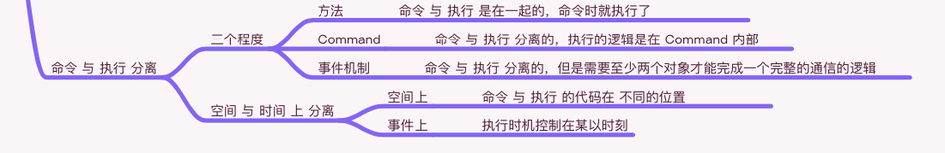

在这一篇，我们来学习经典的命令模式实现。

经典命令模式实现
一般来说，经典的设计模式实现总是绕来绕去劝退初学者，所以笔者把经典命令模式的学习留在了比较靠后的位置，也就是这一篇。
在实现经典模式之前我们来看下之前笔者实现的命令模式，如下:
public interface ICommand
{
void Execute();
}
public class SayHelloCommand
{
public void Execute()
{
Debug.Log("Say Hello");
}
}
void Start()
{
var command = new SayHelloCommand();
command.Execute();
}
以上这个指令模式是最简实现，虽然是最简实现，它还是可以分出一些角色的。
- ICommand：命令接口，对应的经典实现中的 Command 角色。
- SayHelloCommand：命令的实现，对应的经典实现中的 ConcreteCommand 角色。
- Start 方法：命令的发起者、调用者，对应的经典实现中的 Invoker 角色。
从最简实现中，我们得到了经典模式中的三个角色，如下：
- Command：抽象命令（命令接口）。
- ConcreteCommand：具体命令。
- Invoker：命令的调用者，发起者。
除了以上三个角色，经典命令模式中，还有一个 Receiver，也就是命令的接受者。
以上三个角色，加上接受者，总结如下:
- Command：抽象命令（命令接口）。
- ConcreteCommand：具体命令。
- Invoker：命令的调用者，发起者、管理者。
- Receiver：被 Command 访问和操作。
有了这四个角色，我们就比较容易实现经典命令模式了，具体代码如下:
// 接收者
public class Receiver
{
public void SayHello(int times = 1)
{
for (int i = 0; i < times; i++)
{
Debug.Log("Hello");
}
}
}
// 命令接口
public interface Command
{
void Execute();
}
// 具体接口
public class ConcreteCommand
{
public Receiver Receiver;
public int Times;
public void Execute()
{
Receiver.SayHello(Times);
}
}
// 命令的调用者、管理者
public class Invoker
{
List<Command> mCommands = new List<Command>();
public void AddCommand(Command command)
{
mCommands.Add(command);
}
public void ExecuteCommands()
{
mCommands.ForEach(c => c.Execute());
mCommands.Clear();
}
}
// 客户端
void Start()
{
var invoker = new Invoker();
var receiver = new Receiver();
invoker.AddCommand(new ConcreateCommand()
{
Receiver = receiver,
Times = 3
})
invoker.AddCommand(new ConcreateCommand()
{
Receiver = receiver,
Times = 5
})
invoker.ExecuteCommands();
}
// 运行结果为输出了 8 次 Hello
以上就是经典的命令模式实现，确实是比较绕的，不过在我们接触了最简版本之后，以上的代码，应该是比较容易理解了的。
在决定版的架构中的 Command 模式里，Receiver 则是 Model、System 等对象，Invoker 则是 Architecture对象本身，因为负责执行 Command 的实现是在 Architecture 内部，总结如下:
- Receiver：Model、System 等对象
- Invoker：IController
- Client：表现层
OK，到此，我们就实现了经典的指令模式，并且试图用已学过的决定版架构做了一些解释，想必到此大家对实现应该没有什么问题了吧。
此篇的内容就这些，在下一篇，我们简单分析一下经典命令模式。

知识地图
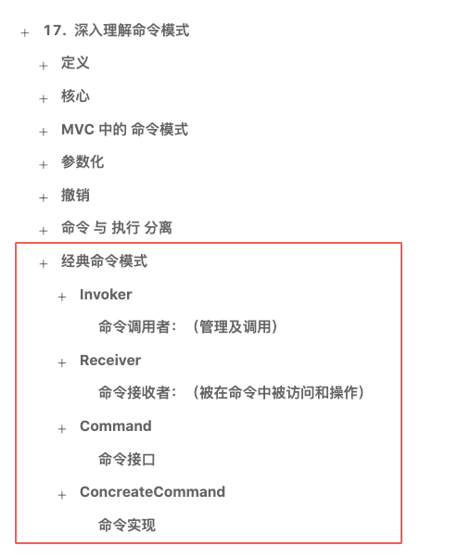

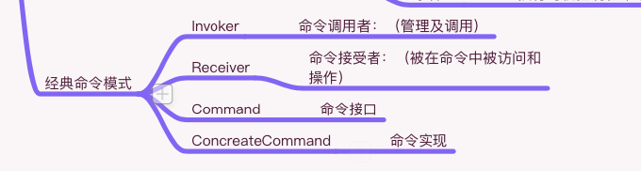

26. 深入理解命令模式（五）经典命令模式
在上一篇，我们聊了一个 命令 与 执行 分离这样的一个话题，其结论如下：

在这一篇，我们来学习经典的命令模式实现。

经典命令模式实现
一般来说，经典的设计模式实现总是绕来绕去劝退初学者，所以笔者把经典命令模式的学习留在了比较靠后的位置，也就是这一篇。
在实现经典模式之前我们来看下之前笔者实现的命令模式，如下:
public interface ICommand
{
void Execute();
}
public class SayHelloCommand
{
public void Execute()
{
Debug.Log("Say Hello");
}
}
void Start()
{
var command = new SayHelloCommand();
command.Execute();
}
以上这个指令模式是最简实现，虽然是最简实现，它还是可以分出一些角色的。
- ICommand：命令接口，对应的经典实现中的 Command 角色。
- SayHelloCommand：命令的实现，对应的经典实现中的 ConcreteCommand 角色。
- Start 方法：命令的发起者、调用者，对应的经典实现中的 Invoker 角色。
从最简实现中，我们得到了经典模式中的三个角色，如下：
- Command：抽象命令（命令接口）。
- ConcreteCommand：具体命令。
- Invoker：命令的调用者，发起者。
除了以上三个角色，经典命令模式中，还有一个 Receiver，也就是命令的接受者。
以上三个角色，加上接受者，总结如下:
- Command：抽象命令（命令接口）。
- ConcreteCommand：具体命令。
- Invoker：命令的调用者，发起者、管理者。
- Receiver：被 Command 访问和操作。
有了这四个角色，我们就比较容易实现经典命令模式了，具体代码如下:
// 接收者
public class Receiver
{
public void SayHello(int times = 1)
{
for (int i = 0; i < times; i++)
{
Debug.Log("Hello");
}
}
}
// 命令接口
public interface Command
{
void Execute();
}
// 具体接口
public class ConcreteCommand
{
public Receiver Receiver;
public int Times;
public void Execute()
{
Receiver.SayHello(Times);
}
}
// 命令的调用者、管理者
public class Invoker
{
List<Command> mCommands = new List<Command>();
public void AddCommand(Command command)
{
mCommands.Add(command);
}
public void ExecuteCommands()
{
mCommands.ForEach(c => c.Execute());
mCommands.Clear();
}
}
// 客户端
void Start()
{
var invoker = new Invoker();
var receiver = new Receiver();
invoker.AddCommand(new ConcreateCommand()
{
Receiver = receiver,
Times = 3
})
invoker.AddCommand(new ConcreateCommand()
{
Receiver = receiver,
Times = 5
})
invoker.ExecuteCommands();
}
// 运行结果为输出了 8 次 Hello
以上就是经典的命令模式实现，确实是比较绕的，不过在我们接触了最简版本之后，以上的代码，应该是比较容易理解了的。
在决定版的架构中的 Command 模式里，Receiver 则是 Model、System 等对象，Invoker 则是 Architecture对象本身，因为负责执行 Command 的实现是在 Architecture 内部，总结如下:
- Receiver：Model、System 等对象
- Invoker：Architecture
- Client：IController
OK，到此，我们就实现了经典的指令模式，并且试图用已学过的决定版架构做了一些解释，想必到此大家对实现应该没有什么问题了吧。
此篇的内容就这些，在下一篇，我们简单分析一下经典命令模式。

知识地图

27. 深入理解命令模式（六）经典命令模式的好处
在上一篇，我们实现了经典命令模式，经典命令模式的各个角色及意义如下：
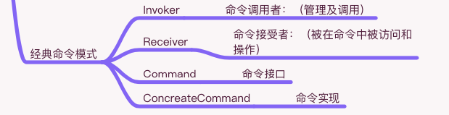

在此篇，我们来分析一下经典命令模式。

经典命令模式
我们先看下命令模式的定义：
- 将请求封装成为对象，让你可以将客户端的不同请求参数化，并配合队列、记录、复原等方法来执行请求操作。
定义其实核心的部分只有将请求封装成为对象这几个字，而后边所说的参数化、队列、记录、复原都是以前边的几个字作为基础的。
毫无疑问，经典的命令模式确实实现了”将请求封装成为对象“这个功能，并且也实现了参数化 和 队列（Invoker 中管理）这些功能。
但是记录 和 复原是没有实现的，也不必实现，因为命令模式的核心就是将”请求封装成为对象“，那么经典命令模式是做到这一点的，也就是说经典命令模式是合格的。
不过经典命令模式绕来绕去，一开始会劝退初学者，就算看明白了代码，也不知道为啥要这样写？这样写有啥好处？
而在此篇，我们就试着推测一下经典命令模式有什么好处？

经典命令模式有什么好处？
经典命令模式中 Invoker 和 Receiver 是完全解耦的状态，这是第一个好处。
当然我们用观察者模式也能实现 Invoker 和 Receiver 的完全解耦状态，那么经典命令模式有什么不同呢？
经典命令模式的不同在于，除了能够实现 Invoker 和 Receiver 的完全解耦，还可以扩展 Command。
当然最简的命令模式也是可以扩展 Command 的，而经典的命令模式则是在 Invoker 与 Receiver 解耦的同时可以对 Command 进行扩展。
现在经典命令模式有两个好处：
- Invoker 和 Receiver 解耦
- 可以扩展 Command
除了以上两个好处，还有另外一个 Invoker 带来的好处。
可以在 Invoker 中实现 Command 的队列、记录、复原，甚至可以实现一个轻量级的行为树出来。
所以加上这一点，总共的好处如下:
- Invoker 和 Receiver 解耦
- 可以扩展 Command
- Invoker 可以做定制，可以支持：队列、记录、复原、行为树等。
OK，关于经典命令模式的好处就说到这里。
此篇的内容就这些，在下一篇我们来聊聊，经典命令模式与什么设计原则有关系呢？

知识地图
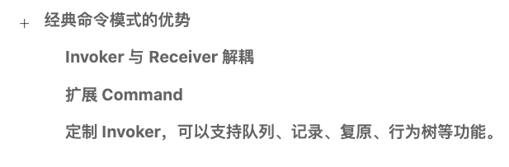

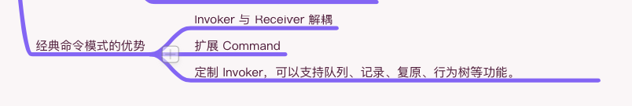

28. 深入理解命令模式（七）命令模式与开闭原则
在上一篇，我们简单分析了下，经典命令模式的好处，总结如下：
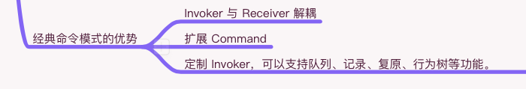

在这一篇，我们来聊聊命令模式相关的设计原则：开闭原则

开闭原则简介
开闭原则，即：OCP（Open-Close Principle)
其定义如下：
- 一个类应该对扩展开放、对修改关闭
什么是对扩展开放，什么又是对修改关闭呢？
其实理解起来非常简单，当一个结构或者一个系统成型之后，除非遇到一些 bug 或者一些软件缺陷，就不应该对系统或结构中的类进行修改，这就是对修改关闭。
而当需要增加一些功能，或者扩展一些功能时，这个系统或结构应该通过扩展的方式来增加或扩展一些功能，这就是对扩展开放。

命令模式 与 开闭原则
那么为什么说命令模式与开闭原则相关呢？
这是因为，在经典的命令模式中，有关闭修改的部分，也有开放扩展的部分。
当一个命令系统完成时，一般都会包含经典命令模式中的几个角色，如下：
- Invoker
- Receiver
- Command
- ConcreteCommand
而其中的 ConcreteCommand 是我们可以不断扩展的部分，也就是整个命令系统中，ConcreteCommand 是开放出来的扩展。
而 Command 则是扩展的标准。
而在系统成型时，Invoker 则是不推荐修改的部分，Receiver 也许会根据 Command 扩展会为自己增加一些方法，或者增加 Receiver 的实现类型，所以也算是开放出来的扩展，但是 Receiver 的内部代码是不推荐修改的，所以也有对修改关闭的部分。
总结如下：
- Invoker：关闭修改
- Receiver：关闭内部修改，开放实现与方法的扩展
- Command：扩展的标准
- ConcreateCommand：开放实现的扩展
如果要真正实现一个命令模式，一般都会把命令模式实现成为一个系统，比如像一些行为树的核心是命令模式。
而像架构中的 Command，并不是在一个系统中，而是把经典命令模式中的几个角色融入到架构中，形成了一套支持命令的架构，这个时候，也是遵循了开闭原则的，因为在决定版架构中的 Invoker（Architecture）、Receiver（System、Model） 相对 Command 来说是对修改关闭的，而 Command 本身是对扩展开放的。如果想实现一套命令队列、复原等功能，和经典的命令模式一样，直接写在 Invoker(Architecture)内部即可。
对于开闭原则的定义其实有一些细节不同的定义，有的时候开闭原则会说成如下：
- 一个软件实体如类、 模块和函数应该对扩展开放， 对修改关闭。
而本篇的定义则是：一个类应该对扩展开放、对修改关闭。
实际上更确切地说，从一个系统或一个结构去定义开闭原则更好一些，这样的话定义可能如下：
- 一个系统应该对扩展开放、对修改关闭。
也是说得通的，系统的这个角度有点太宏观了，所以笔者选择了类这个角度。
OK，关于开闭原则的介绍就先到这里。
此篇的内容就这些。

知识地图
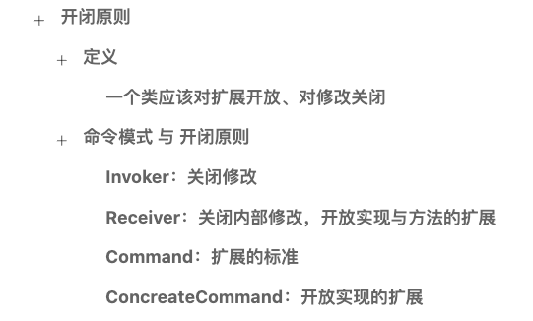

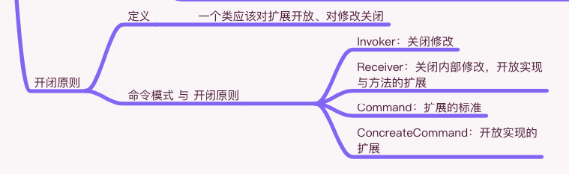

29. 深入理解命令模式（八）小结
在上一篇，我们学习了开闭原则，笔记如下：
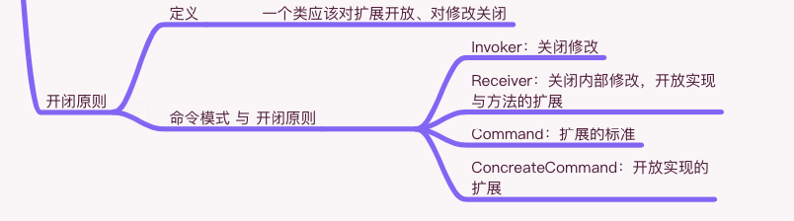

在此篇我们来对 命令模式 总结。

小结
我们第一次接触命令模式是在决定版第一季的时候，决定版架构 中的 Command 对象撑起了整个 Controller 的交互逻辑的职责。
其职责如下：
- 操作 Model、System
- 可以发送 Event
在第一季直接就引入了 Command，但是并没有好好带大家了解一下命令模式，所以就开设了此专题的内容。
最开始，我们学习了命令模式的定义，如下：
- 将请求封装成对象，让你可以将客户端的不同请求参数化，并配合队列、记录、复原等方法来执行请求操作
接着简单聊了一下 架构中的 Command，其优点如下：
- 专注操作 Model 与 System，使 Controller 不再那么臃肿
- 逻辑以对象为单位进行管理，可以实现比较复杂的功能
接着介绍了一下 Command 参数化，非常简单，仅仅只是在 Command 构造上传参即可。
接着我们用 Command 实现了撤销的功能，也非常简单，仅仅是在 ICommand 上增加 Undo 方法即可。
然后我们从 命令 与 执行 隔离的角度介绍了：方法、事件机制、Command 的实现，三者区别如下：
- 方法：命令与执行在一起（没有分离）
- Command：执行在 Command 内部实现（有分离）
- 事件机制：执行在事件注册中实现（有分离）
以上是空间上的隔离，接着还介绍了时间上的隔离，比如 Command 之间的隔帧执行 和 延时执行等。
最后我们迎来了我们的大 boss，经典命令模式，其角色和职责如下：
- Invoker：调用者、管理者
- Receiver：接收者
- Command：接口
- CocreateCommand：实现
学习完经典命令模式后，有分析了其好处，如下：
- Invoker 和 Receiver 解耦
- 可以扩展 Command
- Invoker 可以做定制，可以支持：队列、记录、复原、行为树等。
最后介绍了与 Command 模式相关的原则，开闭原则，如下：
- 一个类应该对扩展开放、对修改关闭
并且用开闭原则去分析了一般的命令系统，如下：
- Invoker：关闭修改
- Receiver：关闭内部修改，开放实现与方法的扩展
- Command：扩展的标准
- ConcreateCommand：开放实现的扩展
最后就到了此篇了。
可以说通过命令模式的学习，我们收获了很多知识和结论。
此篇的内容就这些。

知识地图
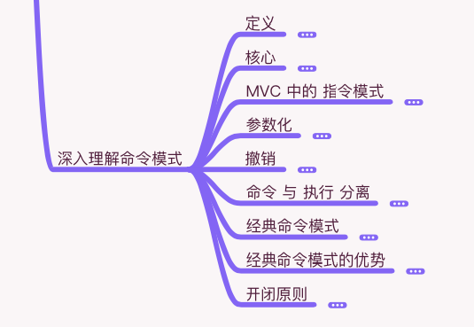

30. IOC（一）IOC 与 DI 简介
在这一篇，我们按照计划学习一个我们接触过的内容，即：IOC。

IOC 简介
IOC 全称为 Invertion Of Control，即控制反转。
控制反转是一种设计思想，而不是一个具体的技术实现。
看到控制反转这个词，大家可能会产生一大堆疑问，控制什么？为啥反转了？有反转那就应该有正转，那么正转又是啥。
这些问题，我们先放在一边，最后一一解答，因为现在理解了也很快会忘掉，所以现在不是介绍的好时机。
在这里我们只要知道，IOC 是一种设计思想。
一种设计思想可以有多种方式去实现，其中最常见的一个实现方式是 DI。

DI
DI，全称为 Dependency Injection，即依赖注入，它是 IOC 思想的一种实现。
依赖这个概念，我们在对象之间的交互里接触过，当时说过一种单向依赖，即自顶向下的依赖。具体是：父节点持有子节点的对象，这是自顶向下依赖的描述，那么单纯的依赖如何描述呢？
其实非常简单，就是持有对象，就是一种依赖，我们先看如下代码:
public class A
{
public B b = new B();
}
我们可以说代码中的 A 依赖 B。
这就是关于依赖的意思，依赖可以理解成持有另一个 对象的引用。
那么注入又是什么呢？
我们看如下代码:
public class A
{
public B b = null;
}
public class B {}
void Main()
{
var a = new A();
var b = new B();
a.b = b;
}
代码很简单，创建了两个对象：a、b，而 a 的 b 成员变量是在 外部设置对象的。即:a.b = b。
而 a.b = b 这个过程就是注入的过程。将 b 对象，注入到 a 对象中的 b 成员变量。
所以这时候，注入是可以理解成设置值的。
那么依赖注入，换成大白话可以理解成，给某个对象的成员变量在设置值。
就是这么简单的东西，非要搞个什么依赖注入这种概念来提高学习门槛。
当然依赖注入这概念在我们达到一定的设计水平的时候，才会知道这个概念为什么这样命名，只不过，这个命名对新手不太友好。
现在我们理解了依赖注入这个概念，即：给某个对象的成员变量在设置值。
知道这一点即可。
到此关于概念的讲解就到这里，在下一篇，我们来试着动手写写代码。
此篇的内容就这些。

知识地图
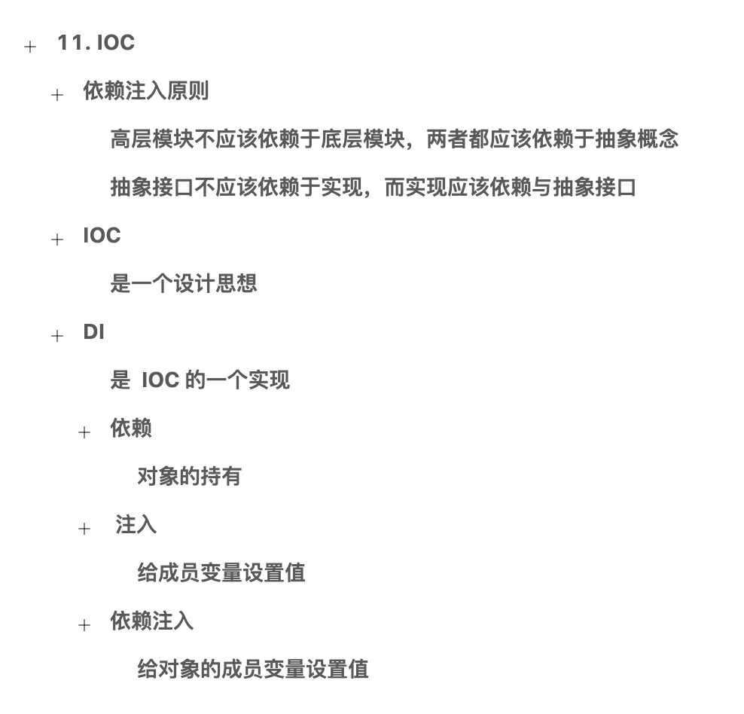

31. IOC（二）IOCKit 中的 IOC
在上一篇，我们简单介绍了 IOC 和 DI 两个概念。
在这一片，我们试着来写一些代码，来更深入地了解 DI 这个方案。

DI 实践
在上一篇我们说到，依赖注入是为对象的成员变量设置值。
在这一小节，我们试着来写一下 DI 方案的使用代码。
在所有的 DI 方案中，都有一个容器的概念。

DI 容器
一般情况下，在我们使用 DI 方案的时候，都离不开 DI 容器这个概念。
有的时候 DI 容器 也叫做 IOC 容器，即：DIContainer 和 IOCContainer。
它俩指的是一个概念。
这个容器是做什么的呢？
这个容器的职责很简单，就是对对象的成员变量设置值。
具体怎么设置值，我们写一些代码就知道了。

QFramework 团队实现的 IOC
在决定版之前的 QFramework 版本中，笔者内置了一个 IOC 容器，即：QFrameworkContainer，地址：https://github.com/liangxiegame/IOCKit，因为只有一个文件，所以最快的安装方式，就是将https://github.com/liangxiegame/IOCKit/blob/master/IOCKit.cs 复制到自己项目中。
安装之后，我们来快速练习一下。
其使用代码如下:
using System.Collections;
using System.Collections.Generic;
using UnityEngine;
using QFramework
namespace QFrameworkExample.Example
{
public class ServiceA
{
public void Say()
{
Debug.Log("I am ServiceA:" + this.GetHashCode());
}
}
public class IOCExample : MonoBehaviour
{
// 声明为需要注入的对象
[Inject]
public ServiceA A {get;set;}
void Start ()
{
// 创建实例容器
var container = new QFrameworkContainer();
// 注册类型
container.Register<ServiceA>();
// 注入对象（会自动查找 Inject Atrribute 的对象)
container.Inject(this);
// 注入之后，就可以直接使用 A 对象了
A.Say();
}
}
}
我们先把目光聚焦于 Start 方法，代码如下:
// 创建实例容器
var container = new QFrameworkContainer();
// 注册类型
container.Register<ServiceA>();
// 注入对象（会自动查找 Inject Atrributet的对象)
container.Inject(this);
// 注入之后，就可以直接使用 A 对象了
A.Say();
在代码中我们先，创建了一个容器实例。
接着，我们在容器实例中注册了一个 ServiceA 类型。
接着就直接进行注入操作，注入操作实际上会创建一个 ServiceA 对象，然后将其赋值给带有 Inject Attribute 同时类型为 ServiceA 的成员变量。
接着，我们就可以直接使用成员变量 A 了。
代码理解起来可能会比较困难。
我们看下边的图就可能会更好理解一点：
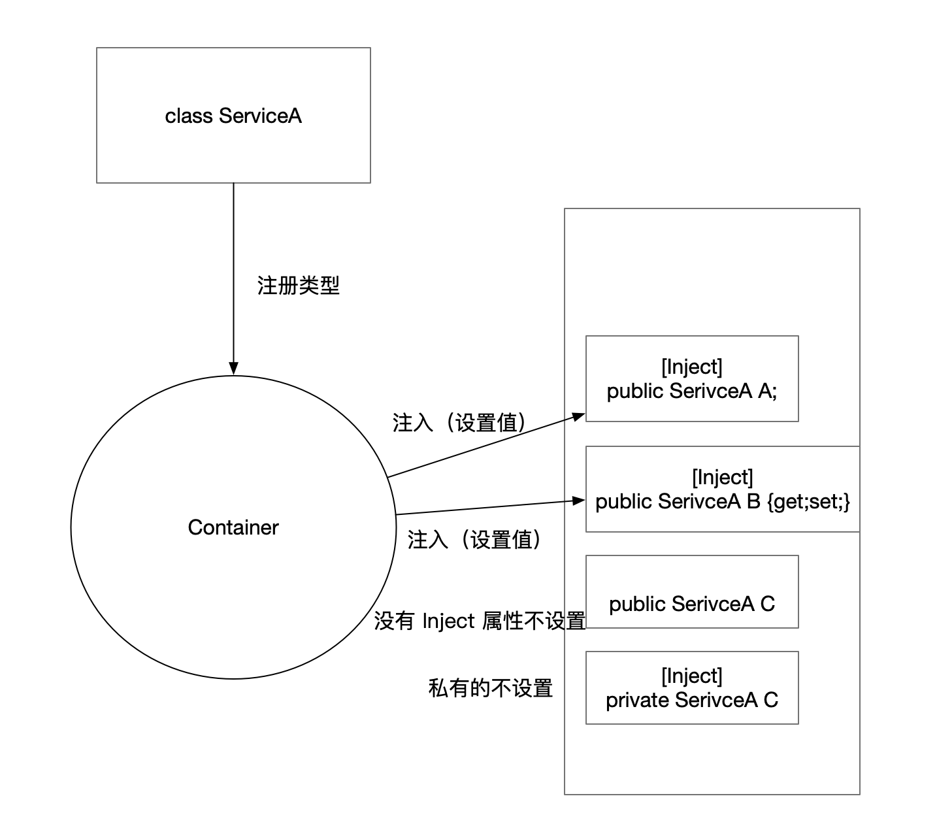

这就是 IOCKit 容器的基本使用。
而我们在第一季决定版中，实现的 IOCContainer，是一个非常简化版本的容器，砍掉了依赖注入的功能，一是因为依赖注入的功能性能消耗很大，二是因为依赖注入的功能实现涉及到反射的 API，而考虑到决定版第一季的内容是针对初学者的，所以就没加上这部分内容。

小结
到此，可能大家不会觉得，IOC 容器有多好用，相反，IOC 容器需要创建容器实例，同时还需要对类型进行注册，还要对需要注入的对象进行显示地注入操作，这么多步骤，还不如直接在 new 一个对象再赋值这样简洁方便。
确实是这样的，在写代码的时候，IOC 容器，并不会让减少我们的代码量，相反还要多写一些准备代码。
那为什么还要用 IOC 容器呢？或者说 IOC 容器强大在哪里呢？
我们在下一篇接着介绍。
此篇的内容就这些。

知识地图
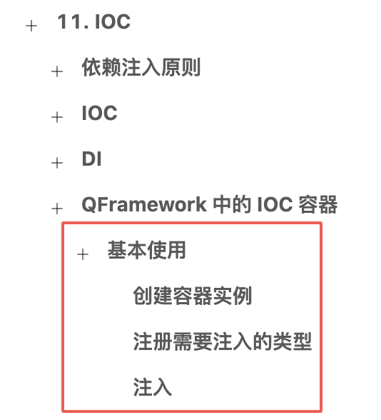

32. IOC（三）强大之处
在上一篇，我们接触了 IOCKit 中的 DI 方案，其使用步骤如下：
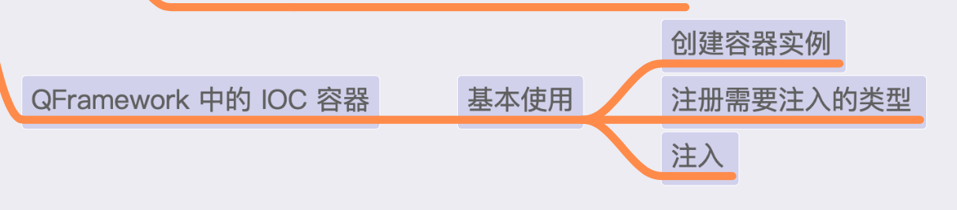

我们还需要知道 DI 容器，它强大在哪里。
在这一篇，我们就来试着了解下 DI 容器的强大之处。

DI 容器的强大之处
在说 DI 容器的强大之处之前，我们需要理解下 DI 容器的职责是什么。

职责
一般情况下，DI 容器会提供如下的 API：
- 注册类型：Register<TSource,TTarget>
- 注入:Inject(object obj)
- 解析:Resolve<T>()
其中的注册类型和注入我们在上一篇接触过了，而解析（Resolve）是什么意思呢？
在 DI Container 中，Resolve 实际上是根据类型返回实例。
比如 Resolve() 会返回一个 ServiceA 对象。
实际上 Inject 方法的底层也调用了 Resolve 。
到这里大家可能会问，Resolve() 每次都是会返回新的对象吗？还是会一直返回同一个对象？
这个问题留到下一篇介绍。
我们接着说 DI 容器的职责。
DI 容器的职责很简单，就是管理依赖和注入依赖，而管理依赖是通过类型来管理依赖。注入依赖就是向一个对象注入实例。
而 DI 容器这个词中的容器，指的就是存储依赖的容器，容器里装的都是依赖。
那么依赖是个什么东西呢？
依赖用英文是 Dependency，在 DIContainer 的具体实现中，依赖是一个以类型为 key，以实例为 value 的一个 key-value 结构
所以一般的 DI Container 会用一个 Dictionary<Type,object> 来作为核心数据结构。
即根据 Type 可以得到 Type 的实例，依赖在代码中就是这样的一个东西。而这个依赖，不是说 Type 依赖 object，而是说 Type:object 这个结构整体就是一个依赖 。
这依赖是相对于要注入的对象的，即它们是 Inject(object obj) 中的 obj 的依赖。
这里可能有一点绕，没关系，我们做一些实践就理解了。
现在，介绍了 DI Container 的职责，以及依赖这个概念在技术上的实现。
接下来就要介绍 DI Container 的强大之处的。

强大之处
在接触 IOC 之前，我们学习了单例的最佳实践。
有了单例这个工具，当我们需要写一个独立模块的时候，很容易用单例就实现了。而且通过单例（或静态类）实现的独立模块，与其他模块之间的交互会变得非常容易。
这种结构好于直接撸的结构，毕竟它有一定的扩展性（只需实现单例），维护性上也还可以（模块独立），但是它很容易达到瓶颈，尤其是当单例的数量逐渐随着项目变多的时候。
为什么说当单例的数量变多就会达到瓶颈呢？
因为单例的获取是没有限制的，任何层级的代码都可以获取到任何层级的单例，如下图示：
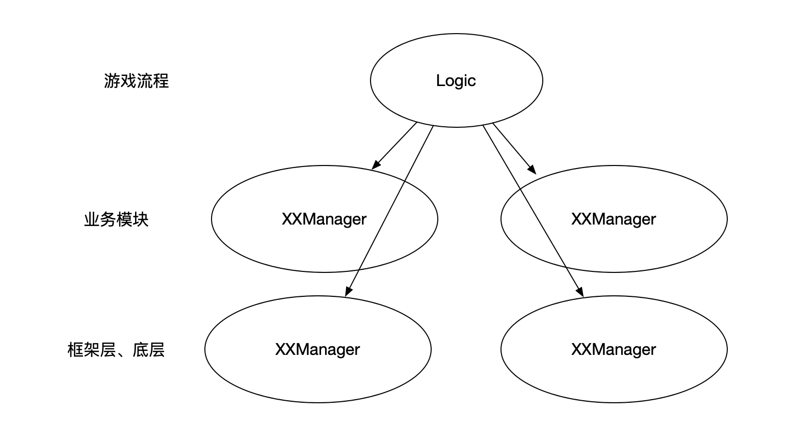

虽然，我们在约定上可能分了很多层，但是约定是在遵循的情况下才会达到效果的。上图中只有四个单例，约定是比较容易达成的，但是当模块数超过一定数量时，约定就会变得越来越难以遵循，因为我们不可能每次访问模块的时候，都去看一遍如下的示意图。
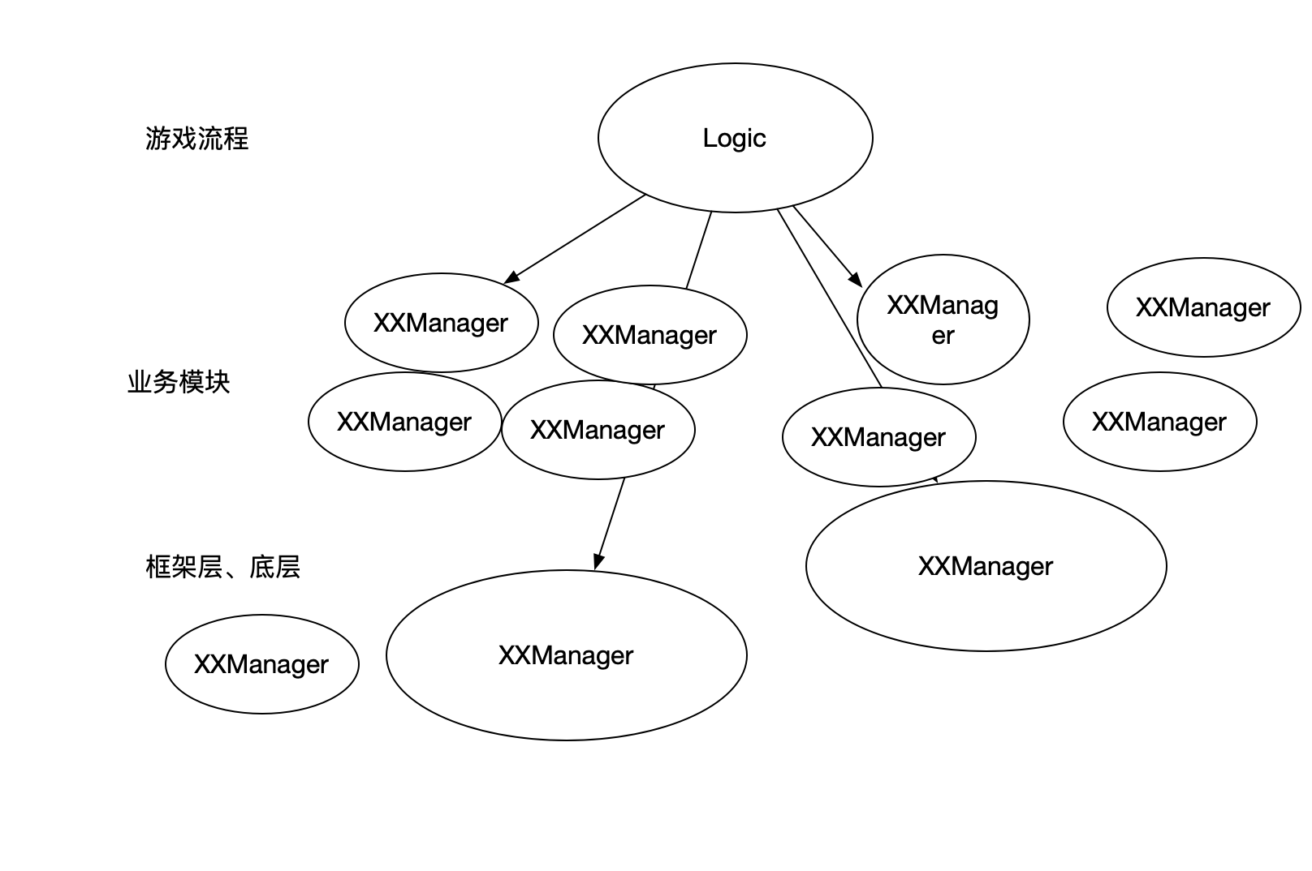

所以但项目规模一旦增多了之后，约定会越来越难以遵循，那么就需要将一部分约定通过技术实现，使约定变成限制。
现在我们可以使用约定和技术限制两个角度来分析下单例结构。
从约定上，来说，我们怎么约定都可以，而约定的图示，就是上边的图。那些分层都是一些抽象的概念，比如游戏流程、主逻辑层、业务模块、框架层、底层，这些都是约定的结构。一般都是存在于文档上，并不会通过技术手段表达。
而从技术限制这个角度来说，单例的访问是没有限制的，就算是用最佳实践，也是没有限制的。而且单例难以表达约定上的分层的那些概念，因为只要一个模块变成单例了，那么这个模块就在技术上失去了层次关系。
如下图所示：
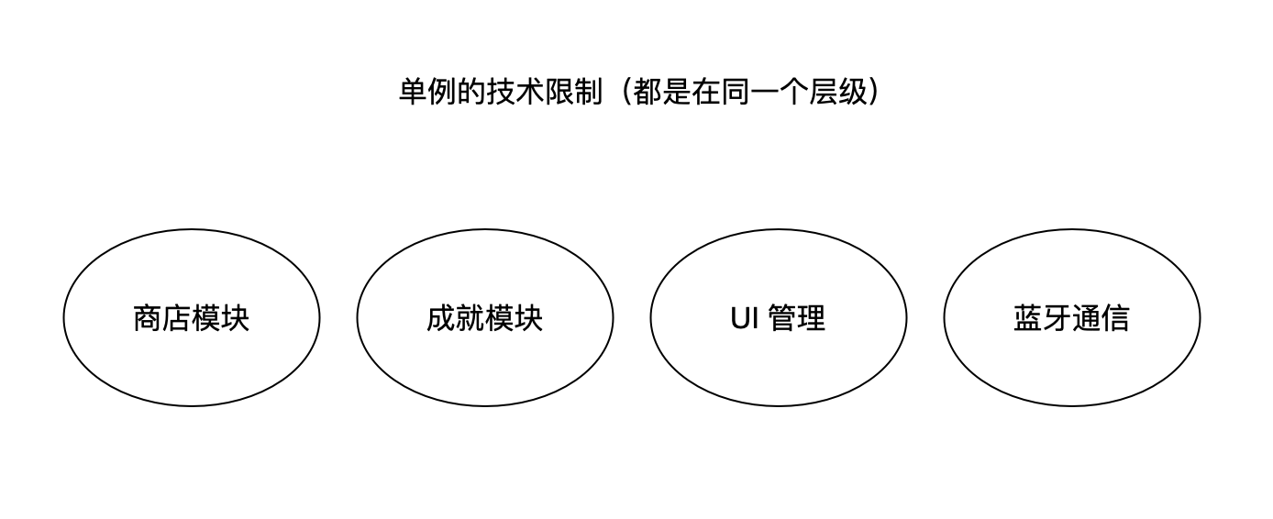

图中，在失去约定的情况下，商店模块居然与蓝牙通信模块是同一个层级，而商店模块在约定的结构上在蓝牙通信模块的上层，这就是单例结构的问题所在了。
即：使用单例时，项目结构的设计非常依赖于约定（文档等等）。
在项目规模比较少的时候，是没问题的，因为模块数量也比较少，但是一旦项目规模变大，模块数量变多，那么约定就会越来越难以遵循，就会非常容易导致项目结构的崩溃。
这个时候，怎么办呢？
解决方式很简单，就是最顶层的模块都用单例，然后一些底层模块，作为顶层模块的成员变量，从而达到逻辑层无法直接访问底层模块，而是必须通过顶层模块间接地使用底层模块的服务
如下图所示:
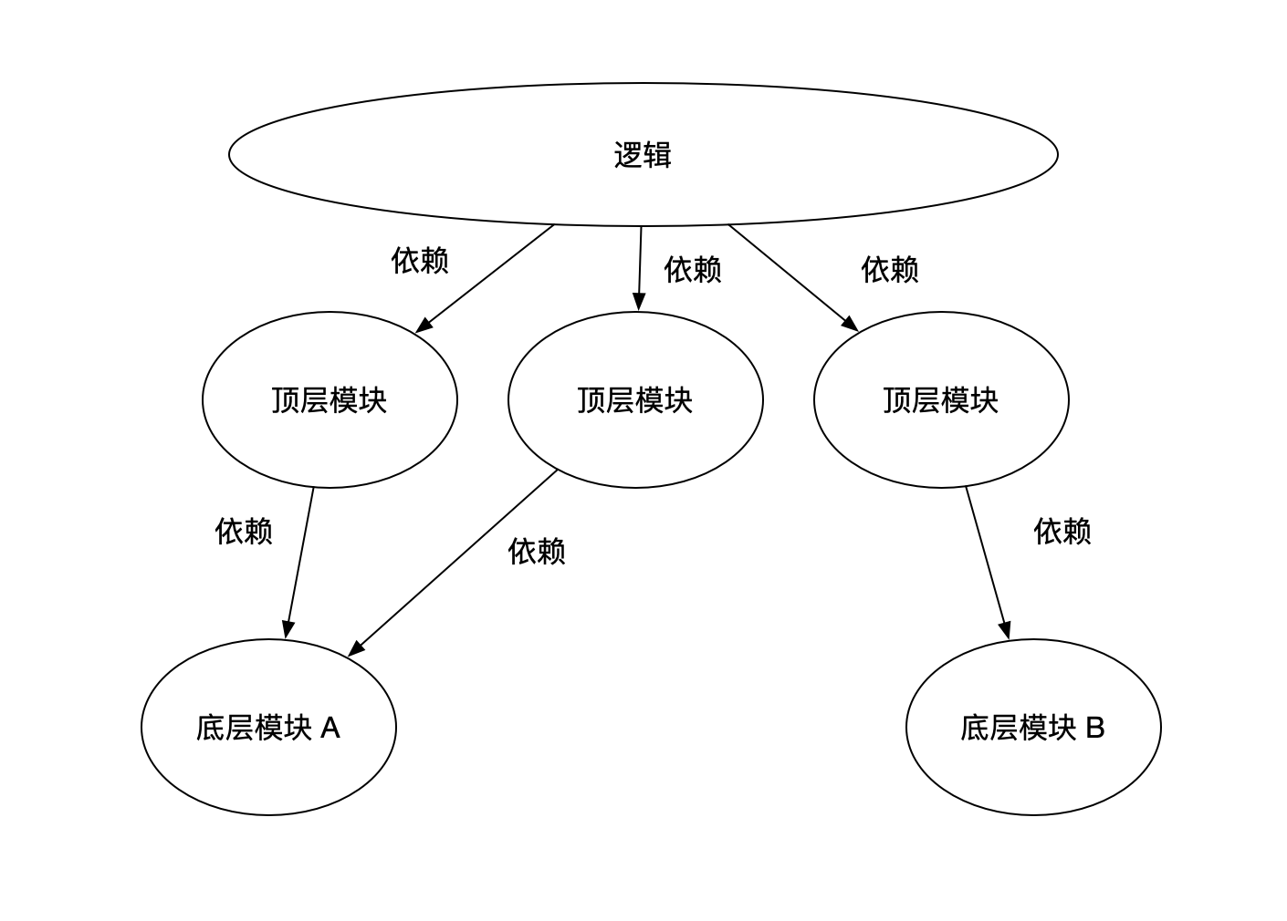

这样就解决了单例结构无法表达层级的问题，但是同时也失去了单例带来的种种好处，比如易扩展，维护性（模块独立）。
现在不容易扩展模块了，因为要扩展模块需要考虑依赖关系，也不容易维护了，因为模块不独立了。
而这里不容易维护指的是各个模块不容易单独维护了，但是整体项目会更容易维护。
那么有没有办法又可以让各个模块容易维护，也容易扩展，同时让整个项目也同样容易维护，而且可以通过技术限制来分担一部分约定呢？
答案当然是有的，就是我们现在正在学的，DI Container。
为什么 DI Container 是答案呢？如何做到的呢?
我们在下一篇介绍。
此篇的内容就这些。

知识地图
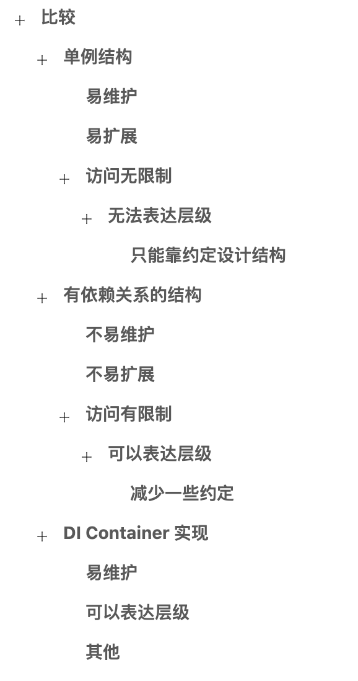

33. IOC（四）引入 DI Container 之后的结构
在上一篇，我们介绍了 DI Container 的职责 与 单例结构的利弊，在结尾提出了 DI Container 可以解决单例结构无法解决的问题。
在这一篇，我们介绍下 DI Container 如何提高维护性和扩展性，从而解决单例结构无法解决的问题。

依赖管理
我们先贴出来，上一篇文章所介绍的第二个结构，设置依赖关系的结构，如下图所示：
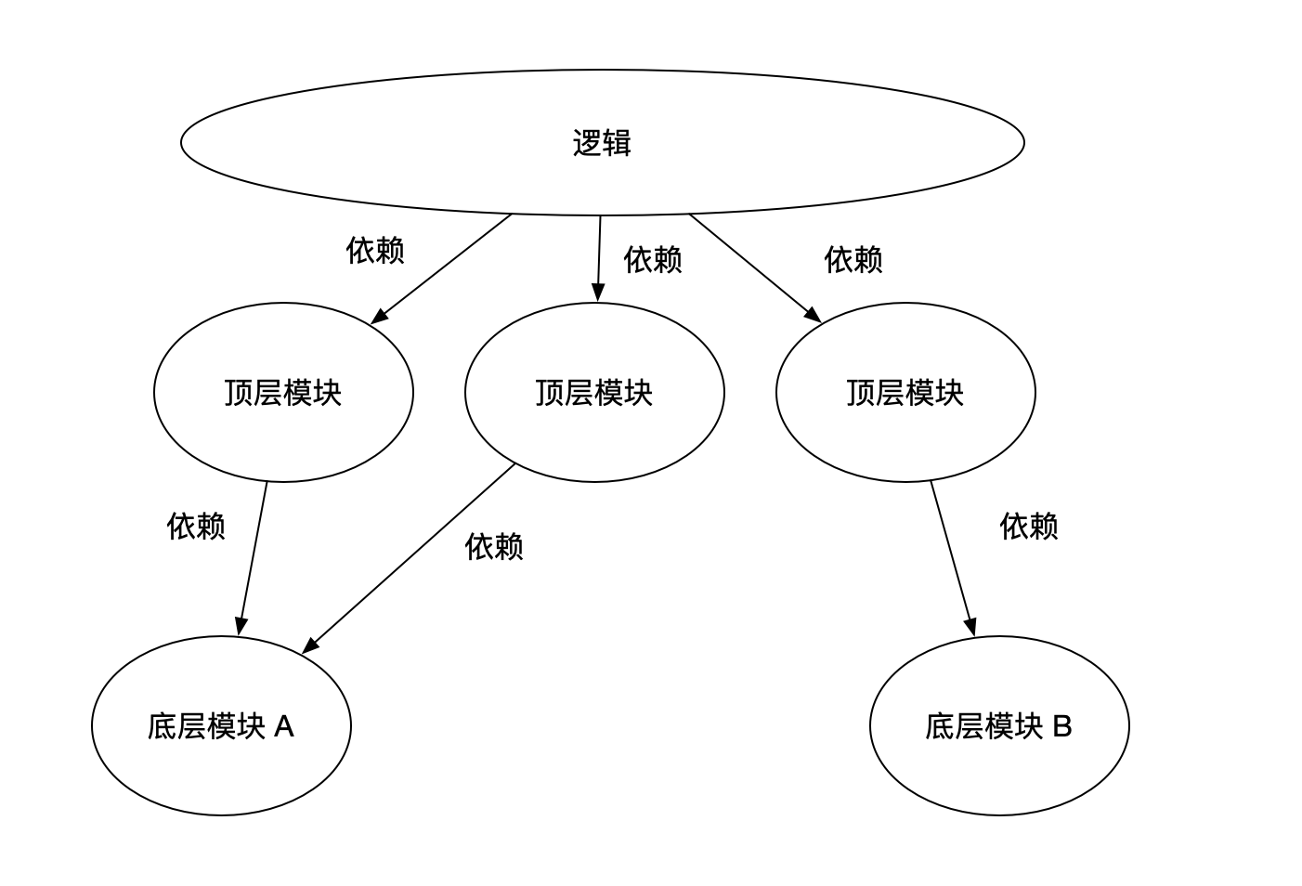

在这个结构中，出现了大量的依赖关系，这个依赖关系我们可以理解成对象的持有或者成员变量。
而事实上这些依赖关系造成了此结构的维护性和扩展性的降低。因为模块本身也是对象，是对象就有生命周期，那么何时去 new 对象就变得很重要。
我们先看如下代码:
public class ModuleA
{
public ModuleB ModuleB;
}
public class ModuleB
{
}
代码中 ModuleA 依赖了 ModuleB，那么在 ModuleA 内部使用 ModuleB 之前需要确保，成员变量 ModuleB 是有值的。
所以在使用之前我们要考虑 ModuleB 的一个创建过程。
而创建过程我们可以分为在 ModuleA 内部 和 在 Module A 外部两种情况。
先看在内部的情况，代码如下:
public class ModuleA
{
public ModuleB ModuleB = new ModuleB();
}
非常简单，但是如果 ModuleB 是共用的呢？这是在内部的创建对象的一个麻烦，这里麻烦是因为 ModuleB 是一个模块而不是一个简单的对象。
那么在再看在外部创建对象的情况，代码如下:
void main()
{
var moduleA = new ModuleA();
moduleA.ModuleB = new ModuleB();
}
这样看起来没问题，因为在外部创建过程中，我们非常清晰地知道，moduleA.ModuleB 是有实例的。
但是我们看下在 ModuleA 内部使用 ModuleB 时的情况，代码如下:
public class ModuleA
{
public ModuleB ModuleB;
...
void XXX()
{
ModuleB. // 在这里会想 ModuleB 到底有没有值？在哪里设置的值？
}
}
问题就是上图中的注释，总之，不管怎么样，依赖都要考虑一个创建过程。
假如直接用单例那就好说了，代码可能如下:
public class ModuleA
{
void XXX()
{
ModuleB.Instance.DoSomething();
}
}
使用单例就不用在 ModuleA 内内部去考虑创建过程。
OK，现在这种结构就是有大量的依赖，不易维护不易扩展也都出现在这个依赖上，因为依赖要考虑依赖对象的创建过程。
现在 DI Container 该登场了。
我们还记不记得 DI Container 的职责？
即：管理依赖、注入依赖。
而现在的结构有大量的依赖，那么这些依赖就应该好好被 DI Container 管管了。

使用 DI Container 管理依赖
我们还是用 ModuleA 和 ModuleB 举例子。
使用 DI Container 后，代码就会变成如下:
public class ModuleA
{
[Inject]
public ModuleB ModuleB {get;set;}
void XXX()
{
ModuleB.DoSomeThing(); // 放心用，因为不用考虑依赖的创建过程。
}
}
而在启动时，我们只需要统一注册依赖，代码如下:
public static QFrameworkContainer Container {get;private set;}
void Main()
{
Container = new Contaner();
Container.Register<ModuleB>();
}
在创建 ModuleA 对象时需要注入依赖。
void MethodA()
{
App.Container.Inject(new ModuleA());
}
使用 DIContainer 之后的我们的结构变成如下:
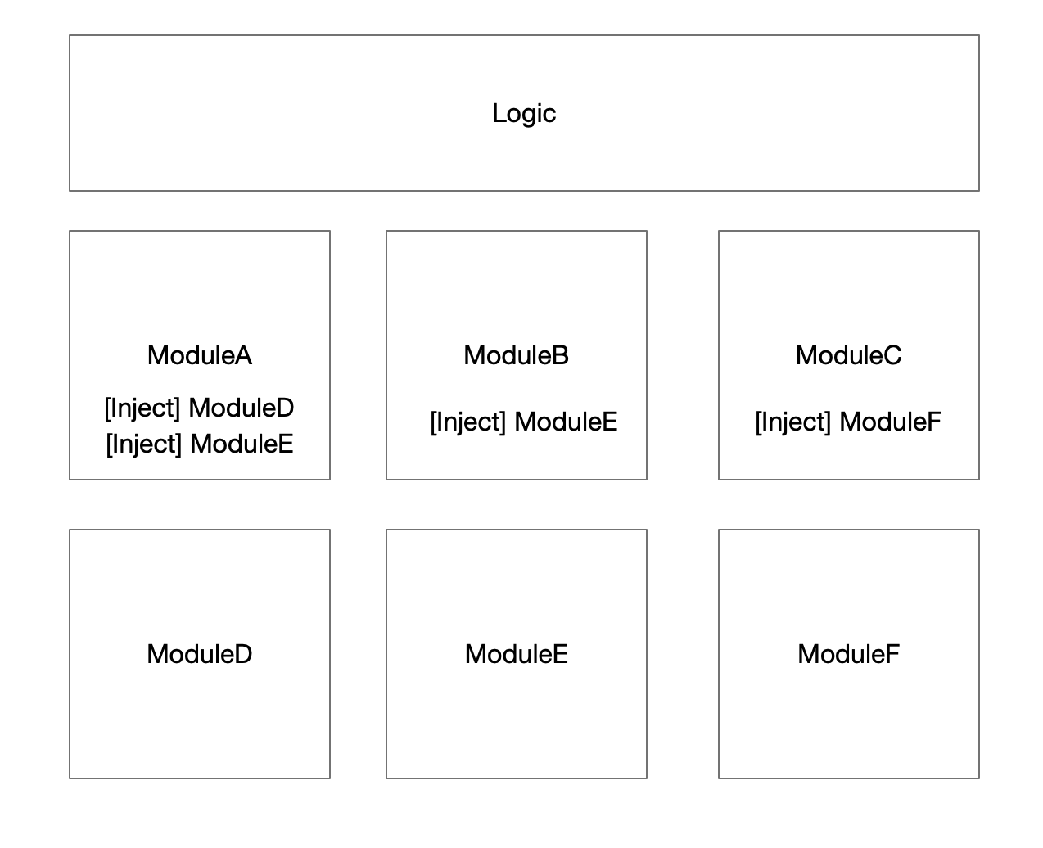

我们只需要，在模块内部声明模块作为变量，而不需要考虑创建过程，这样就导致每个模块都是可独立测试的（易维护），而扩展一个模块，不需要用单例实现，而是注册到类型容器即可，这样的话扩展一个模块比单例还容易。
这就是 DI Container 的最核心的优势。

设计依赖关系就是设计结构
从最开始的对象之间的交互，到单例模式，再到消息机制，都离不开一个概念，就是依赖这个概念。而实际上设计依赖关系就是在设计整个项目的结构，结构这个词其实就是架构，笔者不喜欢说架构这个词是因为这个词听起来太遥远太抽象太装x，所以比较喜欢说结构这个词。
这里想说什么呢？设计依赖关系实际上就是在做项目架构，而 DIContainer 有的时候被叫做架构工具，因为它可以让我们从依赖关系的角度去看待整个项目结构，而 DIContainer 又直接参与了依赖的管理，使我们能够去设计依赖关系，所以很多架构师都非常喜欢用 DIContainer。
很多大名鼎鼎的框架都大量使用了 DIContainer（依赖注入容器）。
比如 .Net Core(C#)、Spring(Java)、uFrame(Unity) 等等。
反正用惯了依赖注入容器，就再也不想回去了。
此篇的内容就这些。

知识地图
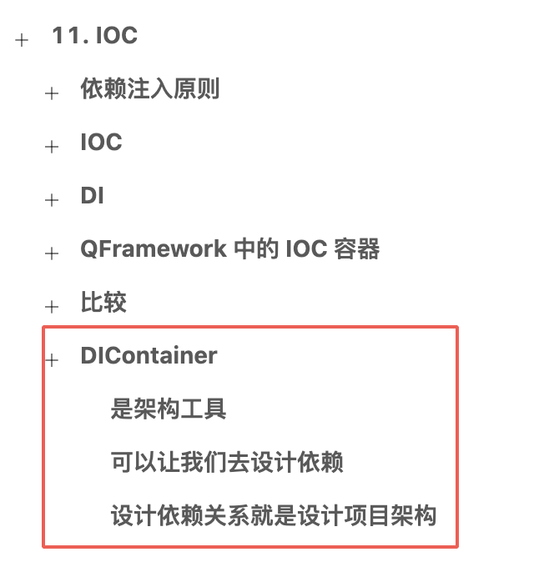

34. IOC（五）生命周期
在上一篇，我们了解了 DIContainer 的强大之处。
在这一篇，我们来了解 DIContainer 的一个基础知识，即：生命周期。

DIContainer 注入实例的声明周期
我们还记不记得之前我们遗留了一些问题，其中一个是：DIContainer 在 注入实例时，实例是每次注入创建新的还是永远返回同一个实例？
而这个问题所描述的行为指的是 DIContainer 的注入实例的生命周期。
即当 DIContainer 注入实例时，所注入实例的是新创建还是复用同一个实例？
在 QFramework DIContainer 方案中是这样的。
- 当注册依赖时，使用 Register() 方法时，每次注入都会创建新的实例，一般情况下管这种方式方式叫做 Transient(短暂的)。
- 当注册依赖时，使用 RegisterInstance(object obj) 方法时，每次注入都会使用 obj 实例，一般情况下管这种方式叫做 Singleton（单例）。
非常简单，我们写个测试代码，如下：
using System.Collections;
using System.Collections.Generic;
using UnityEngine;
namespace FrameworkDesign2021.Exmaple
{
public class SomeService
{
public void Description()
{
Debug.Log("SomeService:" + this.GetHashCode());
}
}
public class SomeObject
{
public void Description()
{
Debug.Log("SomeObject:" + this.GetHashCode());
}
}
public class IOCScopeExample : MonoBehaviour {
[Inject]
public SomeObject ObjA {get;set;}
[Inject]
public SomeObject ObjB {get;set;}
[Inject]
public SomeObject ObjC {get;set;}
[Inject]
public SomeService ServiceA {get;set;}
[Inject]
public SomeService ServiceB {get;set;}
void Start ()
{
var container = new QFrameworkContainer();
// 每次注入都创建新的实例
container.Register<SomeObject>();
// 每次注入都使用同一个实例
container.RegisterInstance(new SomeService());
// 注入
container.Inject(this);
ObjA.Description();
ObjB.Description();
ObjC.Description();
ServiceA.Description();
ServiceB.Description();
}
}
}
代码中分别使用不同的方式注册依赖，接着进行注入操作，最后将注入的实例分别打出各自的 HashCode。我们可以通过 HashCode 来判断两个变量是否是同一个对象。
将以上脚本挂到任意一个 GameObject 上，运行场景，得到结果如下:
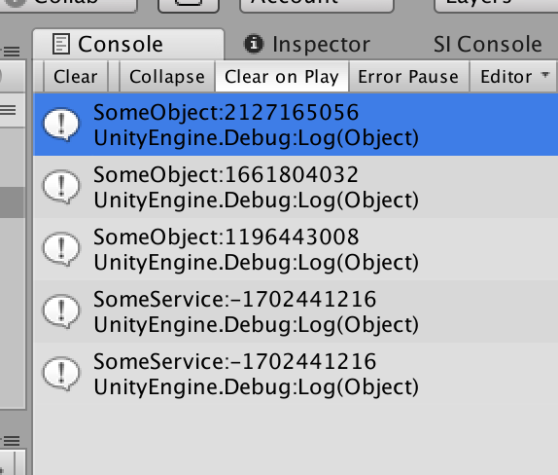

可以看到，三个 SomeObject 的 HashCode 不相同，而两个 SomeService 的 HashCode 相同。
说明通过 Register() 注册的依赖，每次注入时创建新的实例，而通过 RegisterInstance(object obj) 注册的依赖，每次注入都返回同一个 obj 实例。
这就是 DIContainer 注入实例的生命周期。
总结如下：
- Register，每次注入时创建新的实例。
- RegisterInstance(object obj)，每次注入时，返回同一个 obj 对象。
此篇的内容就这些。

知识地图
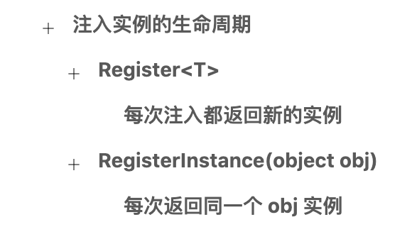

35. IOC（六）依赖倒置原则
在上一篇，我们了解了 DIContainer 的生命周期的概念及使用。
在这一篇，我们来聊聊与依赖注入永远离不开的原则，即依赖倒置原则。

依赖倒置原则
依赖倒置原则，即：Dependency Inversion Principle，很多时候缩写成 DIP。
这个原则包含了两个主题：
- 高层模块不应该依赖于低层模块，两者都应该依赖于抽象概念。
- 抽象接口不应该依赖于实现，而实现依赖于抽象接口
我们先说说第一个主题。

高层模块不应该依赖于低层模块，两者都应该依赖于抽象概念。
什么意思呢？
我们举个简单的例子,即司机开车的例子。
代码如下:
public class Driver
{
// 司机的职责是开车
public void Drive(Benz benz)
{
benz.Run();
}
}
public class Benz
{
public void Run()
{
Debug.Log("奔驰汽车开始运行")
}
}
void Main()
{
var lucas = new Driver();
var benz = new Benz();
lucas.Drive(benz);
}
这是一个开车的例子，非常简单，大家应该都能看懂代码。
目前 liangxie 负责开发并维护 Driver 类，诗远童鞋负责开发并维护 Benz 类。
现在突然得到一个新的需求，说 lucas 换车了，换成了宝马，需要我们再创建一个 BMW 类。
要实现也比较简单，不过这里有一个问题，Driver 类是 liangxie 负责的，而 Benz 类是诗远负责的，现在当再创建一个 BMW 类之后，Driver 类中的 Drive 方法参数需要从 Benz 改成 BMW 变量。
这样就造成了一个简单的扩展，却造需要 liangxie 和 诗远同时改代码。这就说明 Driver 类与 Benz 类耦合太强了。
而目前的类的依赖关系是，Driver 类依赖于 Benz 类，这里要注意一下，在之前我们理解的依赖是持有对象的意思，而现在依赖的意思需要增加一条，即，A 依赖 B，说明 A 需要 B 才能完成自身的职责。换成人话就是司机需要车才能当司机，所以司机依赖车。
这里我们对依赖这个概念的理解进行了升级。
OK，所以现在时候 Driver 类依赖 Benz 类，大家应该都理解了。
接着我们要解决当前 Driver-Benz 结构的扩展问题，即如何减少耦合从而使其易扩展？
答案就是此小节的标题:高层模块不应该依赖于低层模块，两者都应该依赖于抽象概念。
应用在 Driver-Benz 结构的话是这样的，Driver 模块不应该依赖于 Benz 模块，两者都依赖于抽象概念。
也就是说，Driver 不要依赖于 Benz 模块了，而都应该依赖于抽象概念，这里抽象概念可以是接口或者是抽象类。
OK，我们试着改进，当前的代码，改进后代码如下:
public class Driver
{
// 司机的职责是开车
public void Drive(ICar car)
{
car.Run();
}
}
public interface ICar
{
void Run();
}
//public class Benz : ICar
//{
// public void Run()
// {
// Debug.Log("奔驰汽车开始运行")
// }
//}
public class BMW : ICar
{
public void Run()
{
Debug.Log("宝马汽车开始运行")
}
}
void Main()
{
var lucas = new Driver();
var bmw = new BMW();
lucas.Drive(bmw);
}
代码中，Driver 与 BMW 中间，多了一个 ICar 接口。
Driver 不直接依赖 BMW，而依赖于 ICar。
BMW 实现 ICar 接口，是 ICar 的具体实现。
这样的话，我们提高了当前的结构的扩展性，减少了 Driver 与 BMW 之间的耦合。
实际上，要完全实现”高层模块不应该依赖于低层模块，两者都应该依赖于抽象概念“这一个主题的话，Driver 类也应该抽象出来一个 IDriver，不过对于目前的结构来说没有必要。
相信通过这个例子理解了，为什么”高层模块不应该依赖于低层模块，两者都应该依赖于抽象概念”。
大概也能推理出来，依赖倒置原则所解决的问题。
接着我们说第二个主题： 抽象接口不应该依赖于实现，而实现依赖于抽象接口。

抽象接口不应该依赖于实现，而实现依赖于抽象接口
抽象接口不应该依赖于实现，而实现依赖于抽象接口。
我们还用 Driver-Benz 结构。
套用到此主题的描述之后是这样的，ICar 不应该依赖于 BMW，而 BMW 依赖于 ICar。
这个如何实现呢，其实非常简单，使用面向对象中的多态很容易实现此主题。
代码如下:
var lucas = new Driver();
ICar car = new BMW();
lucas.Drive(car);
其中的 ICar car = new BMW() 就实现了“实现依赖于抽象接口”这一主题。
依赖这个概念需要再次更新了，上文中说到司机需要车才能当好司机，所以司机依赖车，那么现在 BMW 需要实现 ICar 接口，才能正常使用，那么 BMW 类依赖 ICar 接口，（实现依赖抽象接口)。
依赖概念的最新理解，就是两个字，需要，关于依赖概念的升级就到这里。
实际上依赖倒置原则的两个主题都在说一件事情，两个类之间的交互通过抽象（接口、抽象类）来完成。
而通过一个抽象，可以将两个类的变化隔离。即 A 类修改或扩展甚至是替换都不影响 B，反过来也是如此。
通过依赖倒置原则可以提高整个系统的灵活性和扩展性还有维护性。
最后做一个小结。

小结
- 依赖倒置原则的核心就是面向抽象(抽象类或者接口)编程
- 依赖倒置原则催生出一个概念，面向接口编程。
关于依赖倒置原则就介绍到这里。
到这里，大家可能会问依赖倒置原则与 DIContainer 有什么关系呢，两者都有个依赖这个词，会不会有所关联呢？
我们在下一篇继续介绍。
此篇的内容就这些。

知识地图
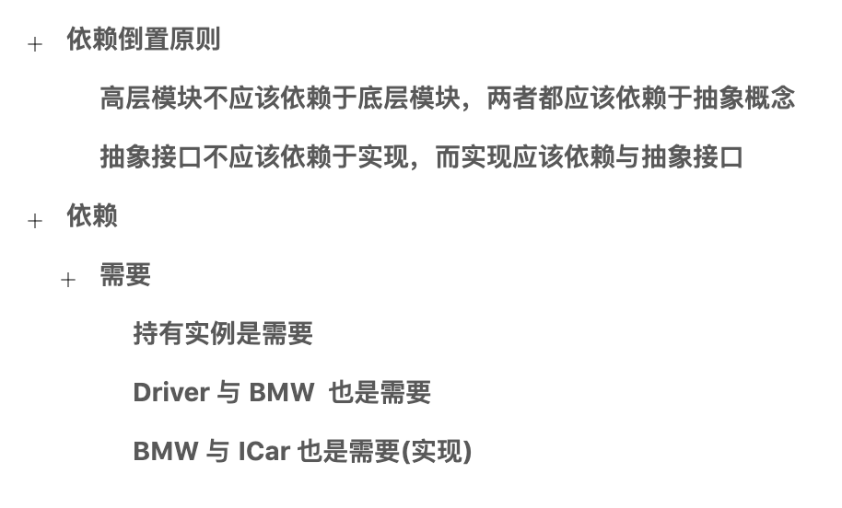

36. IOC（七）通过 DIContainer 实现 DIP
在上一篇，我们花了一整篇的篇幅来介绍依赖倒置原则。
在这一篇，我们通过 DIContainer 来实现 DIP（依赖注入原则）.。

更新后的依赖概念
依赖这个概念在上一篇进行了两次更新，最终版本为：依赖=需要。
这个需要包含了很多关系，即实现接口是依赖关系，持有对象也是依赖关系，司机与车也是依赖关系。
而 IOCKit 中的 DIContainer 支持前两种依赖管理，而市面上有个 IOC 容器，叫做 Zenject，支持以上全部的依赖关系。
接下来我们来看下 IOC 中的 DIContainer 如何支持实现接口的这种依赖。

DIContainer 中的接口依赖管理
我们有说过在注册依赖的时候 DIContainer 提供了两个 API，即 Register 与 RegisterInstance，两者提供了不同的注入时创建实例的行为。
实际上这两者都有一些重载，即支持接口依赖的注册。
我们直接看其测试代码，如下:
using System.Collections;
using System.Collections.Generic;
using UnityEngine;
namespace FrameworkDesign2021.Example
{
public interface ILoginService
{
void Login();
}
public class LoginService : ILoginService
{
public void Login()
{
Debug.Log("登录成功");
}
}
public class IOCInterfaceExample : MonoBehaviour
{
[Inject]
public ILoginService LoginService {get;set;}
void Start ()
{
var container = new QFrameworkContainer();
container.RegisterInstance<ILoginService>(new LoginService());
// Register 也支持注册接口依赖
//container.Register<ILoginService,LoginService>();
container.Inject(this);
LoginService.Login();
}
}
}
代码很简单，代码中可以根据接口注入具体的示例，使脚本可以依赖 ILoginService 接口而不依赖于 LoginService 类。
非常简单。
此篇的内容就这些。

知识地图
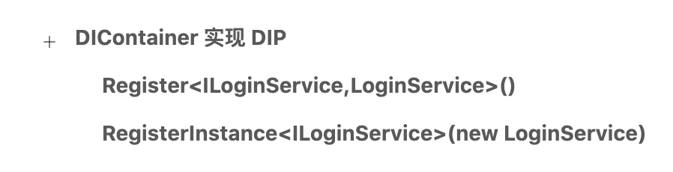

37. IOC（八）控制反转
在上一篇，我们介绍了通过 DIContainer 实现 DIP（依赖倒置原则）。
在这一篇，我们来聊聊 IOC 的最后一个话题：控制反转。

控制反转
到此，我们接触了依赖倒置原则，依赖注入方案，在了解了这两个概念后，我们理解控制反转会更容易一点。
有控制反转，就有控制正转，我们先说说控制正转。
public class ModuleA
{
public ModuleB B = new ModuleB();
}
public class ModuleB
{
}
代码中,ModuleB 对象的创建过程在 ModuleA 内部完成，这就是控制正转，或者说就是正常的控制过程，因为没有正转这个词。以上代码就是在表示一般情况下我们如何实现 ModuleA 对 ModuleB 的依赖。
其中的控制是什么意思呢？这里的控制意思是依赖对象创建过程的控制。
即：以上代码中， B 对象的创建过程的控制。
而以上代码中，是正常的控制，也就是说 B 对象的创建过程是由 ModuleA 控制的。
那么控制反转则很容易理解，就是 B 对象的创建过程由外部控制，所以就”反转了“
控制反转的例子如下:
public class ModuleA
{
public ModuleB B;
}
public class ModuleB
{
}
void Main()
{
var moduleA = new ModuleA();
// 对象创建过程由外部控制
moduleA.B = new ModuleB();
}
非常简单。
控制反转意思是类依赖对象创建的过程由外部控制，而不是在类内部控制。

依赖注入 与 控制反转
控制反转：依赖对象的创建过程交给外部控制。
依赖注入：依赖对象在外部进行设置。
控制反转是设计原则，或者说是设计模式，而依赖注入是控制反转的具体实现。
控制反转的具体实现除了有常用的依赖注入还有一种方案叫依赖查找，这里我们不介绍。
控制反转和依赖注入有一些细微的差别，控制反转的重点在于依赖对象创建过程的控制，而依赖注入的重点在于依赖对象如何设置，实际上这两个概念都在说，依赖对象的创建和设置都在外边搞，不要在类内部搞。

小结
到这里，我们只要记住，控制反转的理解即可：依赖对象的创建过程交给外部控制。

知识地图
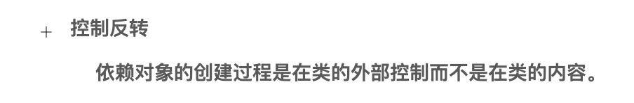

38. IOC（九）小结
在上一篇，我们简单聊了聊控制反转这个概念。
在这一篇，我们做一个小结。

小结
在 IOC 的专题中，我们接触了一些理论概念，如下：
- 依赖注入
- 依赖倒置原则
- 控制反转
除了接触概念，也做了一些实践，如下：
- IOCKit 的基本使用
- IOCKit 改进使用单例结构的项目
- IOCKit 实现 DIP
到此，关于 IOC 这个话题的必要的基础知识我们都接触过了。
而 IOC 概念则是框架搭建系列的一个里程碑的节点，因为在接触 IOC 之后，大家可以基于 IOC 做很多很多的事情，大家的设计水平也会达到一个优秀的水平。
OK，小结就说到这里。

知识地图
11. IOC
- IOC
  - 是一个设计思想
- DI
  - 是 IOC 的一个实现
  - 依赖
    - 对象的持有
  - 注入
    - 给成员变量设置值
  - 依赖注入
    - 给对象的成员变量设置值
- QFramework 中的 IOC 容器
  - 基本使用
- 比较
  - 单例结构
    - 易维护
    - 易扩展
    - 访问无限制
      - 无法表达层级
        - 只能靠约定设计结构
  - 有依赖关系的结构
    - 不易维护
    - 不易扩展
    - 访问有限制
      - 可以表达层级
        - 减少一些约定
  - DI Container 实现
    - 易维护
    - 可以表达层级
    - 其他
- DIContainer
  - 是架构工具
  - 可以让我们去设计依赖
  - 设计依赖关系就是设计项目架构
- 注入实例的生命周期
  - Register
    - 每次注入都返回新的实例
  - RegisterInstance(object obj)
    - 每次返回同一个 obj 实例
- 依赖倒置原则
  - 高层模块不应该依赖于底层模块，两者都应该依赖于抽象概念
  - 抽象接口不应该依赖于实现，而实现应该依赖与抽象接口
- 依赖
  - 需要
    - 持有实例是需要
    - Driver 与 BMW 也是需要
    - BMW 与 ICar 也是需要(实现)
- DIContainer 实现 DIP
  - Register<ILoginService,LoginService>()
  - RegisterInstance(new LoginService)
- 控制反转
  - 依赖对象的创建过程是在类的外部控制而不是在类的内容。

39. 简易 IOC 容器（一）简介
从这一堂课开始，我们利用反射的知识，来实现一个简单的 IOC 容器。

简易 IOC 容器 功能分析
一般的 IOC 容器会包含以下 3 个功能:
- 注册依赖（Register）
  - 注册为单例
  - 注册抽象-实体 依赖
- 获取对象（Resolve）
- 注入（Inject）
而每个功能，会有大量的细节特性可以支持，比如注册类依赖可以只是注册为单例等等。
总之，一个简易的 IOC 容器应该至少包含以上的功能。
所以笔者在接下来的内容中，会一一实现它们。
首先我们创建一个接口，在接口中，定义好以上功能，如下:
namespace Master.Example
{
public interface ISimpleIOC
{
/// <summary>
/// 简单注册类型
/// </summary>
/// <typeparam name="T"></typeparam>
void Register<T>();
/// <summary>
/// 注册为单例
/// </summary>
/// <param name="instance"></param>
/// <typeparam name="T"></typeparam>
void RegisterInstance<T>(object instance);
/// <summary>
/// 注册依赖
/// </summary>
/// <typeparam name="TBase"></typeparam>
/// <typeparam name="TConcrete"></typeparam>
void Register<TBase, TConcrete>() where TConcrete : TBase;
/// <summary>
/// 获取实例
/// </summary>
/// <typeparam name="T"></typeparam>
T Resolve<T>();
/// <summary>
/// 注入
/// </summary>
/// <param name="obj"></param>
void Inject(object obj);
}
}
接着，我们再创建一个具体类，来实现 ISimpleIOC 接口，如下:
namespace Master.Example
{
public class SimpleIOC : ISimpleIOC
{
public void Register<T>()
{
throw new System.NotImplementedException();
}
public void RegisterInstance<T>(object instance)
{
throw new System.NotImplementedException();
}
public void Register<TBase, TConcrete>() where TConcrete : TBase
{
throw new System.NotImplementedException();
}
public T Resolve<T>()
{
throw new System.NotImplementedException();
}
public void Inject(object obj)
{
throw new System.NotImplementedException();
}
}
}
接着我们写下第一个单元测试文件，如下:
using Master.Example;
using NUnit.Framework;
namespace SimpleIOCTests
{
public class SimpleIOCTesting
{
[Test]
public void SimpleIOCRegisterResolveTest()
{
var simpleIOC = new SimpleIOC();
simpleIOC.Register<SimpleIOC>();
var obj = simpleIOC.Resolve<SimpleIOC>();
// 是否创建了实例
Assert.IsNotNull(obj);
// 不相同 说明是 创建了实例
Assert.AreNotEqual(simpleIOC, obj);
}
}
}
单元测试文件的位置如下:
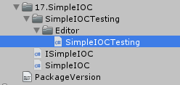

注意，单元测试文件一般都会写在 Editor 文件中。
接着我们运行单元测试，
打开单元测试的位置在：Windows/General/Test Runner 中。
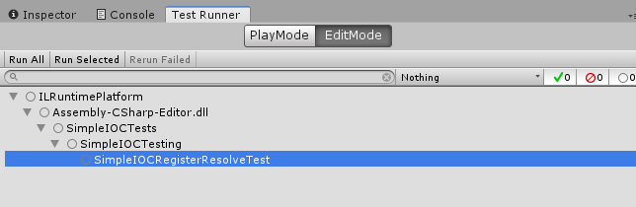

双击选中的单元测试或点击 Run Selected 就可以运行测试，结果如下:
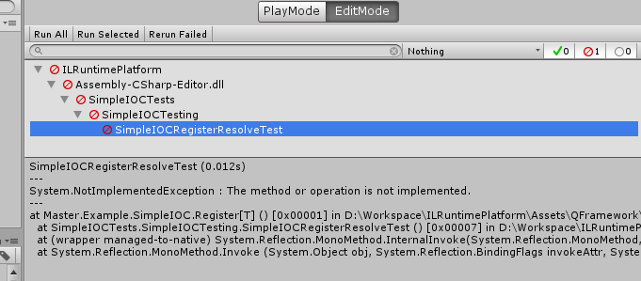

结果肯定是报错了。
那么，我们在下一篇来解决这个问题。
此篇内容就这些。

知识地图
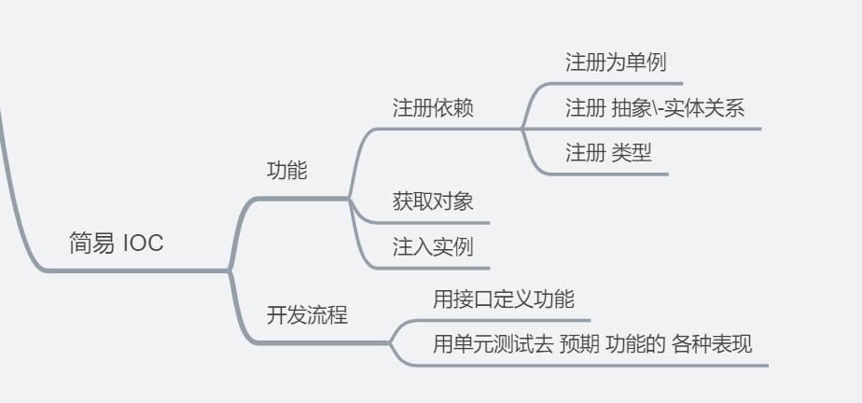

40. 简易 IOC 容器（二）通过第一个单元测试
在上一篇，我们分析好了 IOC 容器的功能，定义好了接口，并且也编写好了单元测试。
在此篇，我们来实现通过第一个单元测试。
我们先看下单元测试的代码:
using Master.Example;
using NUnit.Framework;
namespace SimpleIOCTests
{
public class SimpleIOCTesting
{
[Test]
public void SimpleIOCRegisterResolveTest()
{
var simpleIOC = new SimpleIOC();
simpleIOC.Register<SimpleIOC>();
var obj = simpleIOC.Resolve<SimpleIOC>();
// 是否创建了实例
Assert.IsNotNull(obj);
// 不相同 说明是 创建了实例
Assert.AreNotEqual(simpleIOC, obj);
}
}
}
单元测试描述了我们希望预期的功能，这是单元测试的第一个作用。
我们来尝试把这个单元测试通过了。
首先 SimpleIOC 可以注册类型，并且根据注册的类型来创建实例。
这个功能非常简单，直接实现就就好了，代码如下：
using System;
namespace Master.Example
{
public class SimpleIOC : ISimpleIOC
{
// 只要注释掉就好
public void Register<T>()
{
// throw new System.NotImplementedException();
}
public void RegisterInstance<T>(object instance)
{
throw new System.NotImplementedException();
}
public void Register<TBase, TConcrete>() where TConcrete : TBase
{
throw new System.NotImplementedException();
}
// 通过反射创建就好
public T Resolve<T>()
{
return Activator.CreateInstance<T>();
}
public void Inject(object obj)
{
throw new System.NotImplementedException();
}
}
}
代码很简单，虽然有一大堆的问题，但是最起码我们的单元测试时可以通过的。
我们来运行单元测试，结果如下:
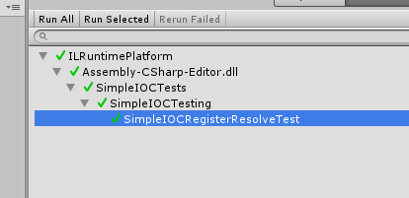

OK，测试通过了。
这样第一个功能就完成了。
不过这有很多的漏洞，比如我们再写一个单元测试，来预测，是否是创建了一注册的类型。
代码如下：
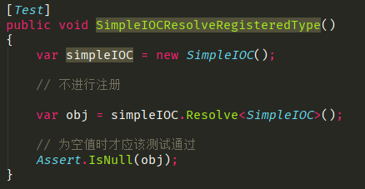

结果如下:
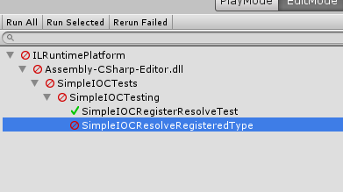

接下来我们要做的就是把这个测试通过了。
实现也很简单，代码如下:
using System;
using System.Collections.Generic;
namespace Master.Example
{
public class SimpleIOC : ISimpleIOC
{
HashSet<Type> RegisteredType = new HashSet<Type>();
public void Register<T>()
{
RegisteredType.Add(typeof(T));
}
...
public T Resolve<T>()
{
var type = typeof(T);
if (RegisteredType.Contains(type))
{
return Activator.CreateInstance<T>();
}
return default;
}
...
}
}
维护一个 存储 Type 的 HashSet 就好，HashSet 中存储的是不重复的类型。
OK，我们运行如下单元测试：

结果如下:
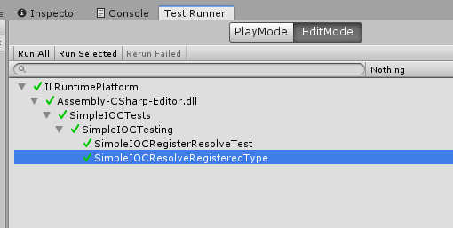

OK，我们使用单元测试实现了简易 IOC 的两个小小的功能。
此篇内容就这些。

知识地图
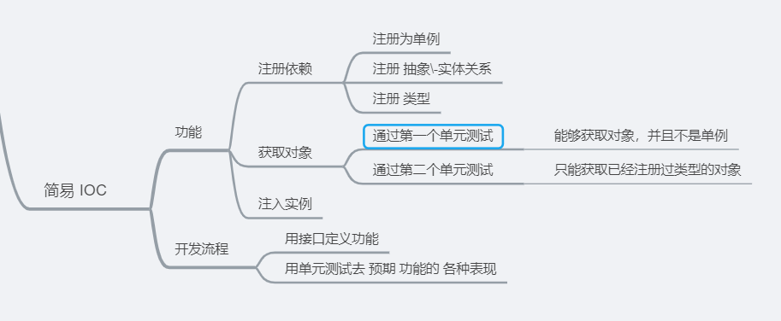

41. 简易 IOC 容器（三）注册为 Instance
在上一篇，我们通过了两个单元测试，如下:
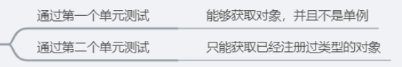

在此篇，我们接着往下开发 简易 IOC 容器。

第三个单元测试
第三个单元从测试很简单，就是测试 SimpleIOC 重复注册。
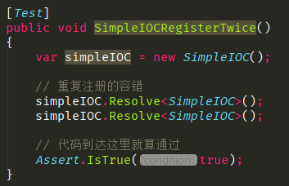

这个测试时直接可以通过的，因为 HasSet 可以添加重复的值。
OK，我们再写下一个功能，注册为 Instance。
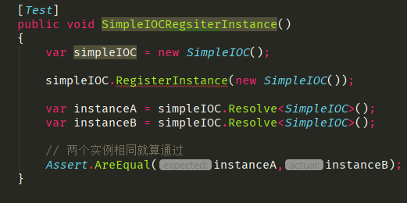

到这里我们发现 RegisterInstance 没有不传入泛型版本，我们只有如下方法:
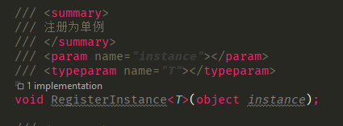

所以在接口处，我们需要定义一个新的方法，如下:
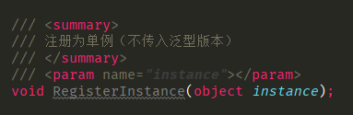

而实现也比较简单， 这次我们把所有的功能都实现好，代码如下:
using System;
using System.Collections.Generic;
namespace Master.Example
{
public class SimpleIOC : ISimpleIOC
{
HashSet<Type> RegisteredType = new HashSet<Type>();
// 用来存储 Instance 的字典
Dictionary<Type,object> mInstances = new Dictionary<Type, object>();
public void Register<T>()
{
RegisteredType.Add(typeof(T));
}
public void RegisterInstance(object instance)
{
var type = instance.GetType();
mInstances.Add(type,instance);
}
...
public T Resolve<T>() where T : class
{
var type = typeof(T);
if (mInstances.ContainsKey(type))
{
return mInstances[type] as T;
}
if (RegisteredType.Contains(type))
{
return Activator.CreateInstance<T>();
}
return default;
}
...
}
}
代码很简单，就是简单的字典管理。
我们运行单元测试:
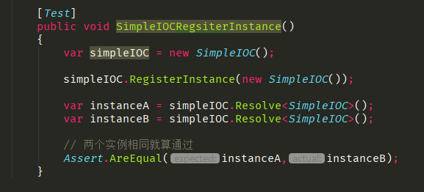

测试结果如下:
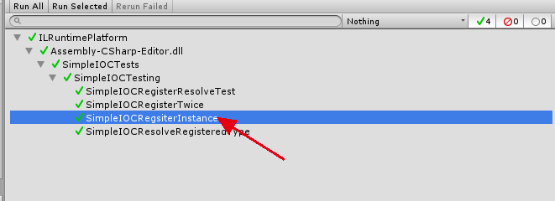

OK，到此，关于注册 Instance 的功能就实现了。
此篇的内容就这些。

知识地图
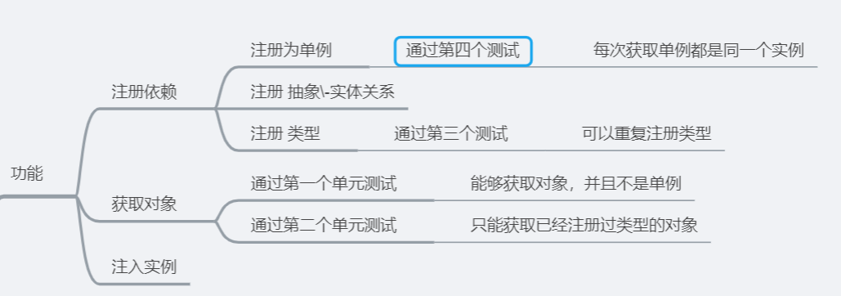

42. 简易 IOC 容器（四）注册依赖
在上一篇，我们完成了注册为 Instance 这样的功能。
在接下来，我们来尝试实现 依赖注册的功能。

依赖注册功能实现
依赖注册的功能描述如下:
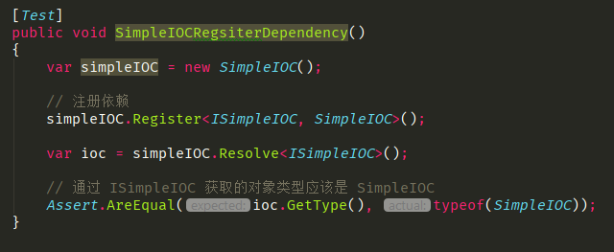

实现也非常简单，代码如下:
using System;
using System.Collections.Generic;
namespace Master.Example
{
public class SimpleIOC : ISimpleIOC
{
HashSet<Type> RegisteredType = new HashSet<Type>();
// 用来存储 Instance 的字典
Dictionary<Type,object> mInstances = new Dictionary<Type, object>();
Dictionary<Type,Type> mDependency = new Dictionary<Type, Type>();
...
public void Register<TBase, TConcrete>() where TConcrete : TBase
{
var concreteObj = typeof(TConcrete);
var baseObj = typeof(TBase);
mDependency.Add(baseObj, concreteObj);
}
public T Resolve<T>() where T : class
{
var type = typeof(T);
if (mInstances.ContainsKey(type))
{
return mInstances[type] as T;
}
if (mDependency.ContainsKey(type))
{
// 转换 BaseType 为 ConcreteType
return Activator.CreateInstance(mDependency[type]) as T;
}
if (RegisteredType.Contains(type))
{
return Activator.CreateInstance<T>();
}
return default;
}
...
}
}
接着我们运行测试，测试如下:
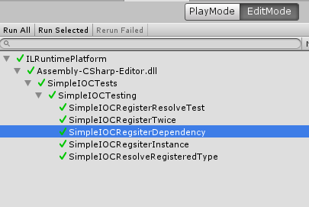

OK，此篇的内容就这些。

知识地图
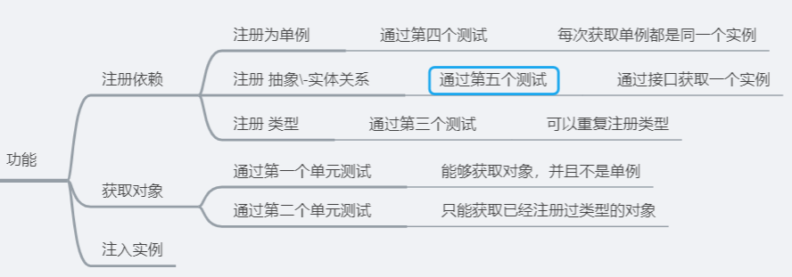

43. 简易 IOC 容器（五）注册依赖 Instance
在上一篇，我们通过单元测试实现了 注册依赖 功能。
在这一篇，我们通过单元测试来实现 注册依赖的功能。
我们写给出功能描述:
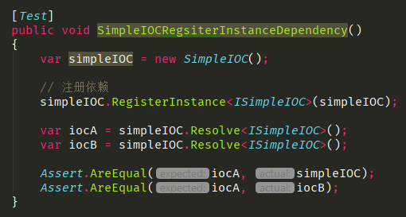

代码的实现非常简单，如下所示:
using System;
using System.Collections.Generic;
using UnityEngine;
namespace Master.Example
{
public class SimpleIOC : ISimpleIOC
{
HashSet<Type> RegisteredType = new HashSet<Type>();
// 用来存储 Instance 的字典
Dictionary<Type,object> mInstances = new Dictionary<Type, object>();
Dictionary<Type,Type> mDependency = new Dictionary<Type, Type>();
...
public void RegisterInstance<T>(object instance)
{
var type = typeof(T);
mInstances.Add(type, instance);
}
...
public T Resolve<T>() where T : class
{
var type = typeof(T);
if (mInstances.ContainsKey(type))
{
return mInstances[type] as T;
}
if (mDependency.ContainsKey(type))
{
// 转换 BaseType 为 ConcreteType
return Activator.CreateInstance(mDependency[type]) as T;
}
if (RegisteredType.Contains(type))
{
return Activator.CreateInstance<T>();
}
return default;
}
...
}
}
测试如下:
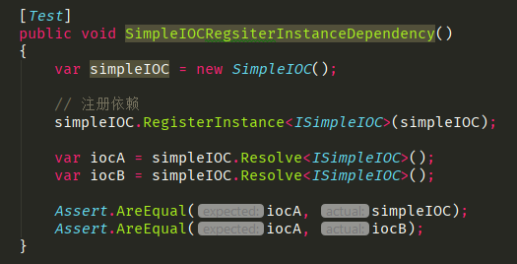

结果如下：
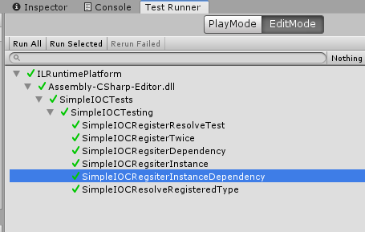

此篇内容就这些。

知识地图
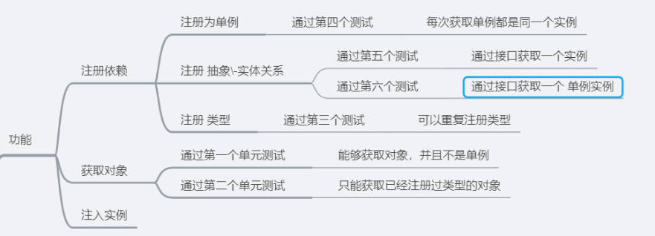

44. 简易 IOC 容器（六）注入实例实现
在上一篇，我们完成了 注册依赖单例的功能。
在此篇，我们来实现注入实例功能。

注入实例功能实现
描述如下:
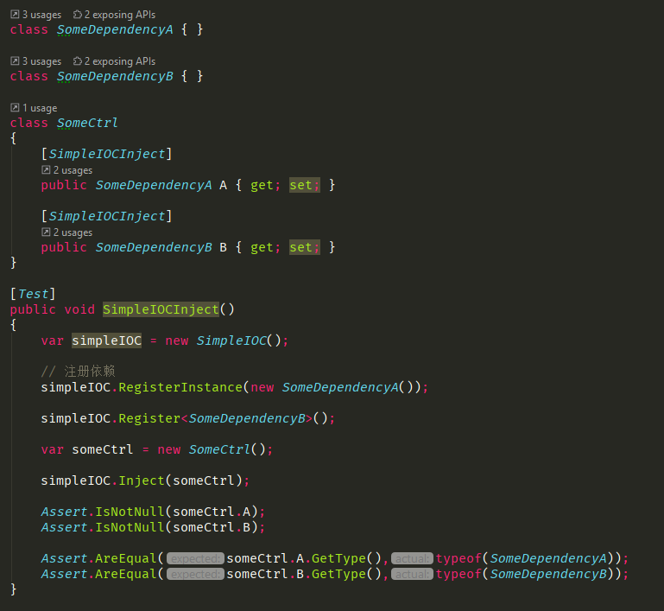

代码如下:
using System;
using System.Collections.Generic;
using System.Linq;
using System.Reflection;
using UnityEngine;
namespace Master.Example
{
public class SimpleIOCInject : Attribute
{
}
public class SimpleIOC : ISimpleIOC
{
...
public T Resolve<T>() where T : class
{
var type = typeof(T);
return Resolve(type) as T;
}
// 把原来的 T Resolve<T>() 中的根据类型创建实例的部分提取了出来，提供给 Inject 调用
object Resolve(Type type)
{
if (mInstances.ContainsKey(type))
{
return mInstances[type];
}
if (mDependency.ContainsKey(type))
{
// 转换 BaseType 为 ConcreteType
return Activator.CreateInstance(mDependency[type]);
}
if (RegisteredType.Contains(type))
{
return Activator.CreateInstance(type);
}
return default;
}
public void Inject(object obj)
{
foreach (var propertyInfo in obj.GetType().GetProperties()
.Where(p => p.GetCustomAttributes(typeof(SimpleIOCInject)).Any()))
{
var instance = Resolve(propertyInfo.PropertyType);
if (instance != null)
{
propertyInfo.SetValue(obj, instance);
}
else
{
Debug.LogErrorFormat("不能获取类型为:{0} 的对象", propertyInfo.PropertyType);
}
}
}
}
}
代码涉及到了反射部分，如果跟不上基础的童鞋可以看下 C# 中毒专栏。
我们看下测试结果:
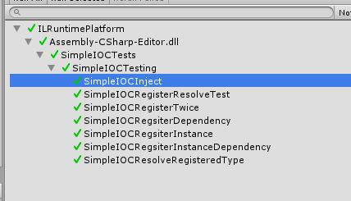

这样，注入的功能就实现了。
此篇的内容就这些。

知识地图
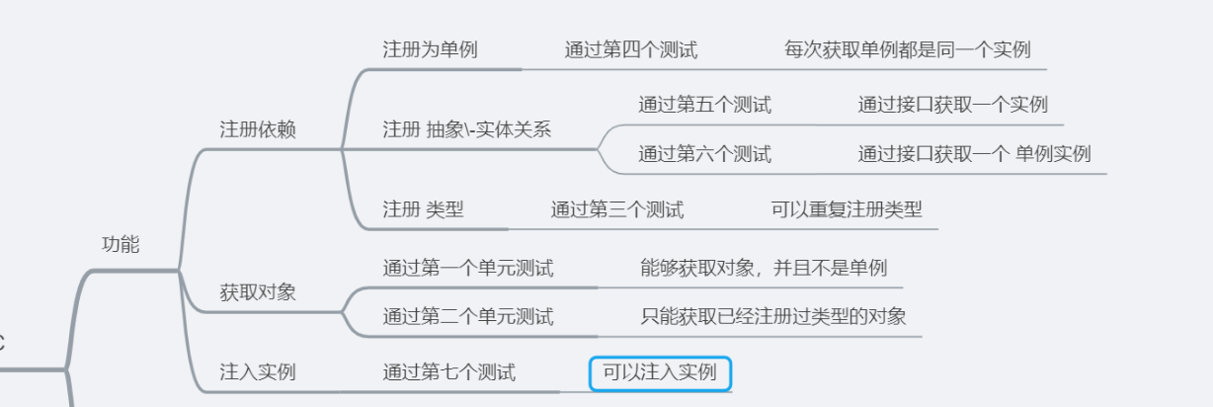

45. 简易 IOC 容器（七）清空功能
在上一篇，我们完成了 IOC 容器的 注入实例功能。
在此篇，我们来实现 IOC 容器的最后一个功能：清空功能。

清空功能实现
功能描述如下:
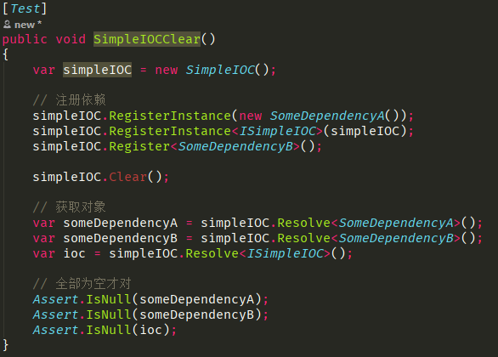

Clear 这个 API，我们还没有定义。
所以我们首要先做的就是定义 Clear 这个 API，如下:
namespace Master.Example
{
public interface ISimpleIOC
{
...
/// <summary>
/// 清空 类型 和 实例
/// </summary>
void Clear();
}
}
实现如下:
using System;
using System.Collections.Generic;
using System.Linq;
using System.Reflection;
using UnityEngine;
namespace Master.Example
{
public class SimpleIOCInject : Attribute
{
}
public class SimpleIOC : ISimpleIOC
{
...
public void Clear()
{
RegisteredType.Clear();
mDependency.Clear();
mInstances.Clear();
}
}
}
代码很简单，接着我们运行测试:
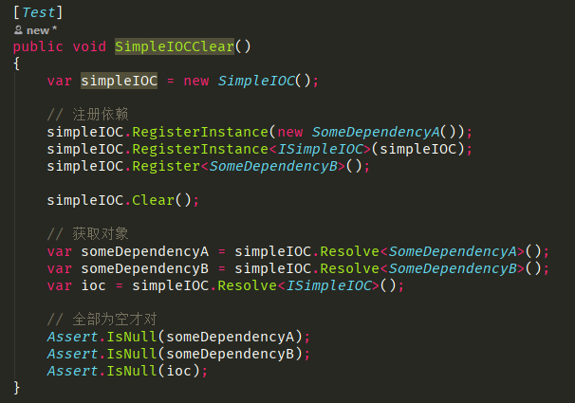

结果如下:
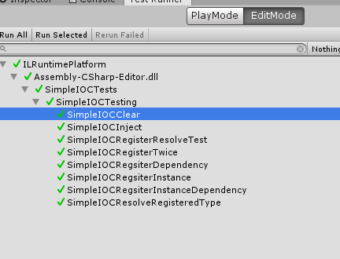

非常简单。
这样我们就实现了一个 简易的 IOC 容器。
此篇内容就这些。

知识地图

46. 简易 IOC 容器（八）小结
在上一篇，我们通过单元测试实现了 清空功能。
在此篇，我们对 简易 IOC 容器 系列做一个小结。

简易 IOC 容器 小结
我们终于结束了 简易 IOC 容器的开发。
它包含最基本的 IOC 功能：
- 注册
- 获取
- 注入
而 QFramework 的 IOC 容器也是仅仅提供了这些功能。
对于轻度使用 IOC 容器的项目来说足够使用了。
但是如果想重度使用，可以使用目前最成熟的 Extenject 插件，它围绕着 IOC 概念做了很多优化和 Unity API 支持，比如它有基于对象池的工厂来创建对象，为容器划分了层级关系等等。
当然各位童鞋自己也可以试试在自己的 IOC 容器里支持对象池、工厂等机制的支持。
接下来我们说说这次简易 IOC 容器开发过程的一个重点：单元测试。

单元测试
在笔者写作过程中，单元测试做了两个非常关键的事情:
- 描述预期的功能
- 确保功能正确
描述预期的功能，就是说明单元测试有一定的表达性，可以让读者知道这个 API 如何使用。
总之是一举三得。
为什么说是一举三得呢？明明不是两个吗？
其实还有一个，就是当我们为 代码新增了功能后，可以防止破坏代码原有的功能。
比如我们的 SimpleIOC 提供了工厂适配，在写完这个新功能之后，我们只要跑通原来的单元测试，就可以保证原有功能的正确性。
换成大白话就是，代码你可以随便改，只要你跑通所有单元测试就行了。
总之按照笔者的理解，单元测试能做的事情有如下三点:
- 描述功能
- 保证功能正确
- 确保改定后的功能正确
而我们可以利用这三点，使我们的系统更加准确和健壮。
此篇的内容就这些。

知识地图
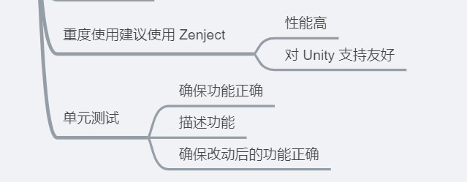

47. 观察者模式（一）：简介与示意图演化
从这一篇开始，我们来学习观察者模式。

观察者模式
观察者模式有一些其他叫法，比如：发布者-订阅者模式，pub-sub 模式等，都指的是观察者模式。
相比观察者模式这个叫法，发布者-订阅者模式更容易让人理解。即有发布者 和 订阅者 这两个角色，同时有发布行为以及订阅行为。而观察者模式这个名字，只有一个观察者，并且只有一个观察这个行为，显然名字传达的信息量太少，所以我们还要去看下观察者模式的定义。
观察者模式的定义：在对象之间定义一个一对多的连接方法，当一个对象变换状态时，其他关联的对象都会自动收到通知。
提取下关键内容：
- 对象之间一对多的连接方式
- 变化时关联对象收到通知
通过这个定义我们脑海中，很容易想到如下的画面:
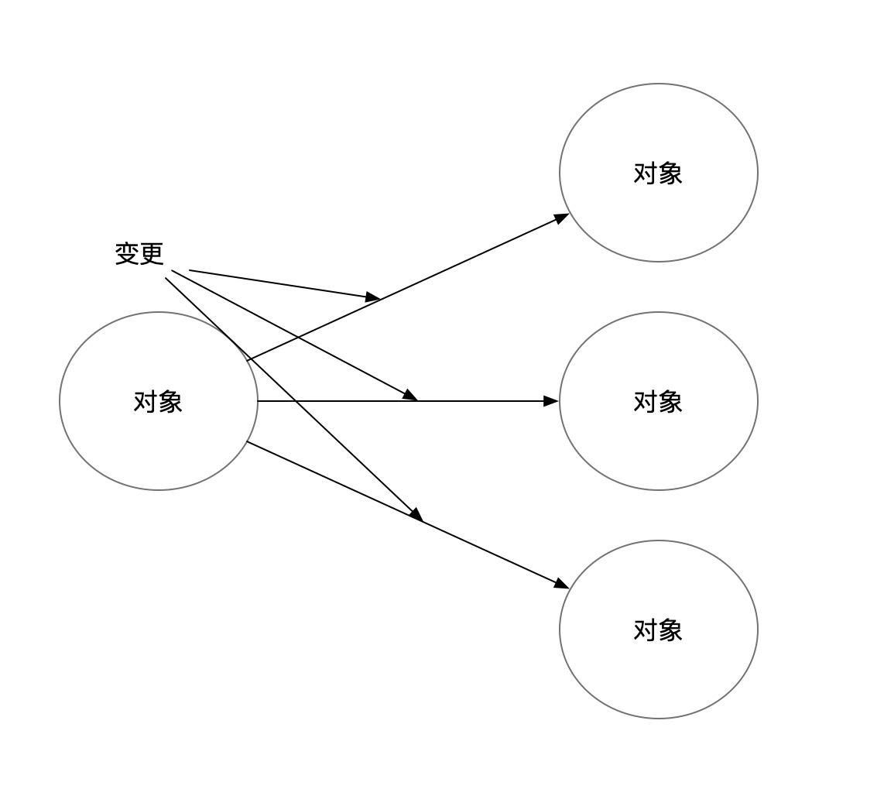

这就是我们的 TypeEventSystem 做的事情。
如果上图从一个发布者订阅者的角度来想象应该是是下图这样的:
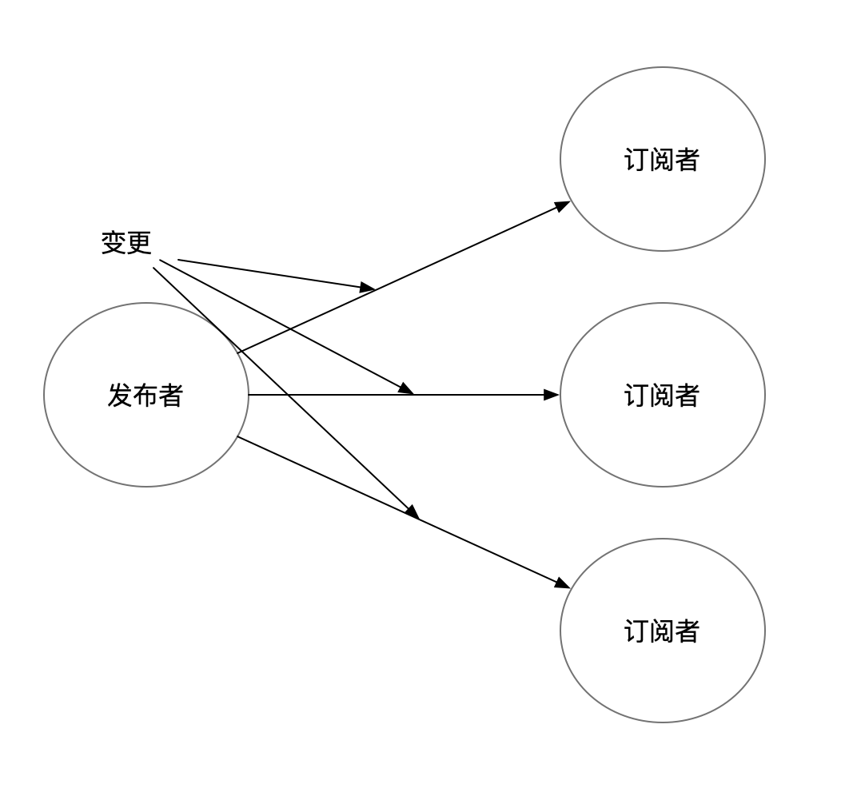

而如果从观察者的角度来看，应该是这样的：
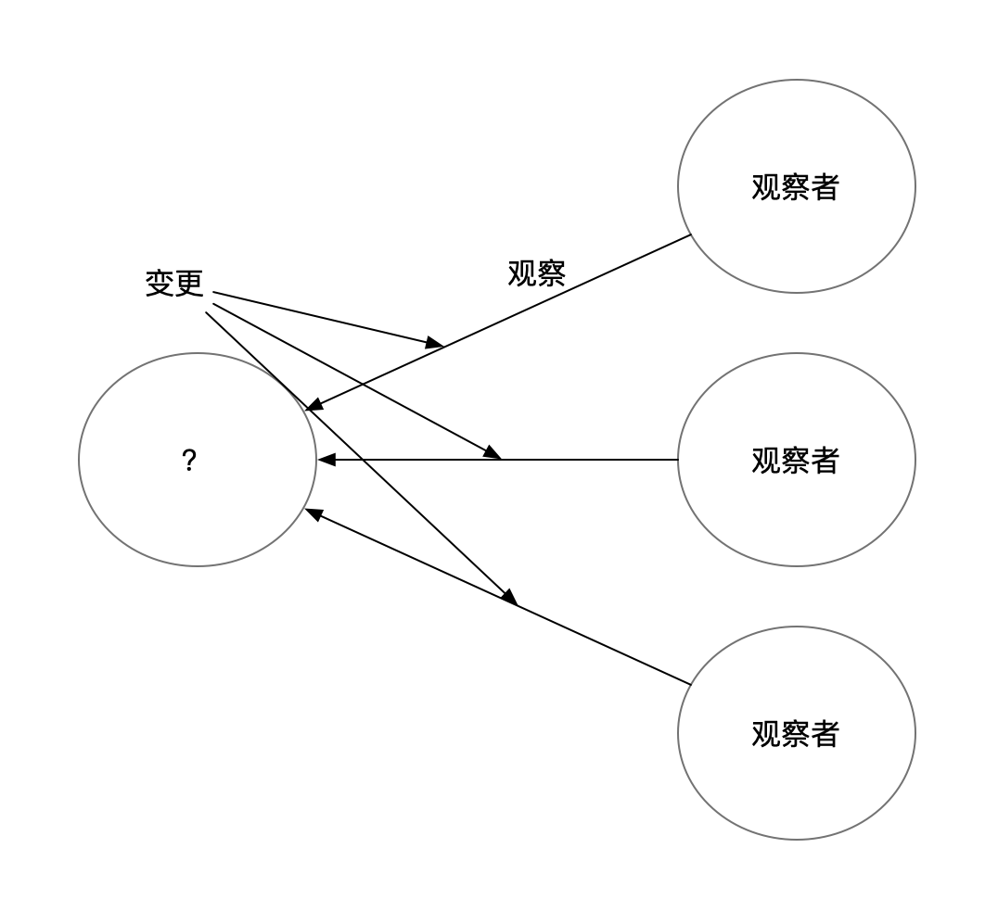

只有观察者这个角色，而观察的对象，是一个大大的问号，因为以目前的信息来看，无法知道观察者观察的是什么。
这就是为什么设计模式有学习门槛，原因就是光通过名字和定义，无法在脑海中进行推测。
那该怎么办呢?
只能去研究网上的观察者模式的 uml 或者看经典的观察者模式实现，这两种都不是很简单的事情。
经过笔者翻阅资料，现在知道了，上图中大大的问号，叫做主题（Subject），主题和观察者有毛关系？em...
总之就是能画出来一个稍微完整的图了，如下所示:
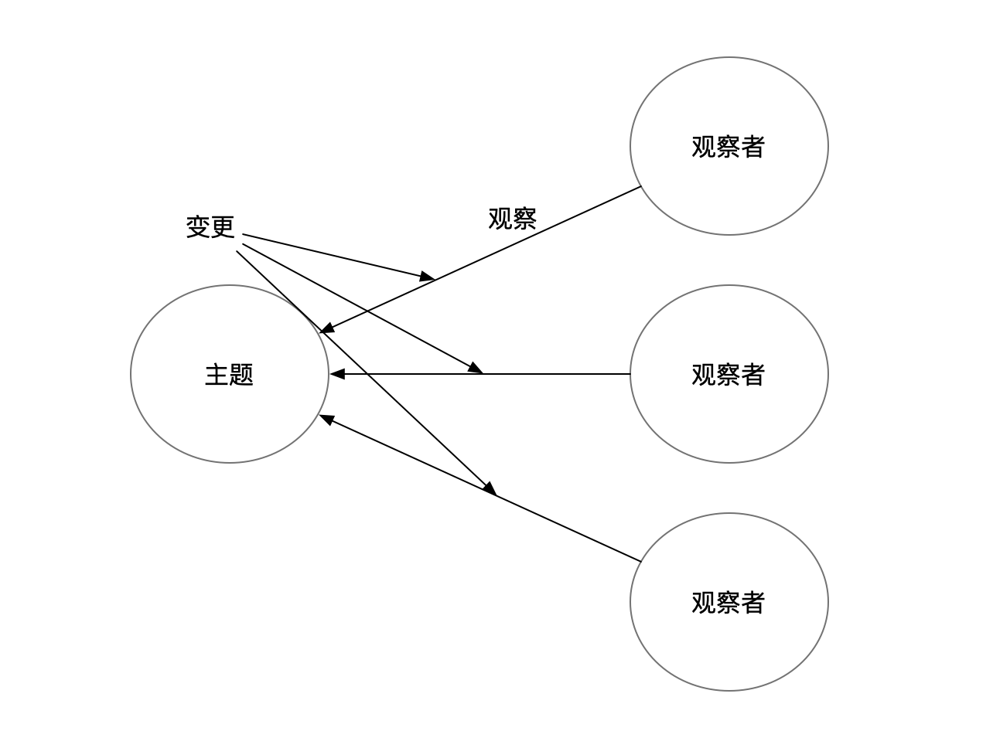

“观察者观察主题”很显然是说不通的，主题是要被订阅（Subscribe）的，如下图所示:
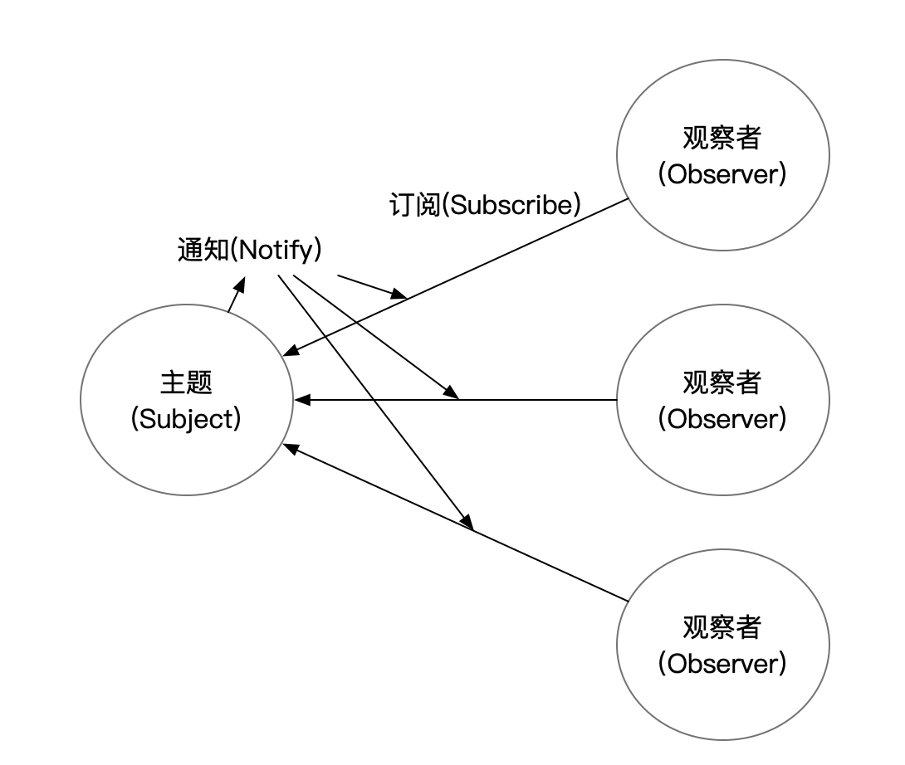

除了订阅，笔者还补充了通知（Notify）这个概念。这样就是一个完整的观察者模式的示意图了。
图中只展示了角色概念以及角色之间的交互关系。
我们简单总结一下这几个概念：
- 观察者（Observer）
- 主题（Subject）
- 通知（Notify）
- 订阅（Subscribe）
它们之间的关系为
- 观察者订阅主题
- 主题通知观察者
这里我们要注意一下，在经典的观察者模式中是没有订阅（Subscribe）这个概念的，在这里提出纯粹是为了为之后的 UniRx 做准备。
此篇的内容就这些。
那么在下一篇，我们使用我们的事件机制，来试着实现以上的观察者模式。

知识地图
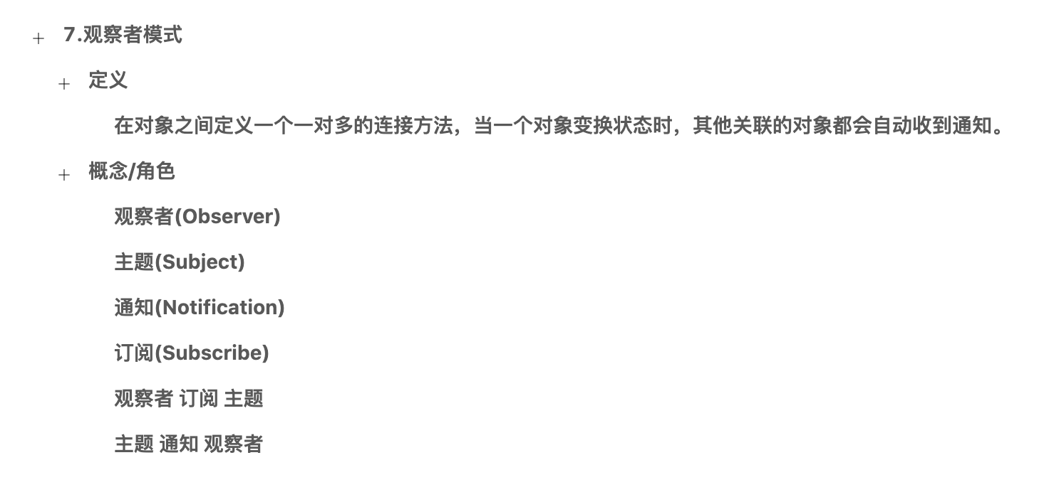

48. 观察者模式（二）：通过 TypeEventSystem 实现示意图中的逻辑
在上一篇，我们简单介绍了观察者模式的定义，以及对观察者模式的示意图做了一个演化，如下：
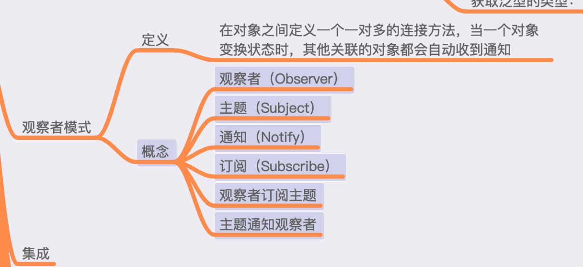

观察者模式示意图。
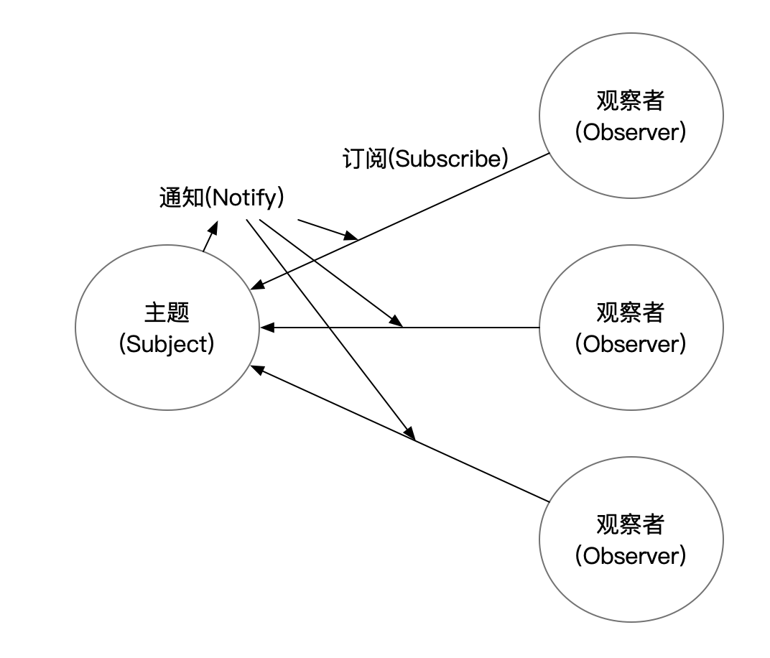

在这一篇，我们试着使用我们的 TypeEventSystem 实现上图中的逻辑。

TypeEventSystem 实现经典观察者模式
首先，我们要创建两个角色：Subject 和 Observer，再创建 Notify 类。
代码如下:
/// <summary>
/// 通知消息
/// </summary>
class NotifyEvent
{
}
/// <summary>
/// 主题
/// </summary>
class Subject
{
}
/// <summary>
/// 观察者
/// </summary>
class Observer
{
}
在 Subject 类中，实现发送通知的逻辑，如下所示:
class Subject
{
public void DoObserverInterestedThings()
{
Notify();
}
void Notify()
{
TypeEventSystem.Send(new NotifyEvent());
}
}
DoObserverInsterestedThings 意思是 做观察者感兴趣的事情，也就是当调用此方法，观察者就会收到通知，因为此方法里边做的是观察者感兴趣的事情。
在 Observer 类中，实现接收通知的逻辑，如下所示:
/// <summary>
/// 观察者
/// </summary>
class Observer
{
public Observer()
{
Subscribe();
}
void Subscribe()
{
TypeEventSystem.Register<NotifyEvent>(Update);
}
void Update(NotifyEvent notifyEvent)
{
Debug.Log("Received Notification");
}
public void Dispose()
{
TypeEventSystem.UnRegister<NotifyEvent>(Update);
}
}
代码很简单。
接着我们写测试代码，如下:
void Start()
{
var subject = new Subject();
var observerA = new Observer();
var observerB = new Observer();
subject.DoObserverInterestedThings();
}
全部代码如下:
using UnityEngine;
namespace FrameworkDesign2021.Example
{
public class ObserverPatternWithTES : MonoBehaviour
{
/// <summary>
/// 通知消息
/// </summary>
class NotifyEvent
{
}
/// <summary>
/// 主题
/// </summary>
class Subject
{
public void DoObserverInterestedThings()
{
Notify();
}
void Notify()
{
TypeEventSystem.Send(new NotifyEvent());
}
}
/// <summary>
/// 观察者
/// </summary>
class Observer
{
public Observer()
{
Subscribe();
}
void Subscribe()
{
TypeEventSystem.Register<NotifyEvent>(Update);
}
void Update(NotifyEvent notifyEvent)
{
Debug.Log("Received Notification");
}
public void Dispose()
{
TypeEventSystem.UnRegister<NotifyEvent>(Update);
}
}
// Use this for initialization
void Start()
{
var subject = new Subject();
var observerA = new Observer();
var observerB = new Observer();
subject.DoObserverInterestedThings();
}
}
}
将此脚本挂到任意 GameObject 上，运行结果如下:
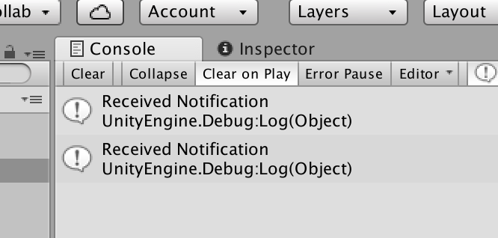

结果完全正确。
现在我们贴出来示意图，看下，我们实现的逻辑是不是和图中表示的一样。

看起来是一样的，主题、观察者、订阅、通知这些概念都在代码中体现了出来，所以使用 TypeEventSystem 来实现示意图的实现就完成了。
而这份实现，与经典的观察者模式更进了一步。
此篇的内容就这些。
在下一篇，我们聊聊经典观察者模式，经典观察者模式就是设计模式书中对观察者模式的实现。

知识地图
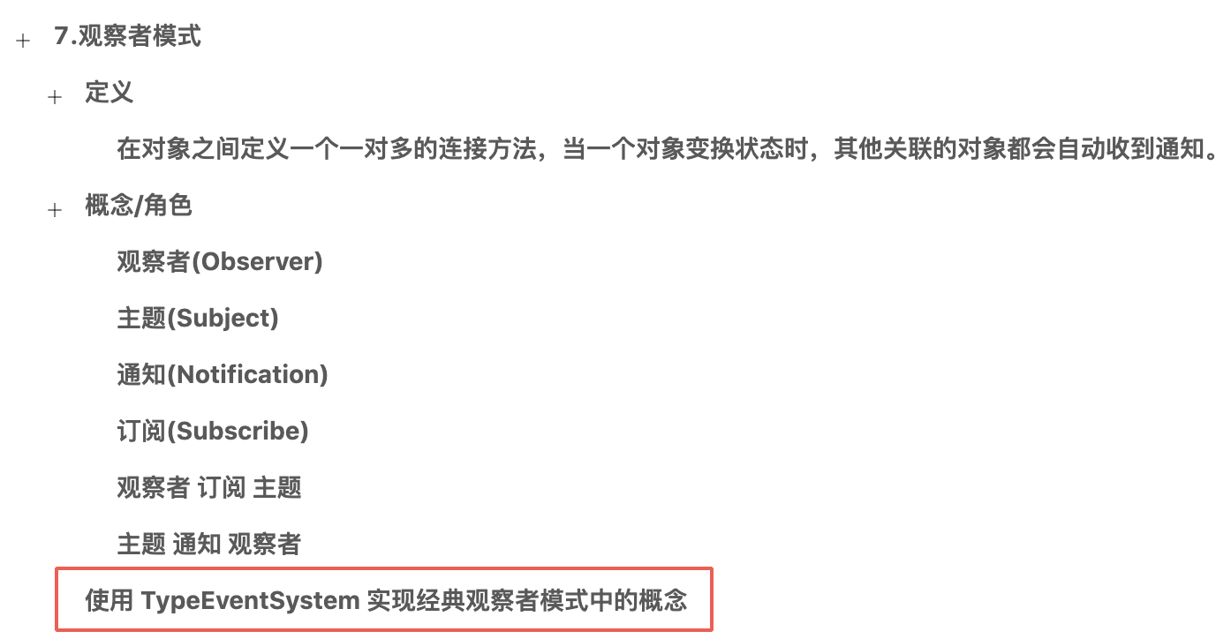

49. 观察者模式（三）：经典观察者模式实现
在上一篇，我们使用 TypeEventSystem 实现了经典的观察者模式中的概念。
在这一篇，我们试着接触下经典观察者模式的实现以及其结构图。
我们先看下上一篇的测试代码:
void Start()
{
var subject = new Subject();
var observerA = new Observer();
var observerB = new Observer();
subject.DoObserverInterestedThings();
}
在测试的代码中，并没有体现 Subject 与 Observer 的关联操作，这是因为我们把关联操作都让各自类通过 TypeEventSystem 实现了。
而经典的观察者模式，是在测试的代码中需要写一些关联操作的。
现在，TypeEventSystem 在维护 Observer 与 Subject 的关联，存储在数据结构 Dictionary<Type,IRegisteration>。
那么在经典的观察者模式中，是谁来维护 Observer 与 Subject 之间的关联呢？
答案是 Observer。
如下图所示:
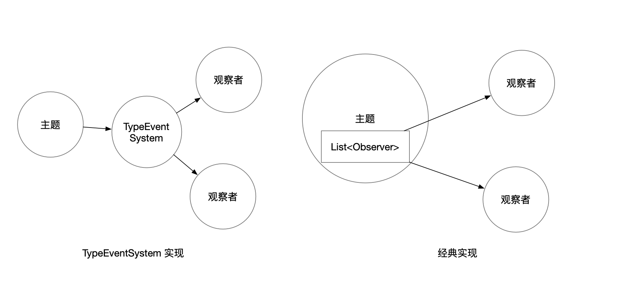

经典的观察者实现如下所示:
abstract class Subject
{
List<Observer> mObservers = new List<Observer>();
// 加入观察者
public void Attach(Observer observer)
{
mObservers.Add(observer);
}
// 删除观察者
public void Detach(Observer observer)
{
mObservers.Remove(observer);
}
// 通知所有观察者
public void Notify()
{
mObservers.ForEach(observer=>observer.Update());
}
}
abstract class Observer
{
public abstract void Update();
}
这里我们要注意下， Subject 和 Observer 都是抽象类。两者之间目前已经形成了一个结构,如下图所示。
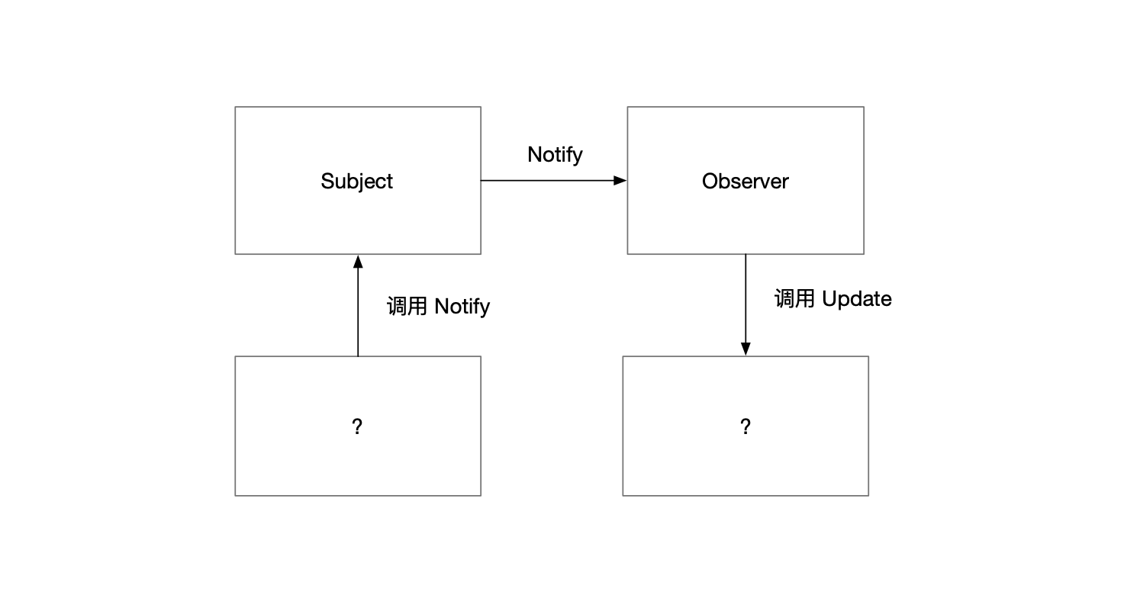

在经典设计模式的实现中，除了 Subject 和 Observer，还有两个 ConcreteSubject 和 Conrete Observer，笔者觉得，不介绍这两个概念的话观察者模式更容易理解。上图所示的结构已经很清晰了。
这个 Subject 和 Observer，形成了一个可复用的结构，想要使用观察者模式，可以通过继承 Subject 和 Observer 实现。
代码如下：
class ConcreteSubject : Subject
{
/// <summary>
/// 主题状态
/// 即：Observer 感兴趣的数据
/// </summary>
private string mSubjectState;
public void SetState(string state)
{
mSubjectState = state;
// 数据变更时通知
Notify();
}
public string GetState()
{
return mSubjectState;
}
}
class ConcreteObserver : Observer
{
private ConcreteSubject mSubject = null;
public ConcreteObserver(ConcreteSubject subject)
{
mSubject = subject;
}
public override void Update()
{
Debug.Log("ConcreteObserver.Update");
Debug.Log("ConcreteObserver:Subject 当前的主题:" + mSubject.GetState());
}
}
代码的逻辑不难，就是当为 ConcreteSubject 设置 State 值时，ConcreteObserver 收到通知，并输出 State 值。
我们接着写测试代码，如下所示:
void Start()
{
var subject = new ConcreteSubject();
var observer = new ConcreteObserver(subject);
subject.Attach(observer);
subject.SetState("测试");
}
全部代码如下所示:
using System.Collections.Generic;
using UnityEngine;
namespace FrameworkDesign2021.Example
{
public class ObserverPattern : MonoBehaviour
{
abstract class Subject
{
List<Observer> mObservers = new List<Observer>();
// 加入观察者
public void Attach(Observer observer)
{
mObservers.Add(observer);
}
// 删除观察者
public void Detach(Observer observer)
{
mObservers.Remove(observer);
}
// 通知所有观察者
public void Notify()
{
mObservers.ForEach(observer=>observer.Update());
}
}
abstract class Observer
{
public abstract void Update();
}
class ConcreteSubject : Subject
{
/// <summary>
/// 主题状态
/// 即：Observer 感兴趣的数据
/// </summary>
private string mSubjectState;
public void SetState(string state)
{
mSubjectState = state;
// 数据变更时通知
Notify();
}
public string GetState()
{
return mSubjectState;
}
}
class ConcreteObserver : Observer
{
private ConcreteSubject mSubject = null;
public ConcreteObserver(ConcreteSubject subject)
{
mSubject = subject;
}
public override void Update()
{
Debug.Log("ConcreteObserver.Update");
Debug.Log("ConcreteObserver:Subject 当前的主题:" + mSubject.GetState());
}
}
void Start()
{
var subject = new ConcreteSubject();
var observer = new ConcreteObserver(subject);
subject.Attach(observer);
subject.SetState("测试");
}
}
}
将此脚本挂到任意 GameObject 上，得到如下结果:
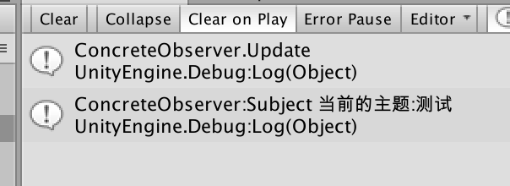

结果没啥问题。
目前的示意图如下:
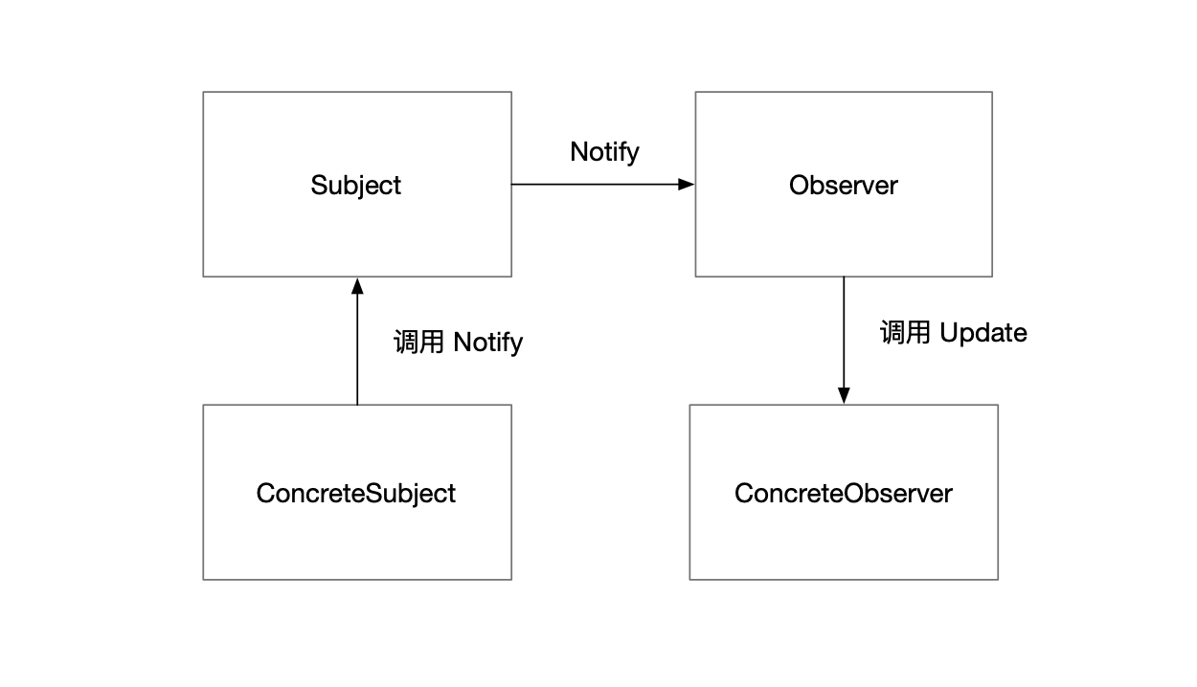

Concrete 是具体的意思，即：Subject 是抽象的 Subject，Observer 是抽象的 Observer，Concrete Subject 则是 具体的 Subject，而 ConcreteObserver 是具体的 Observer。
抽象的概念形成基本结构，而具体的概念则是与业务相关的东西。
在下一篇，我们简单讨论下 TypeEventSystem 与 观察者模式 之间的差别。

知识地图
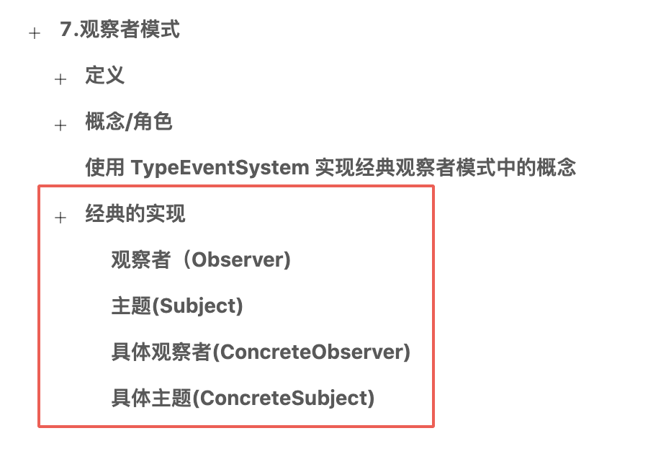

50. 观察者模式（四）：经典观察者模式
在上一篇，我们实现了经典的观察者模式，示意图如下:
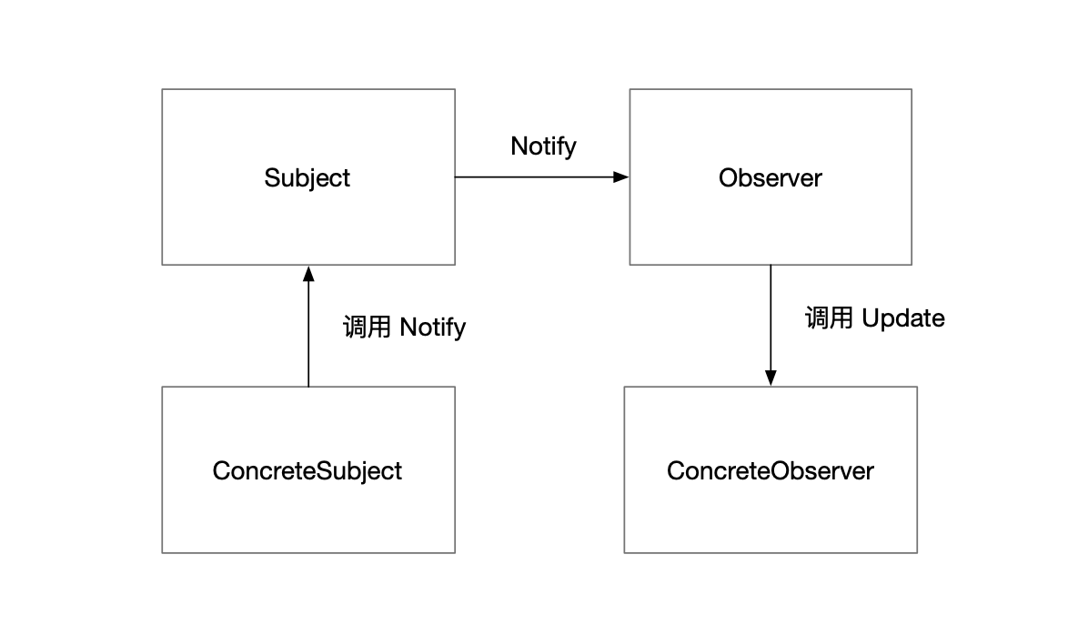

在这一篇，我们聊聊经典观察者模式。

经典观察者模式
首先，先说说，为什么笔者叫它经典观察者模式实现。不是因为它很经典，是因为它很老。。。。
最初的 Gof 的实现是用 c++ 写的，后来在 java 遍地开花，有非常多的 java 实现，而现在书籍上大部分都是与 java 实现一致的。都会分出个 ConcreteSubject 和 ConcreteObserver。
其次，经典的观察者模式是纯粹的面向对象实现，不包含一些现代的编程概念，比如函数式、lambda 表达式等。这一点是其优势。

TypeEventSystem 与 经典观察者模式 使用方式比较
观察者模式，是典型的把可复用的代码交给父类，而子类实现具体的逻辑，这是一种设计套路。在我们工作中会经常遇到。
而 TypeEventSystem，是把可复用的代码交给一个类管理，使其成为一个工具。这两者虽然实现的功能一致，但是在使用上是由很大的区别的。
经典观察者模式实现的使用的方式为继承，而 TypeEventSystem 的使用的方式，只需要写注册、注销、发送的代码即可。这两者相比谁的使用代价更低呢？结果显而易见。
这里的结论就是，从对一个项目的影响来说，经典的观察者模式的侵入性更强，对于只能对类进行单继承的 C# 来说，用继承来实现一对多的通信，简直是个硬伤，因为只要继承了观察者模式，就不能再继承其他的类了。
这并不是说经典的观察者模式不好，而是说它使用的概念非常少且非常纯粹。

TypeEventSystem 与 观察者模式 所使用的概念
经典观察者模式是很面向对象的，使用靠继承，内部的实现依赖了多态和封装的特性，除此，再无其他多余的概念。
而我们仔细回顾一下 TypeEventSystem 使用了哪些概念？
- 泛型
- 委托（lambda 表达式)
- 反射
- 封装
- 多态
而泛型和委托，这两个概念是在 2000 年之后才陆续集成到 C# 或 java 中的，在 java 中 委托不叫委托，而是通过匿名类实现。
从 TypeEventSystem 与 经典观察者模式 比较就知道 C# 泛型和委托的强大之处了，简直是不在一个维度上的。
那么经典观察者模式的实现好处是什么的？
- 纯粹的面向对象
- 现代语言基本都支持面向对象（java、php、c++、Objective-C、swift 甚至是 python 和 javascript (ES5 之后)
总结起来就是，经典的观察者模式每个语言都容易实现。
而 TypeEventSystem 同样的功能，移植到 java 版本肯定没有 经典观察者模式的移植容易。
除此之外，观察者模式解除了主题和具体观察者的耦合，让耦合的双方都依赖于抽象，而不是依赖具体。
而让对象依赖于抽象，而不是依赖具体，是依赖倒置原则。
我们可以在下一篇好好聊聊这个原则。

共同的缺点
经典的观察者模式在项目中如果使用太多的话，会影响开发效率，使用 TypeEventSystem 会好一点，但是问题的本质是一样的。
消息在项目中乱飞可不是一个好的前兆，使用消息机制会影响调试，当然如果你从来不用调试的话另说。
此篇的内容就这些。

知识地图
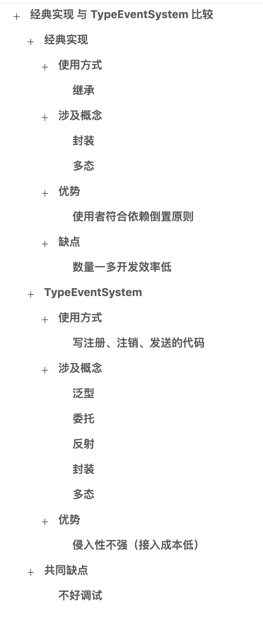

51. 观察者模式（五）：小结
在上一篇对观察者模式与 TypeEventSystem 做了一些比较。
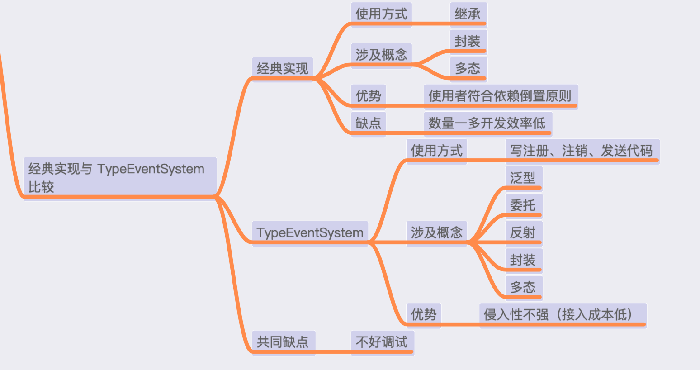

这些比较是纯粹的个人观点，目的不在于向大家灌输自己的观点，而是通过这种比较，大家对观察者模式有更加立体的认识。

依赖倒置原则
在上文中我们提到依赖倒置这个原则，这个原则包含了两个主题：
- 高层模块不应该依赖于底层模块，两者都应该依赖于抽象概念；
- 抽象接口不应该依赖于实现，而实现应该依赖于抽象结构。
而经典的观察者模式，刚好符合第二个主题。
看下如下示意图童鞋们会不会也这样觉得呢？
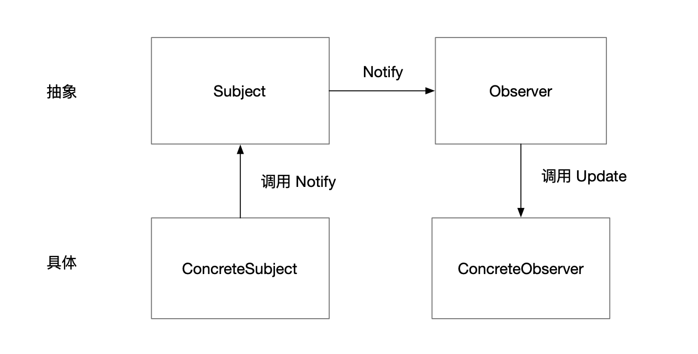

依赖倒置原则是本月非常重要的一个原则，它将会在介绍 IOC/DI 时做详细的介绍。

观察者模式应用场景
我们要知道 Unity 的 GameObject 和 MonoBehaviour 是 Entity-Component 架构。同时在 Unity 中写游戏是事件驱动编程，执行逻辑前提是接收到 Unity 发送过来的事件（Awake、Start、Update、OnDestroy、ApplicationQuit 等），并且游戏中也包含了大量的事件，角色死亡、玩家通关，都可以当做一个事件看到，当我们对这些事件感兴趣的时候，我们就可以想想，是否可以使用观察者模式或者 TypeEventSystem 来更优雅地实现逻辑。
比如一些任务系统不断地期待一些事情发生，一些成就系统也不断地观察玩家得到的分数、击杀的怪物、得到的金币等等。
此篇的内容就这些。

知识地图
